Dear Alessia,
your texts are good, as always, but there are a few mistakes. Please correct them:

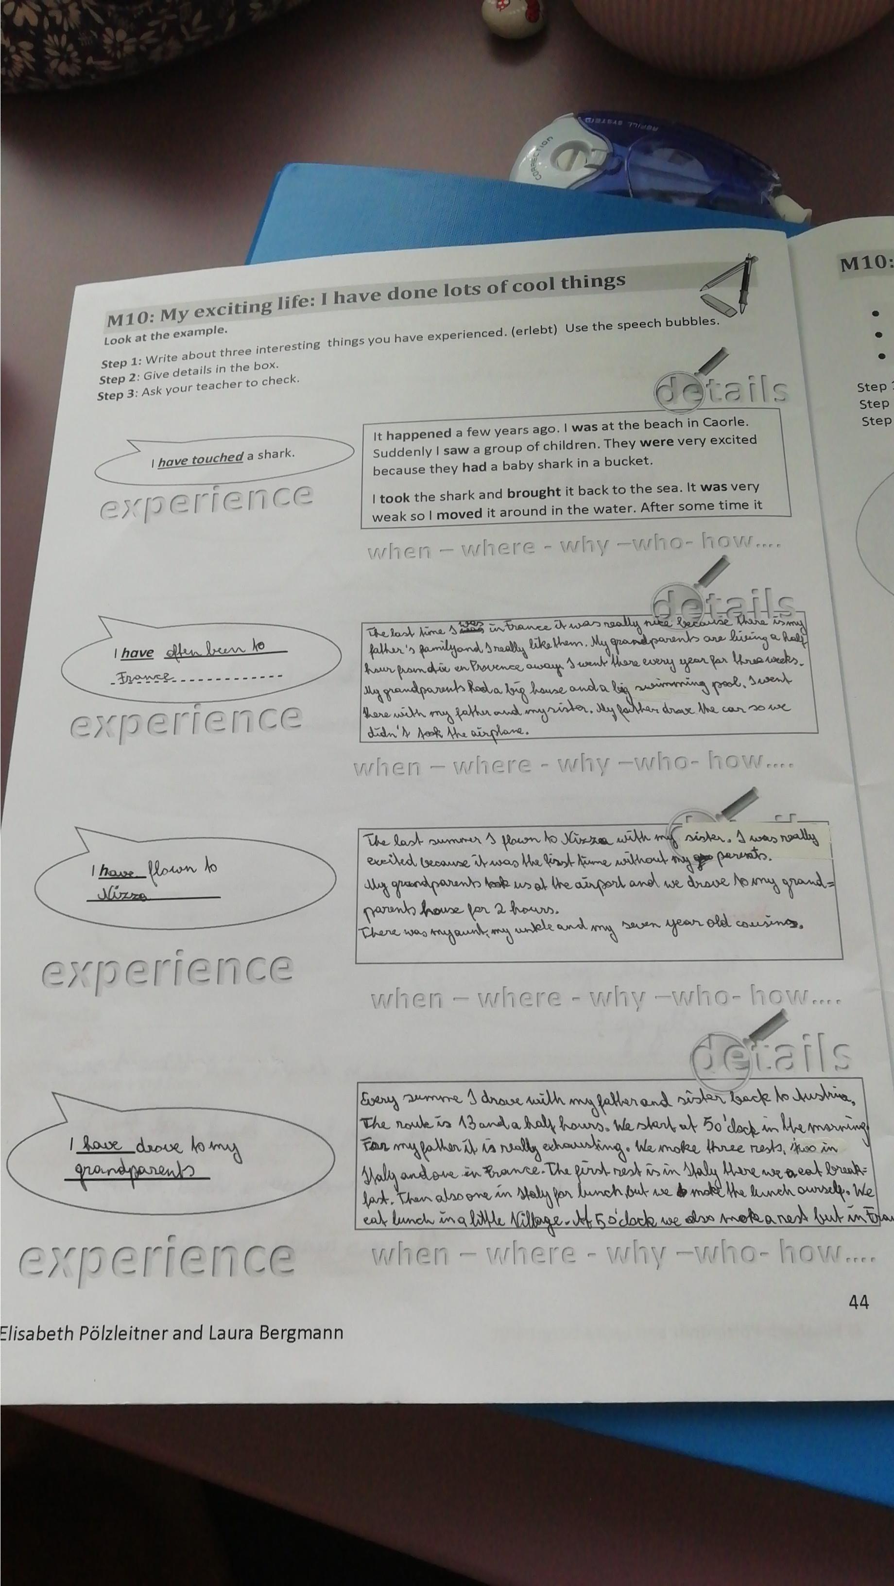

It was really nice because my father’s family was there and I really like them
My granparents live (-das ist immer so – denk an die Routinen) half an hour away from Aix…
…have (wenn sie es immer noch haben, sonst passt had) a big house

….so we didn’t take the plane

Last summer I flew to Nizza ….

picked us up at the airport

I have driven to my granparents (that means, you drove the car)
I have gone to France by car
Every summer I go back to Austria by car. My father drives and it takes us 13 and a half hours.
Last summer, we started at 5 o’clock in the morning. It was really exhausting for my father. We made three stops, two in Italy and one in France. The first stop was in Italy, where we ate breakfast. Then another one in Italy for lunch, but we made lunch ourselves. We ate lunch in a little village. At five o’clock we took a third rest, but that was already in France.

