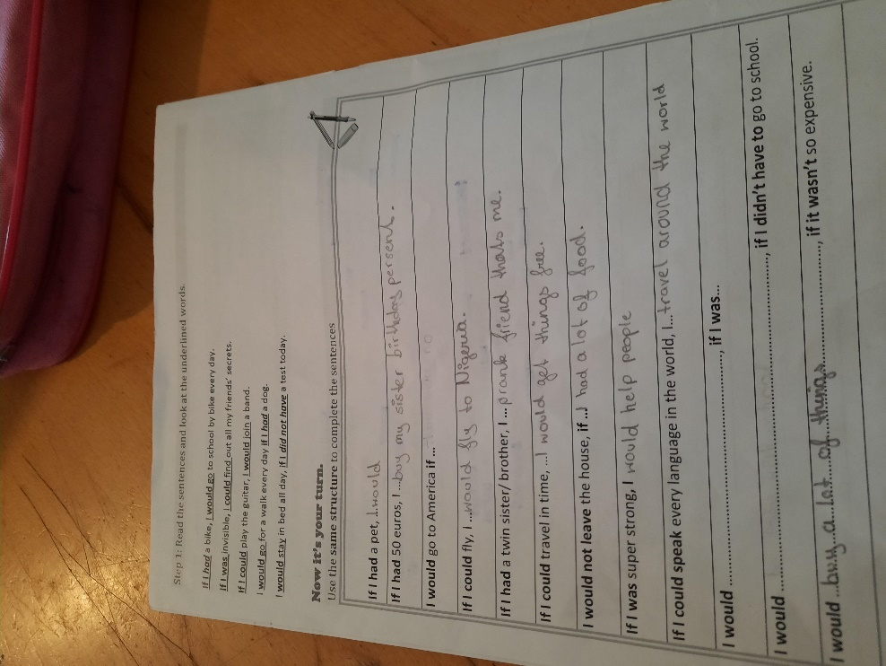

Be careful and look at the structure of the if sentences again!

1st sentence – incomplete!
2nd sentence: I would buy ….
4th sentence: I would play a prank on my friends and pretend that she’s me.

Why would you get things for free if you could travel in time? I don’t understand that.

Please complete ALL the sentences.

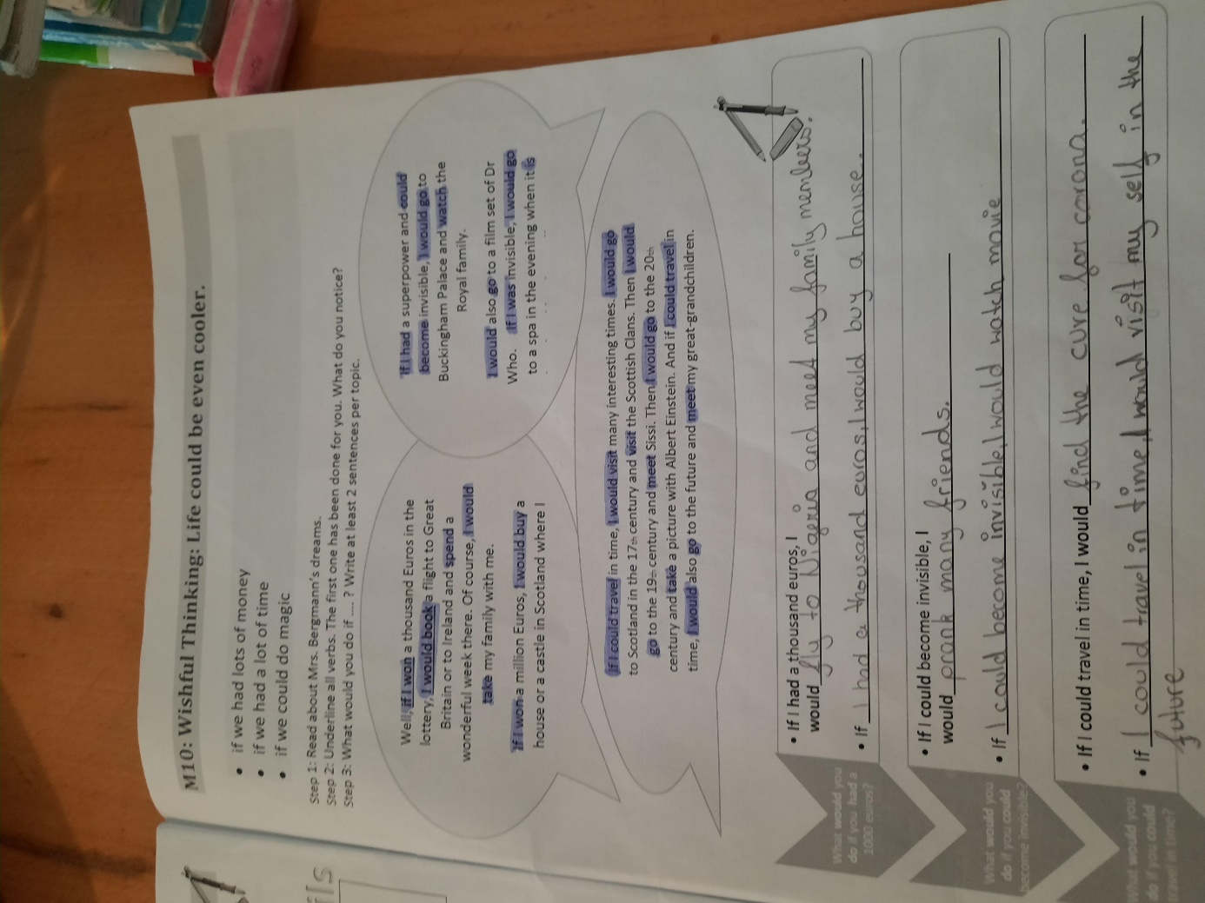

I would play a prank on my friends.

