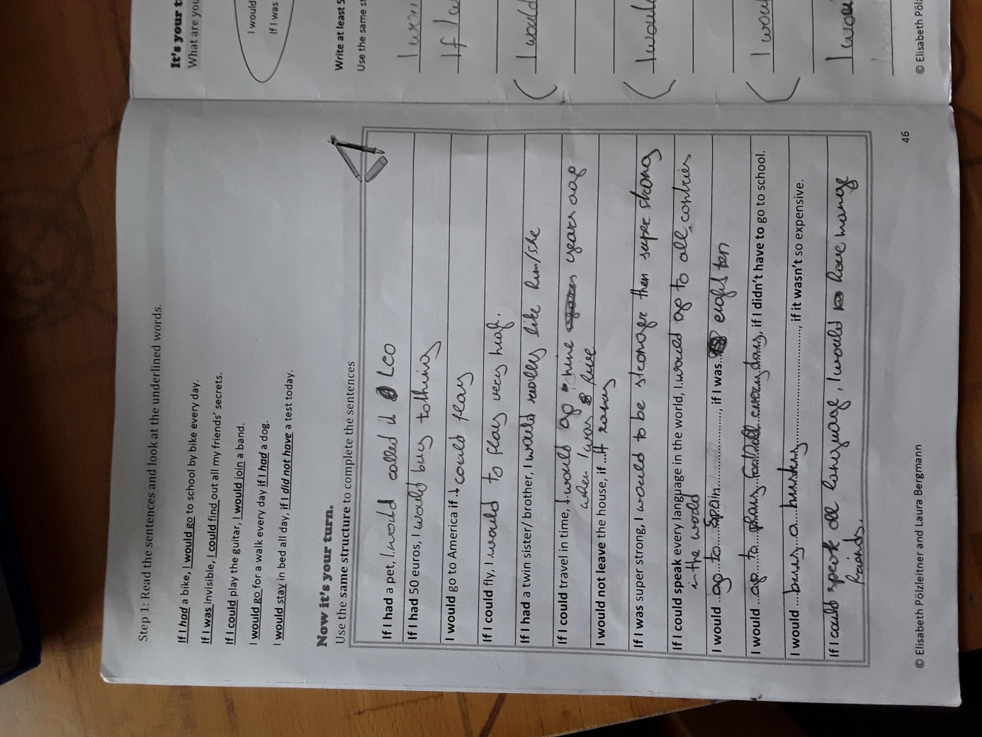

I would call it Leo.

I would buy ?? nothing?

America, if I could fly ??
If I could fly, I would fly very high.
him/her
I would go nine years back to when I was five (Why? What happened a that time?)
if it rained
eighteen
I would play football every day, ….
all languages

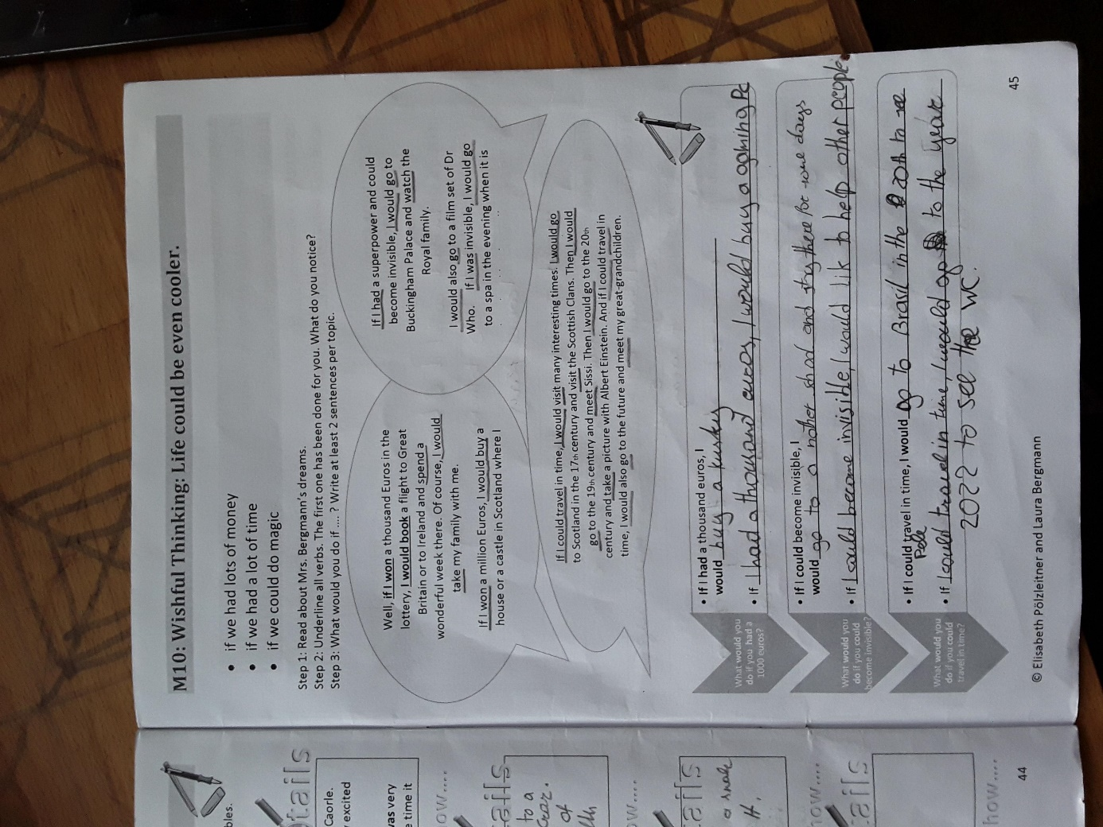

to another school
like

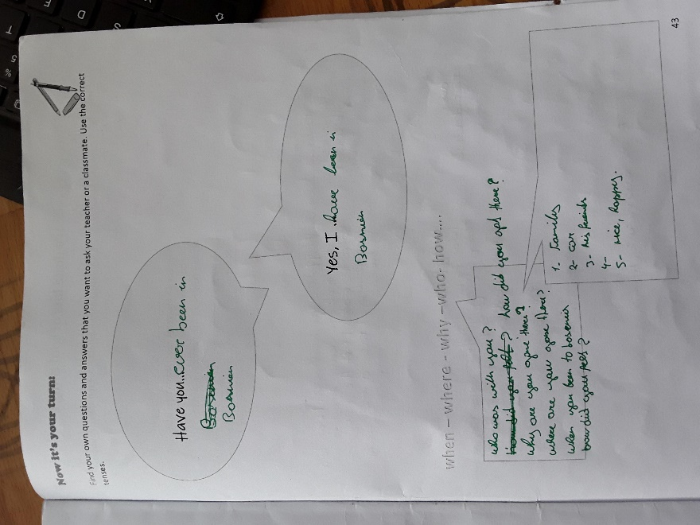

to Bosnia

to Bosnia

Why did you go there?
When did you go there?
How did you feel, when you went to Bosnia?
=> Write an answer in whole sentences please.

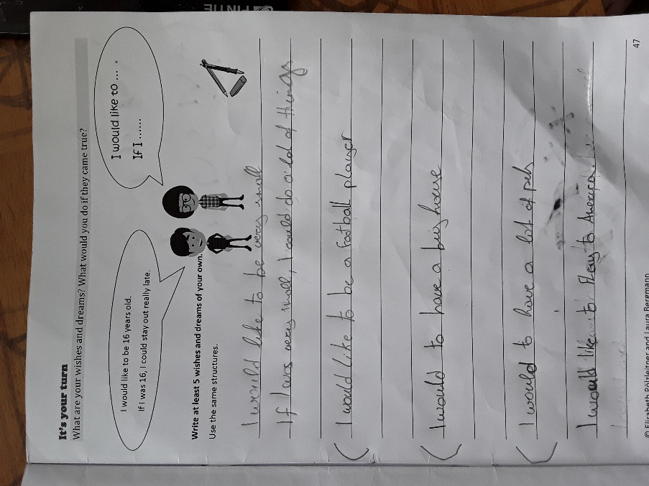
Please use ALL the lines and write a bit more.

what could you do then? give a few examples!

ok – now go on: If I was a football player, I would….

I would like to have or buy a house….
I would like to have….

fly

