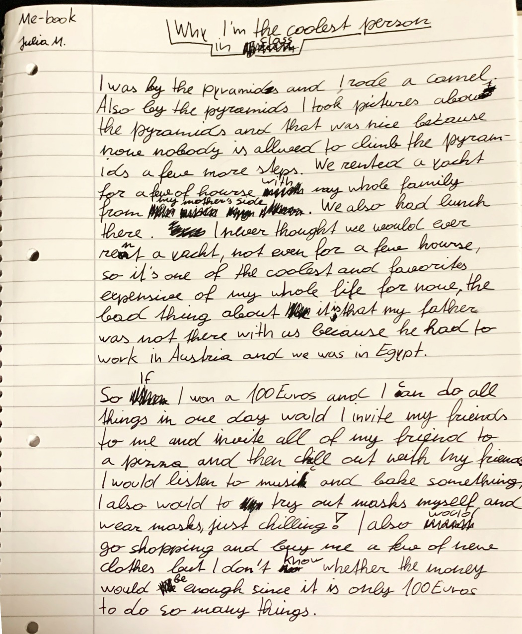
EXPERIENCES!:
I have climbed the pyramides and I have ridden a camel
At the pyramids, I took pictures of me climbing on the pyramids…
hours (2x)
on my mother’s side
it’s one of the coolest and most expensive things I have done in my life.
we were in Egypt
I could do whatever I wanted for one day, I would invite all of my friends to my place
I also would try out masks (?? why ??)
and buy some new clothes for myself

Dear Julia,

when you told me about your boat trip, you didn’t say that it was a yacht – wow – I’ve never been on a yacht. You’ll have to tell me about some time!

Your paragraph with the pyramids is a bit confusing because you say that taking pictures was nice but you don’t tell your readers that you actually climbed the pyramids. I only knew because you told me, when we had our zoom meeting. I’ve tried to change the sentence but I’m not sure if it is what you wanted to say – have a look.
There are some tense mistakes in the text – please correct them carefully – if you do not know why I corrected the sentences, ask me!

Kind regards
Laura Bergmann

