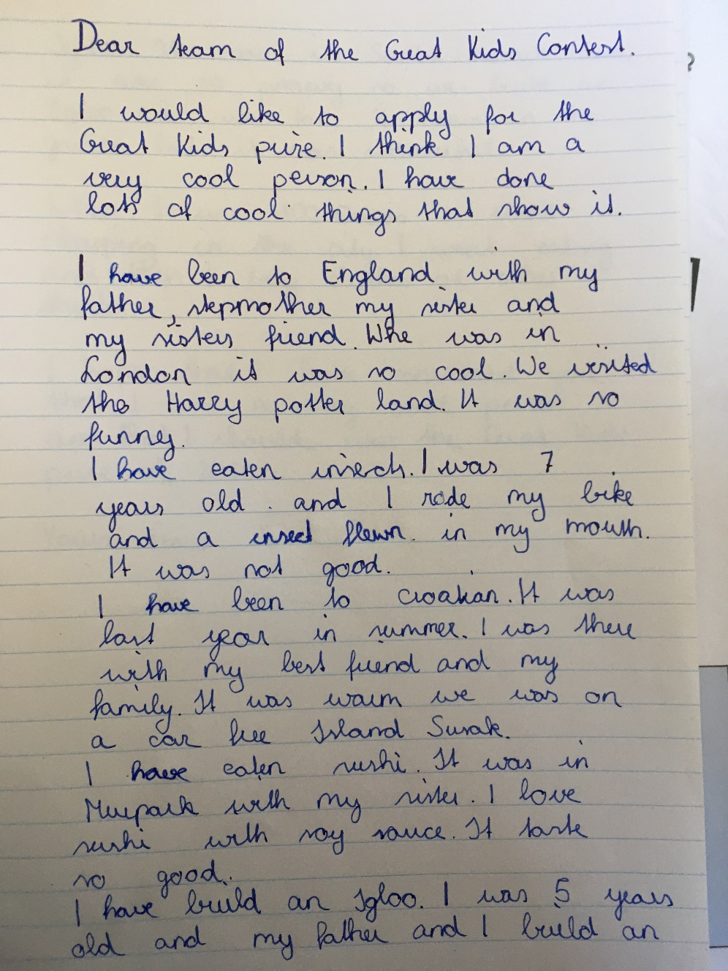

When we were

fly – flew – flown / into my …
Croatia

we were
a car-free island, called Susak

I loved the sushi with … it tasted
OR I love sushi with…. it tastes…
built

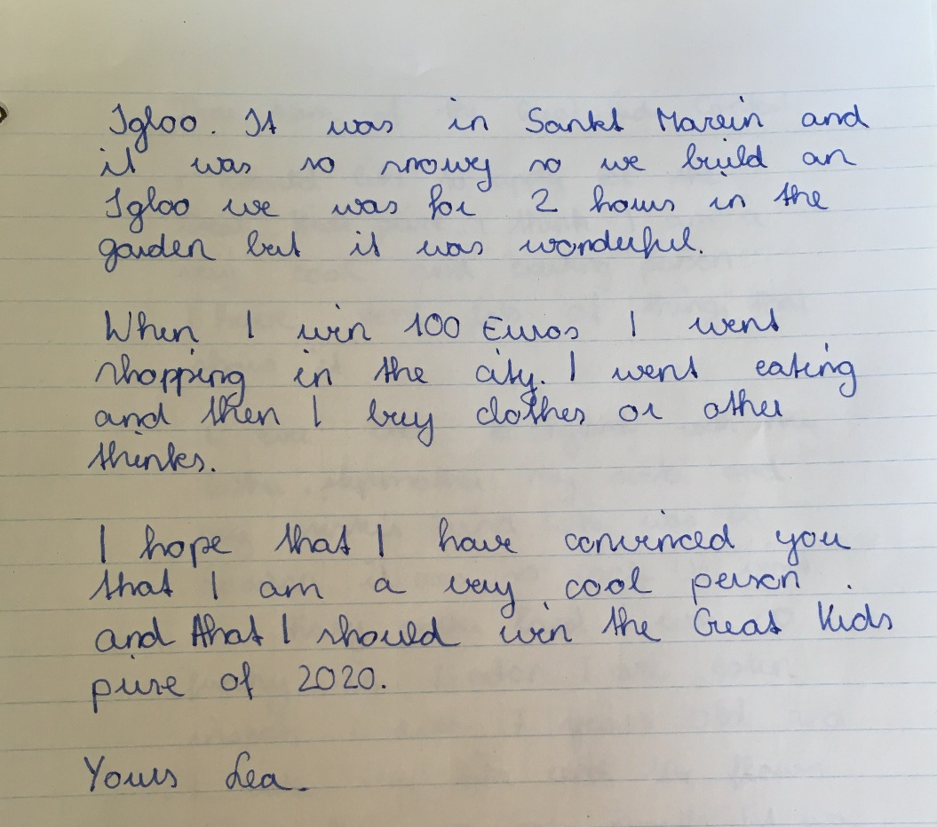
igloo

we were in the garden for two hours and it …

If I won the 100 euros, I would go shopping in the city. I would go out for lunch and then I would buy clothes or other things.

Yours,
Lea
If = deutsch: wenn
If I + past tense , I would ……..

