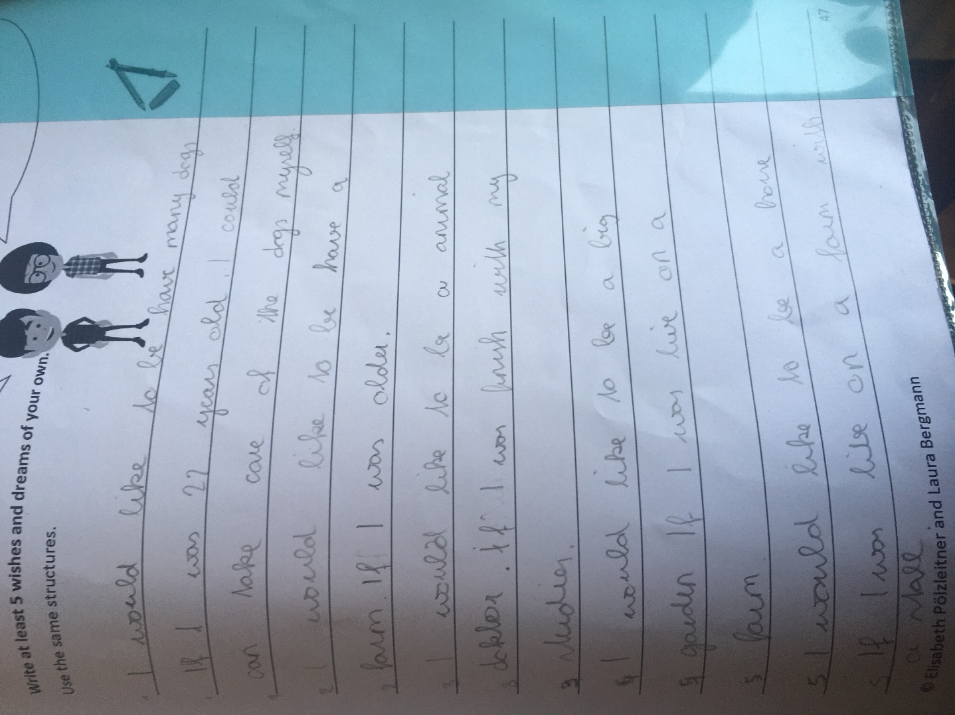
XXXXX

could

---------

n animal doctor = vet
doctor ------------- ed

better: If I was a university student, I would study to be a vet.
have

-------------- if I lived

really BE a horse?
ein Pferd sein?? lived
----------------------------
stable = Stall

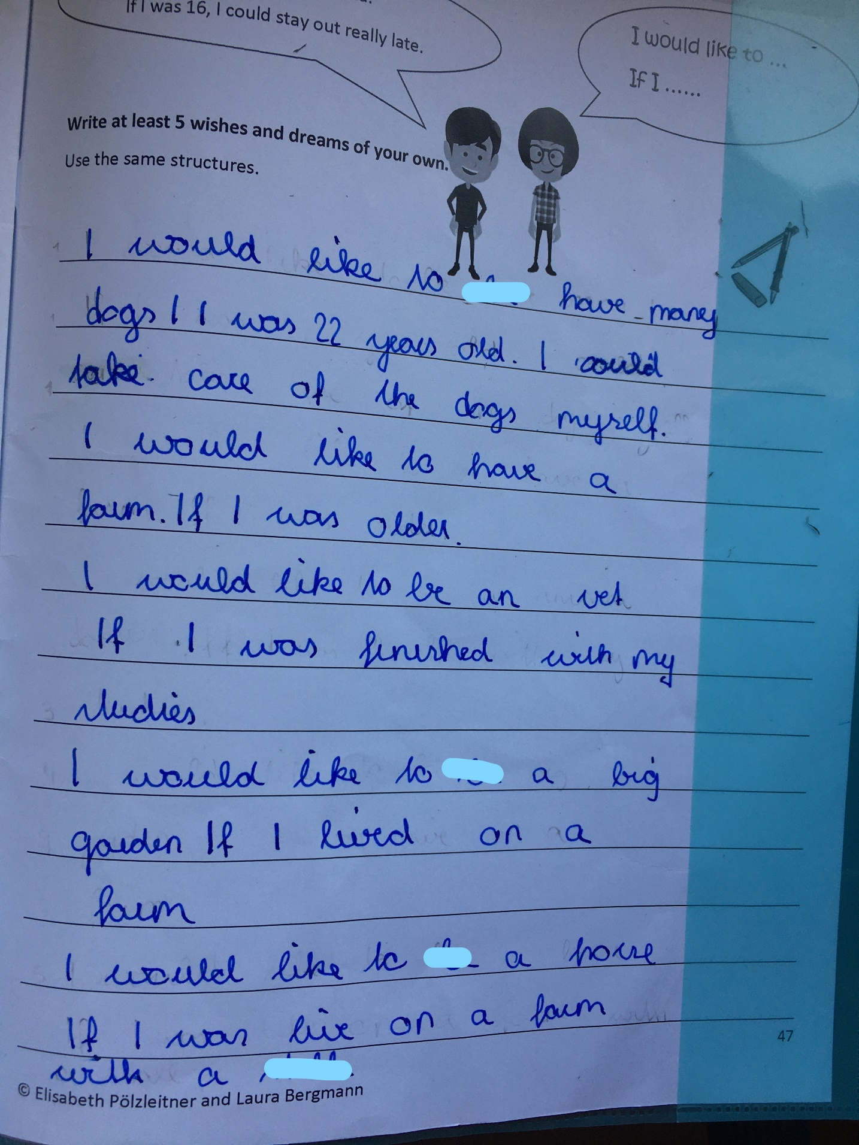

X

X F

better: If I was a university student, I would study to be a vet.

have

have/build

d
stable

