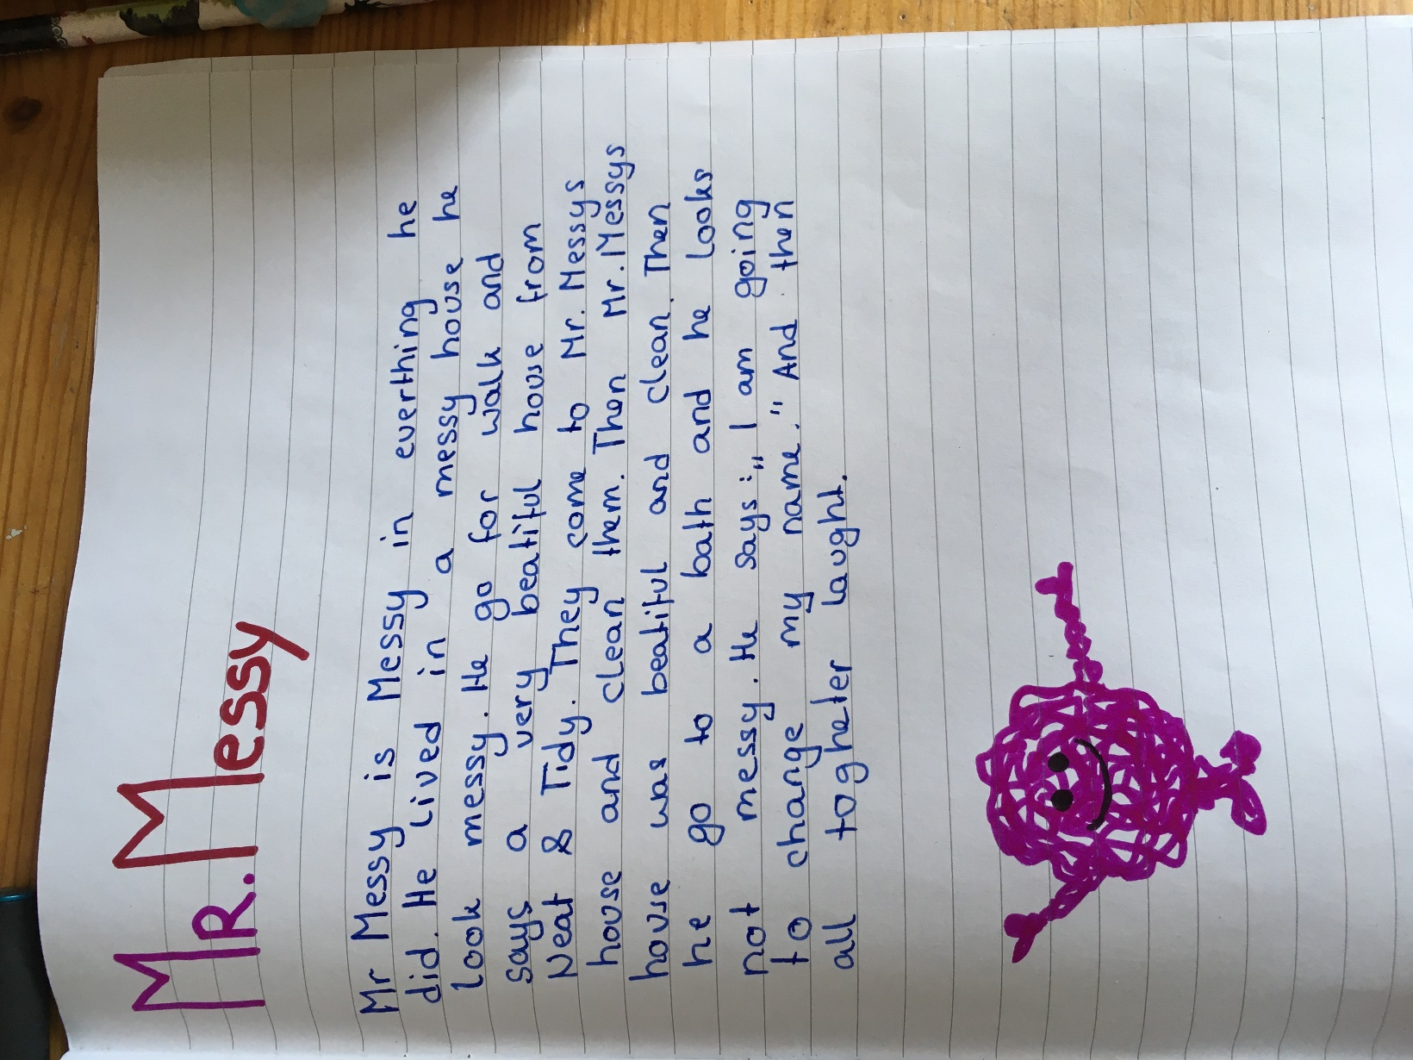

does / lives
S es
sees?? of
it = one house houses it
them = two
takes

And then they all laugh together

