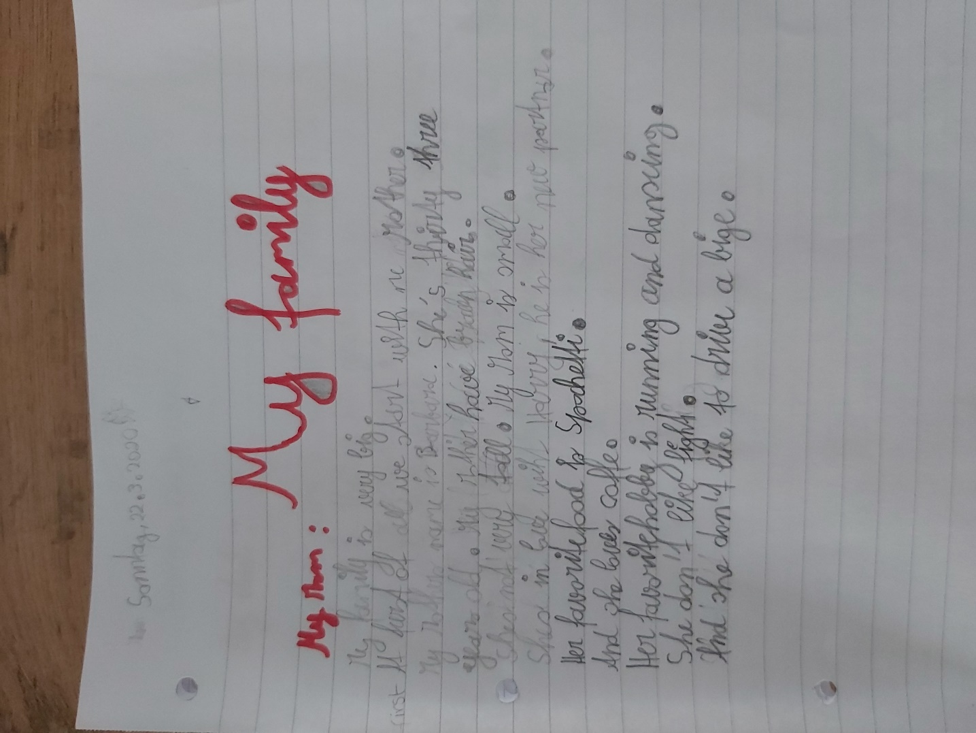

with my mother

My mother ‘ s …
My mother has ….
She’s

coffee
She doesn’t like fighting and she doesn’t like to ride a bike.

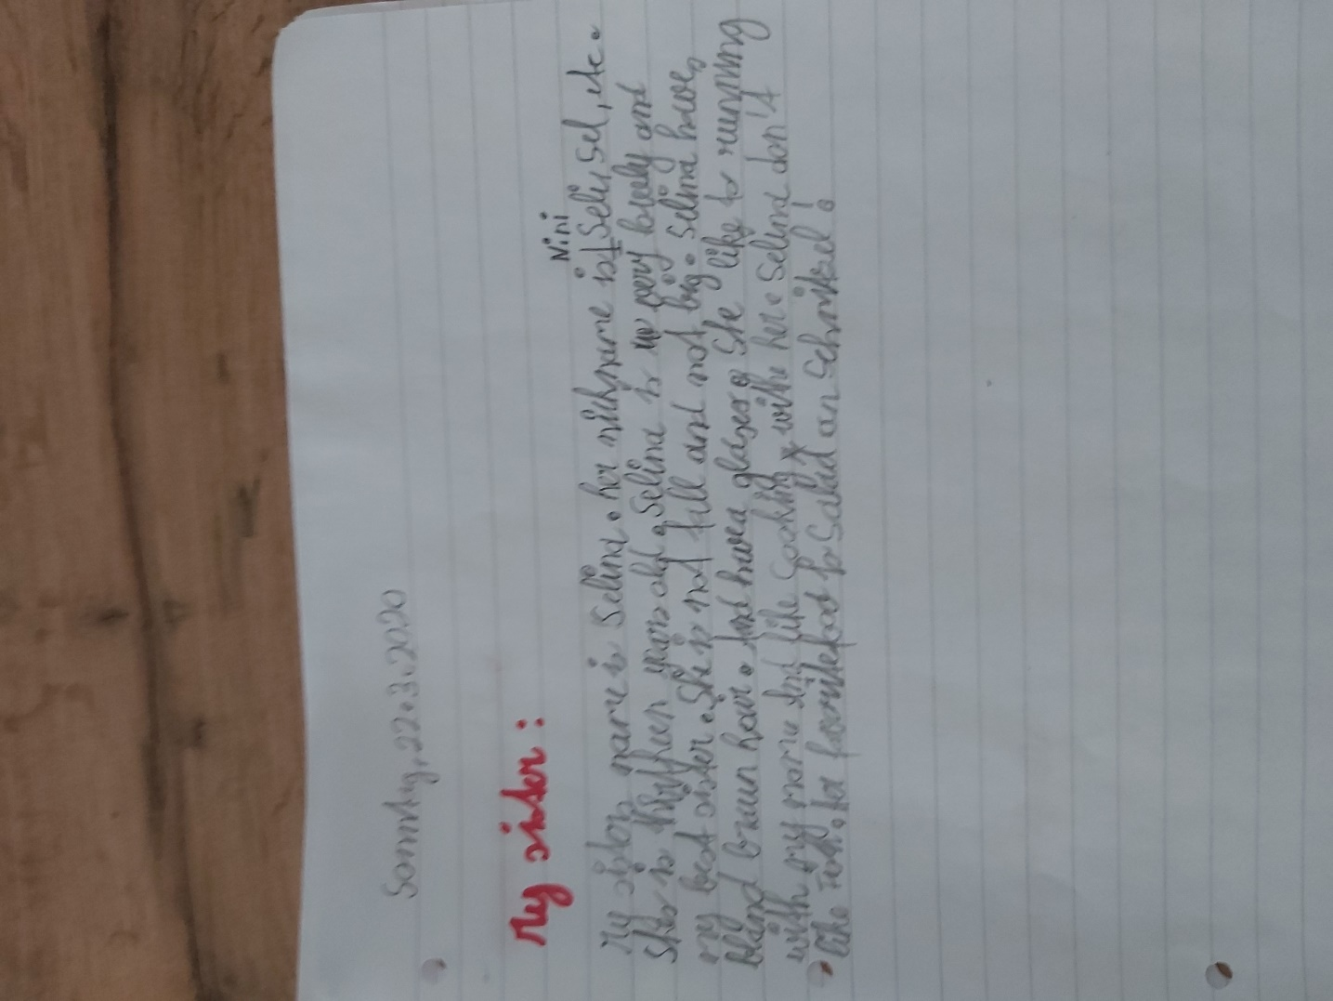

my sister’s …

Selina has …. and wears glasses.
She likes to go jogging with …
and
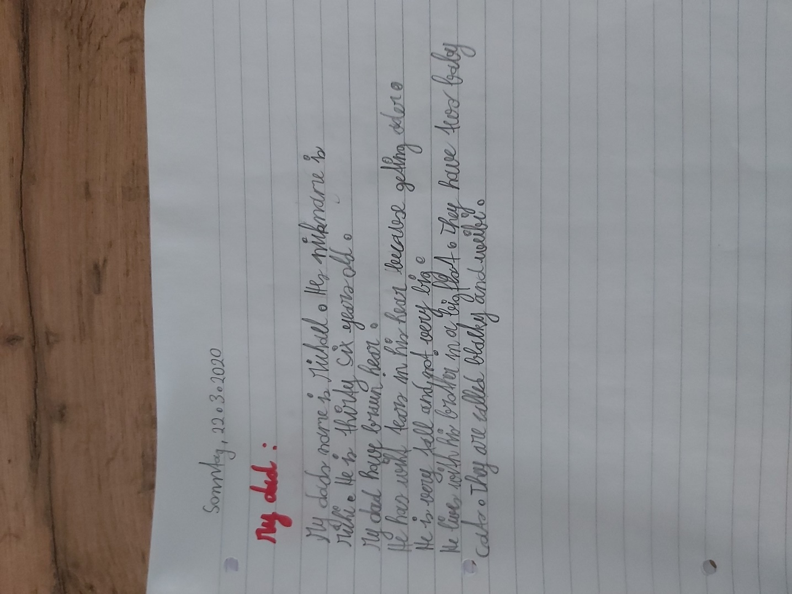

dad’s name
His nickname….
has brown hair

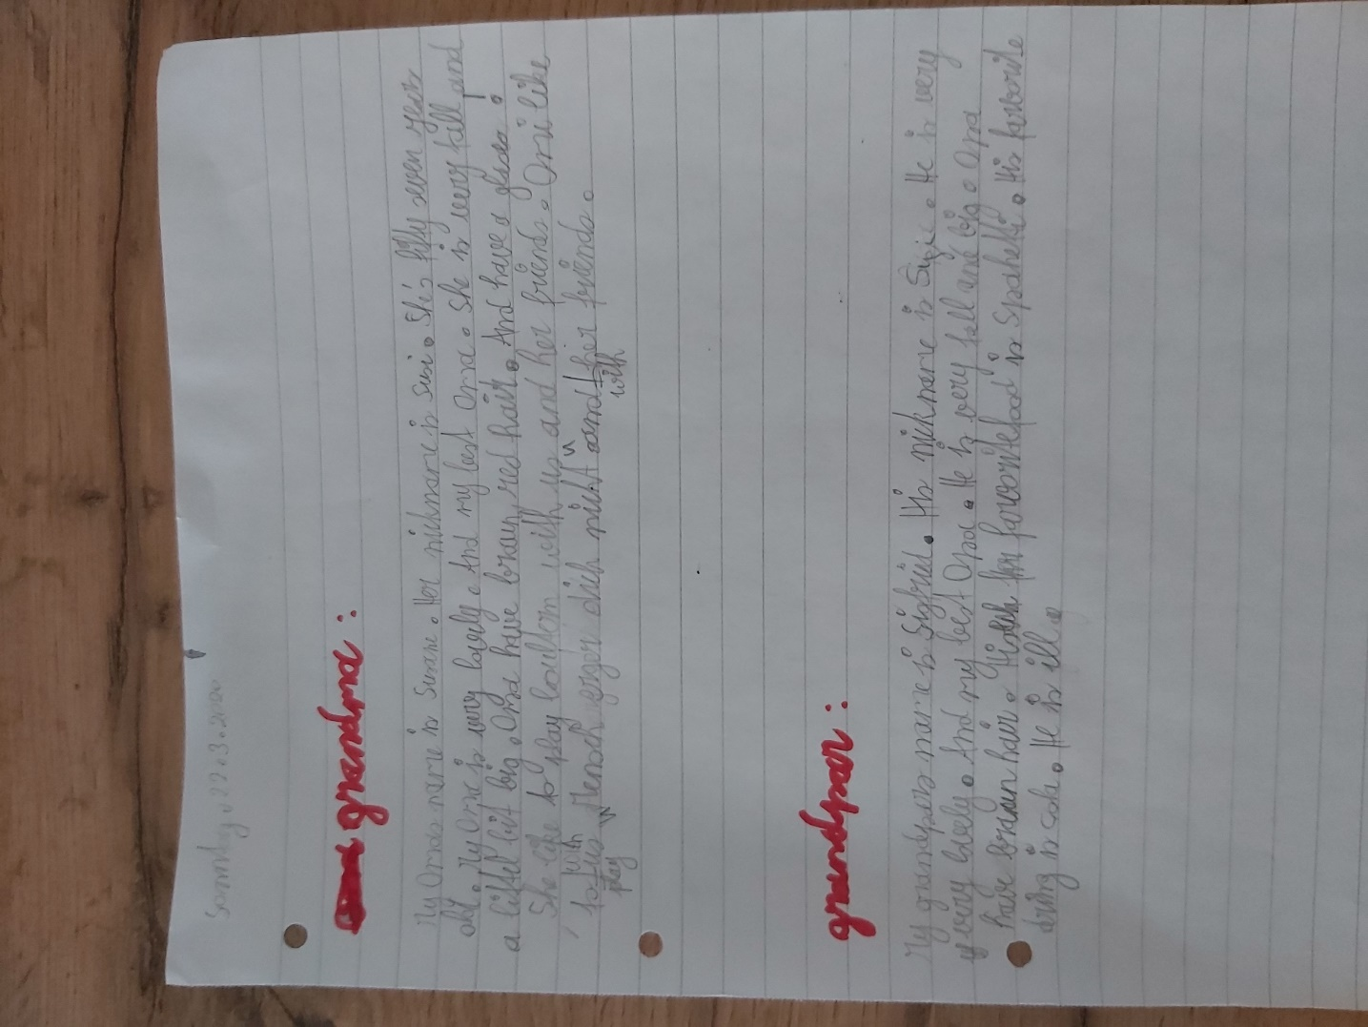
He has white hairs in his hair because he is getting older

grandma’s name
my grandma / my granny
Granny has brown-red hair and wears glasses.
She likes to play ?
Granny likes to play “Mensch ärgere dich nicht” with us and her friends.
grandpa’s
Grandpa has brown hair.
favourite drink

