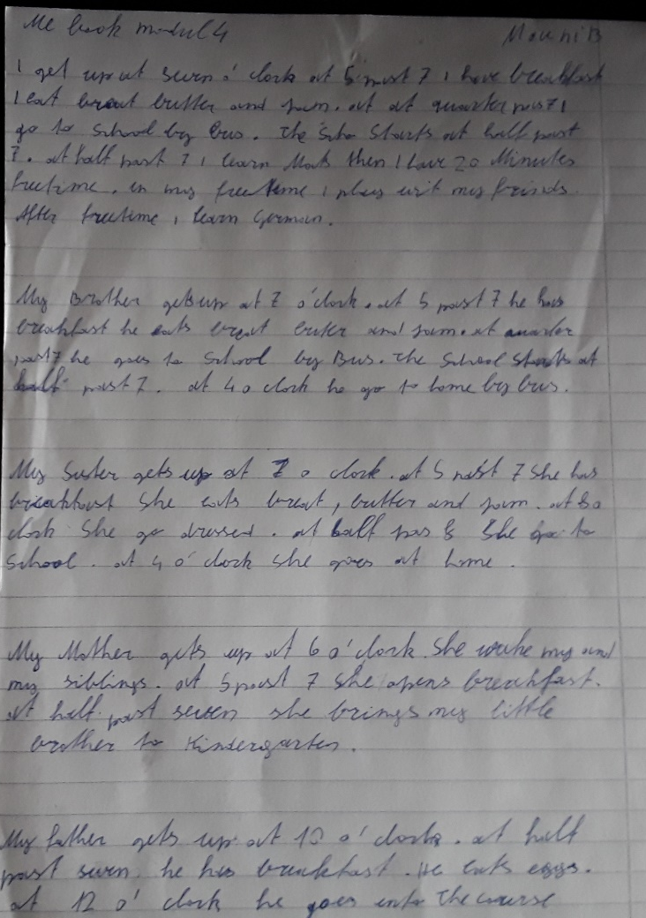
WRITE all numbers up to 12 as words: five, seven….
bread with butter and jam
The School starts…
20 minutes of free time / a 20-minute break

At quarter past seven, he goes to school by bus.
At four o’clock he goes home by bus.

…she gets dressed / At half past eight she goes to school / … she goes home

She wakes me and …

… he goes to his courses.

