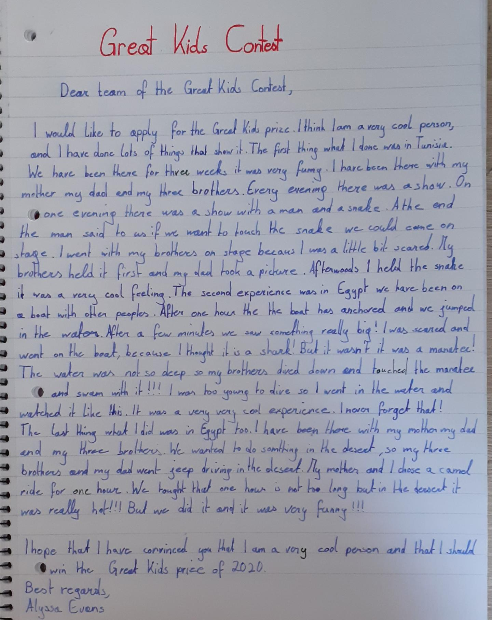

I was there for … / I was there with (das ist ein Detail)
if we wanted to touch
I have seen a manakee. It was in Egypt and we were on a boat with….
the boat anchored (= detail)
into the water (wohin => into / wo => in)
I will never forget that!
I have ridden a camel.
I was in Egypt with … (detail)

