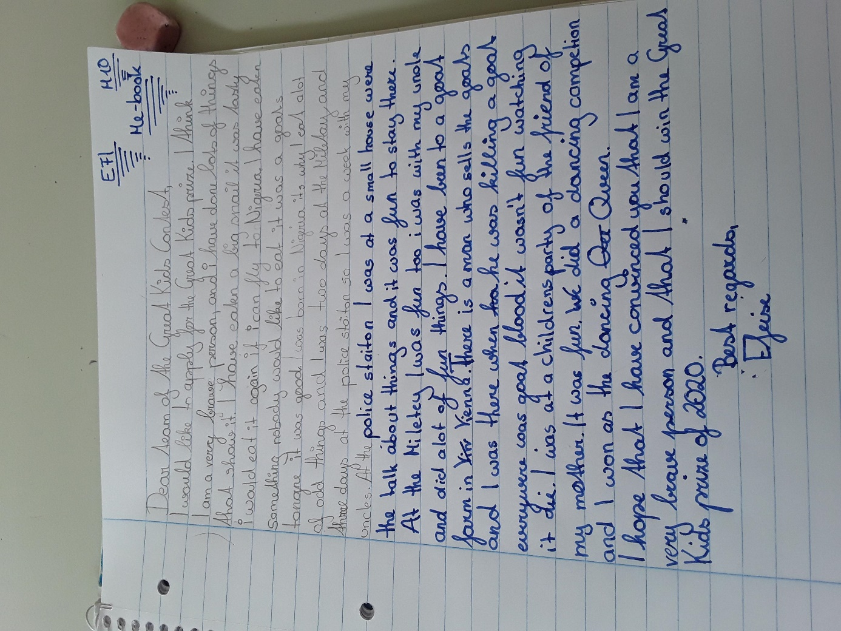

I (always a capital letter, ne make a paragraph – start in a new line

I have eaten a big snail (=experience). It was tasty and I would…if I could fly…(details – new sentence)
NEW PARAGRAPH:
I have spent two days in the military and three days a police station.
I was at the military station with my uncle and we did ….
The police station was a small house (??? the rest of the sentence is unclear. Why did you stay there??)
NEW PARAGRAPH:
I have seen some kill a goat.
That was at a goat farm in Vienna. There was…
NEW PARAGRAPH:
I have won a dancing competition.
When we went to a children’s party of one of my mother’s friends, we did a dancing competition and….

