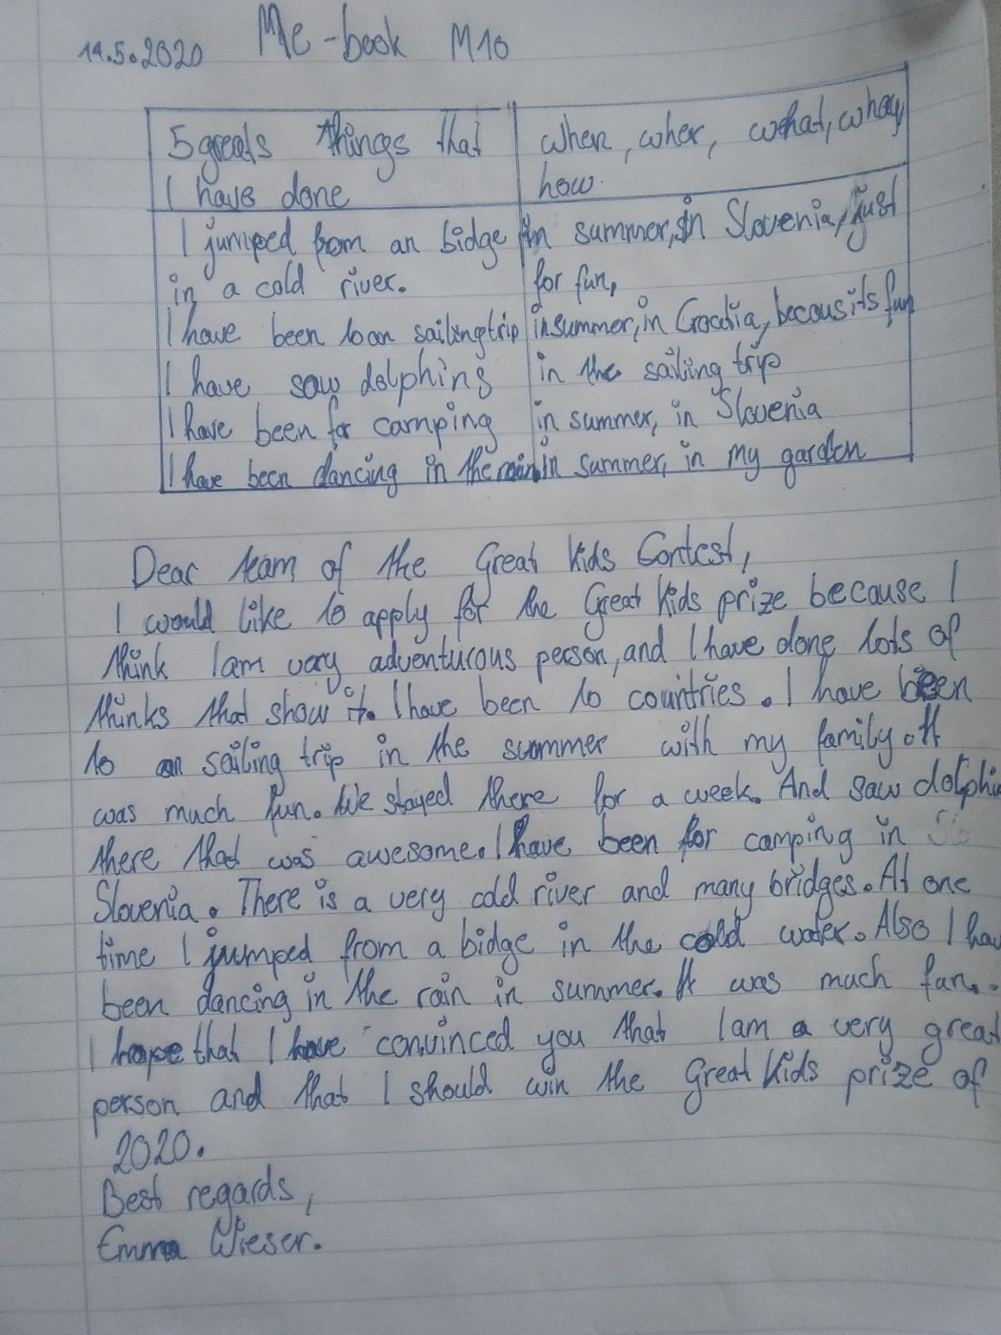

to a lot of countries (?) – details for this part are missing
on a sailing trip. (why don’t you start with: I have seen dolphins in the wild – it’s more exciting than sailing, isn’t it?)
a lot of fun
we stayed there …. WHERE? on the boat?
I have been camping in Slovenia. . (why don’t you start with: I have jumped from a bridge. That sounds really adventurous!)
I have danced in the rain. details for this part are missing

