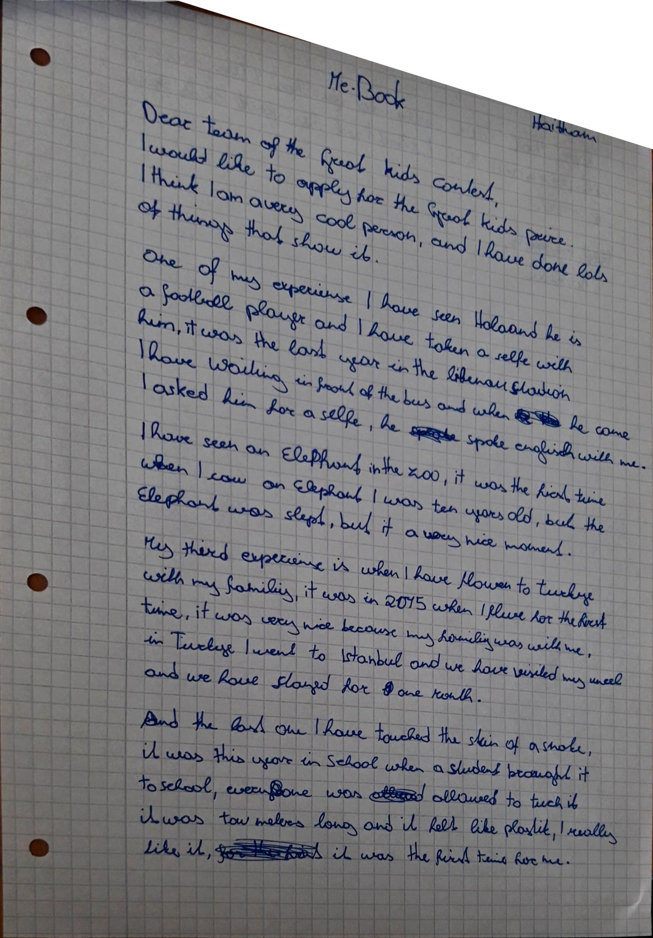

One of the coolest things I have done is that I have taken a selfie with…
I was waiting

flown / Turkey

we visited / we stayed (past tense – you are telling us the details)

two =2
plastic
I really liked it

th

