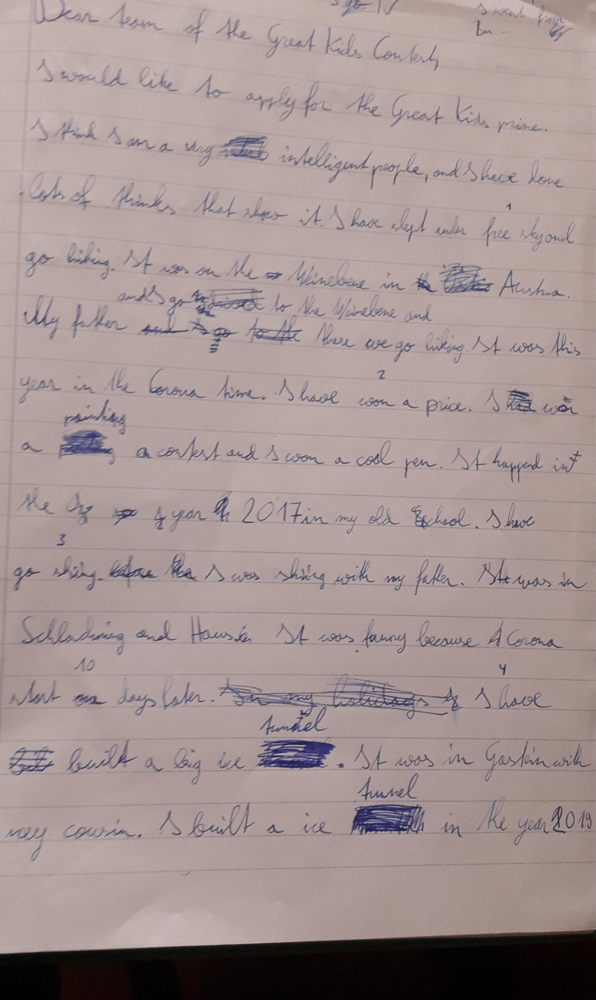
in the year xxx => schreib einfach nur: in 2018

intelligent person
(people = Leute – mehrere)
things (Dinge) thinks (=er denkt)
..and gone hiking (gone = 3rd form)
went to the Weinebene and there we went…
NEW PARAGRAPH (=Absatz): I have won….
NEW PARAGRAPH (=Absatz): I have gone….

started
NEW PARAGRAPH (=Absatz): I have built….

an ice tunnel

