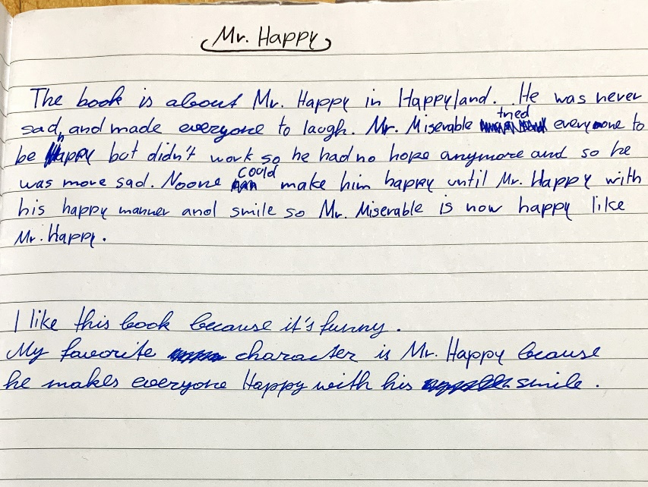

he made everyone laugh
I don’t understand this sentence: Mr Miserable tried ?? to be happy but it didn’t work?
so he was even sader.

happy (not H)

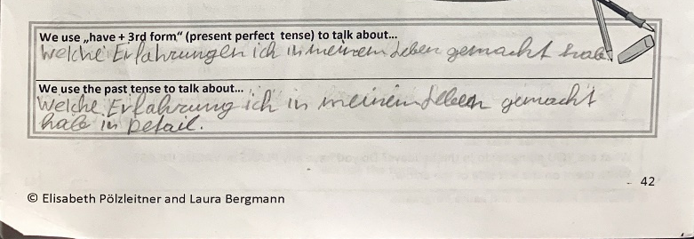

past tense:
über Vorkommnisse und Ereignisse in der Vergangenheit im Detail zu sprechen.
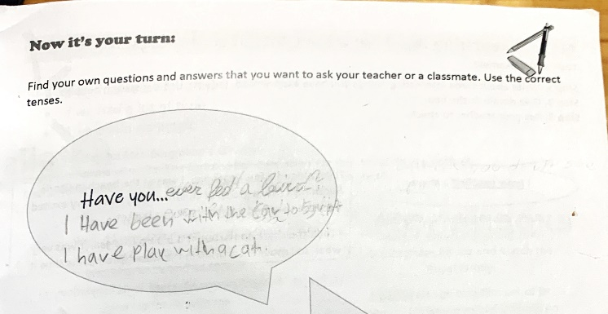

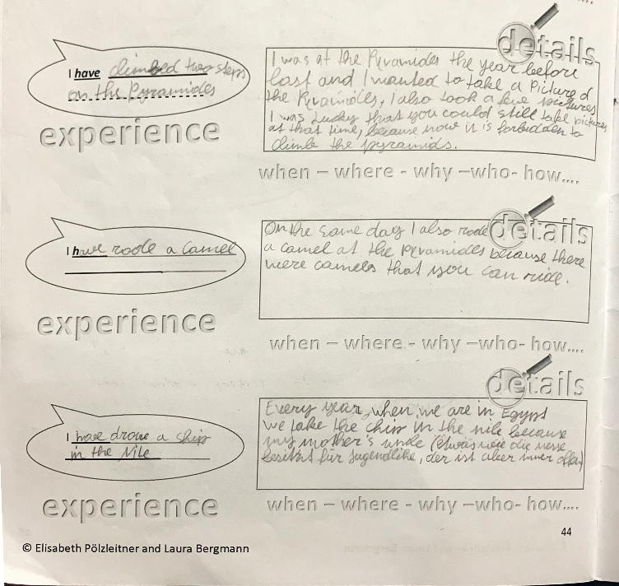

I have ridden a camel (ride – rode –ridden)
… that you could ride

I have driven (drive- drove- driven)
on the Nile
my mother’s owns a funfair where you can rent a boat?

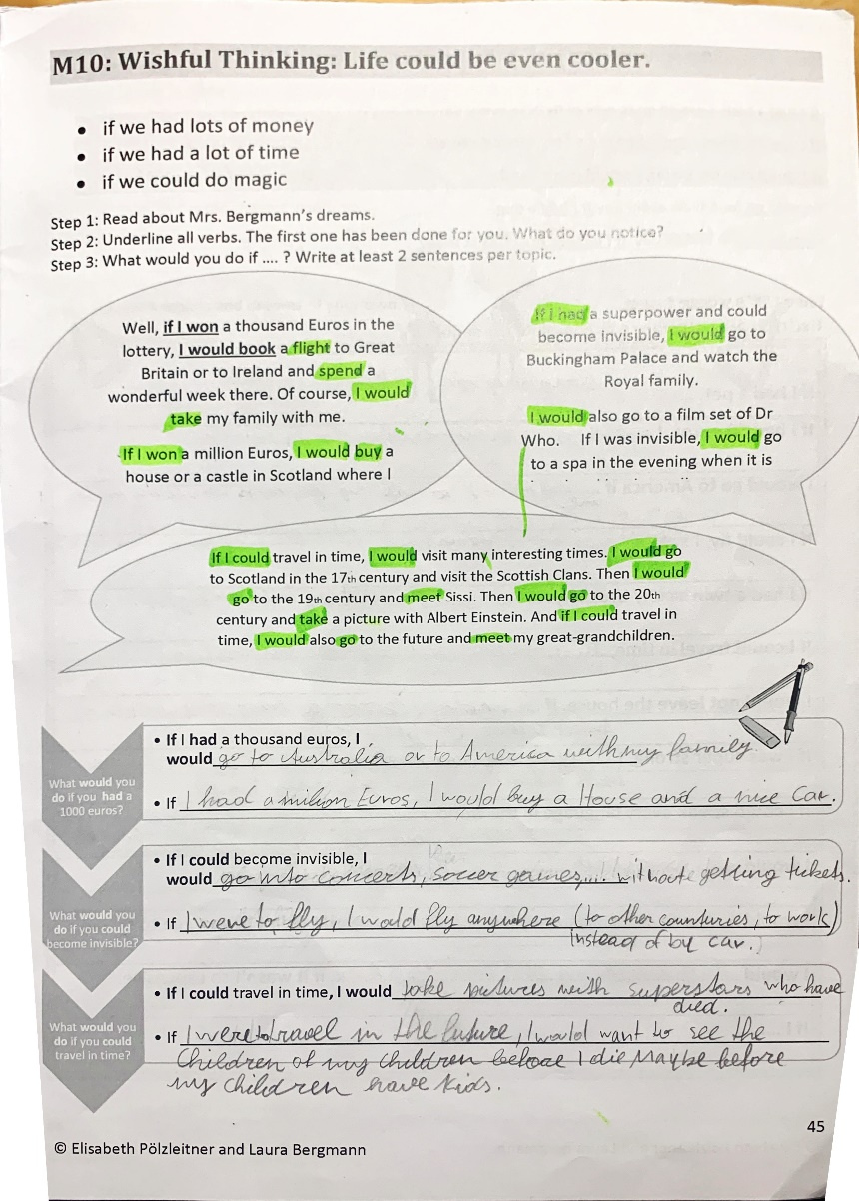

If I was able to fly, I would … / countries
If I could travel into the future

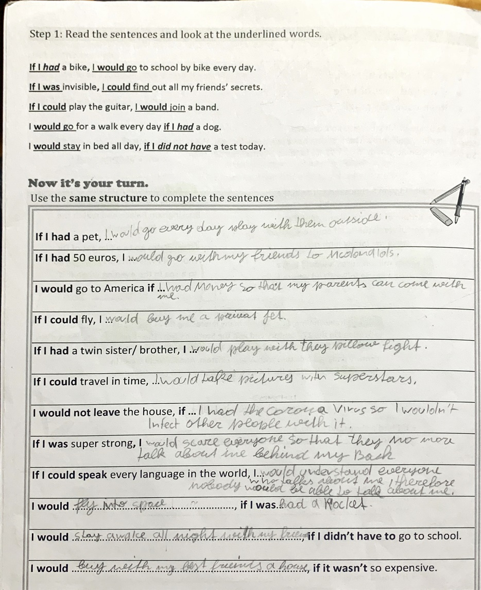

I would play with it outside every day
I would go to McDonalds with me my friend
if I had so much money that my parents could come with me
I would buy me a private jet
I would have a pillow fight with them

so the wouldn’t talk about me behind my back

If I was had a rocket
I would buy a house with my best friends, if …

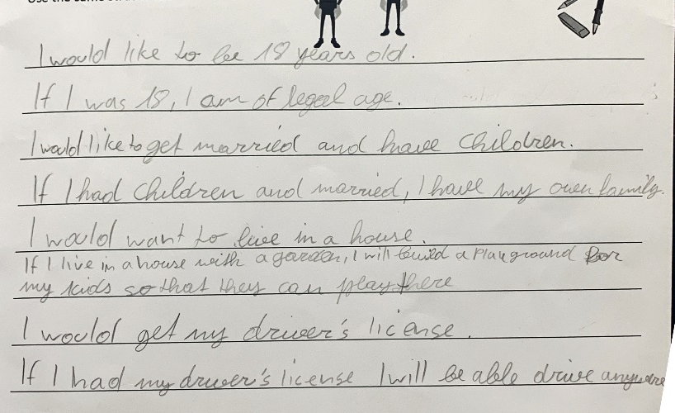

If I was 18 years old, I was of legal age

I would have my own family
If I lived in a house…
I would like to get my driver’s licence

