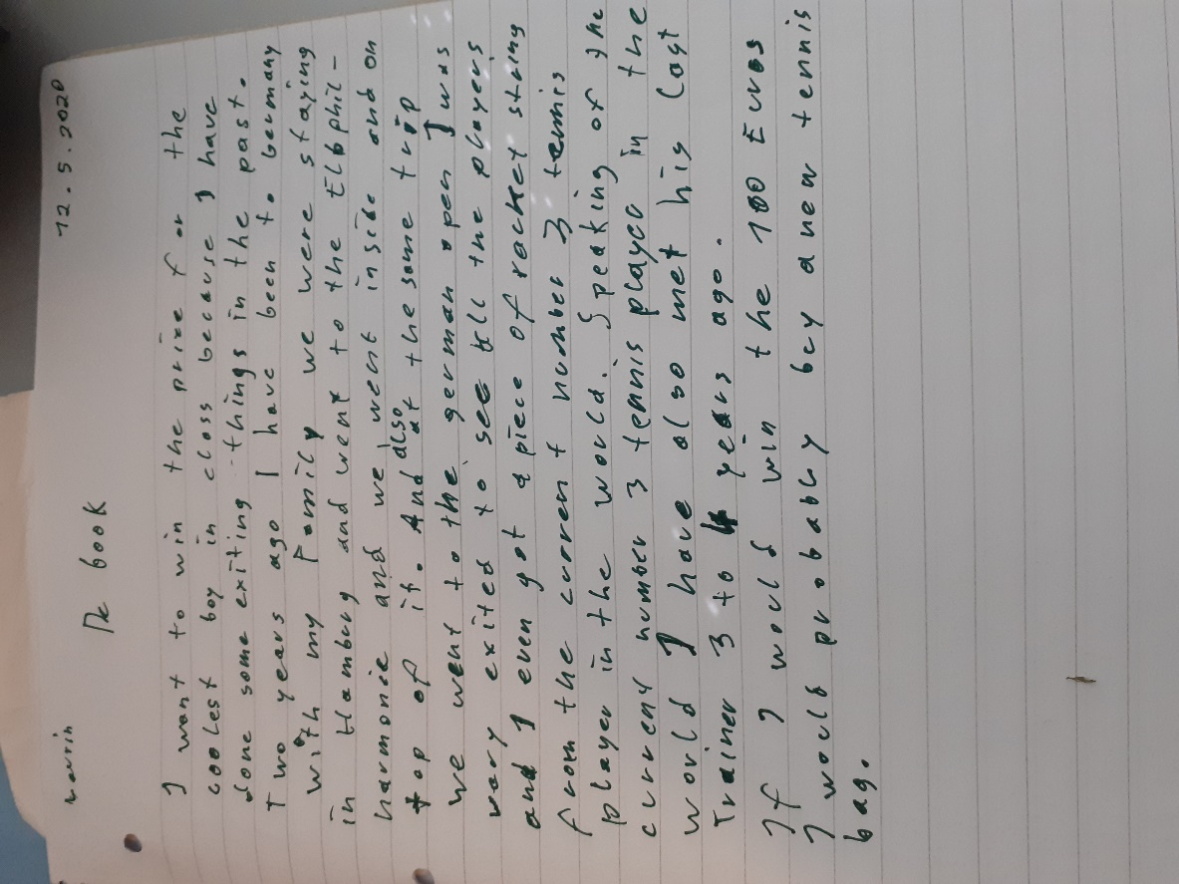

experience vs details (when):
I have been to one of the most expensive buildings in the world: Two years ago I went to Germany with…

new sentence: That was three or four years ago.
If I won … (im if Teil ist niemals ein WOULD)
I would have liked to hear a few more things about that bag. Why is it so expensive? Why do you need a new bag? ….

