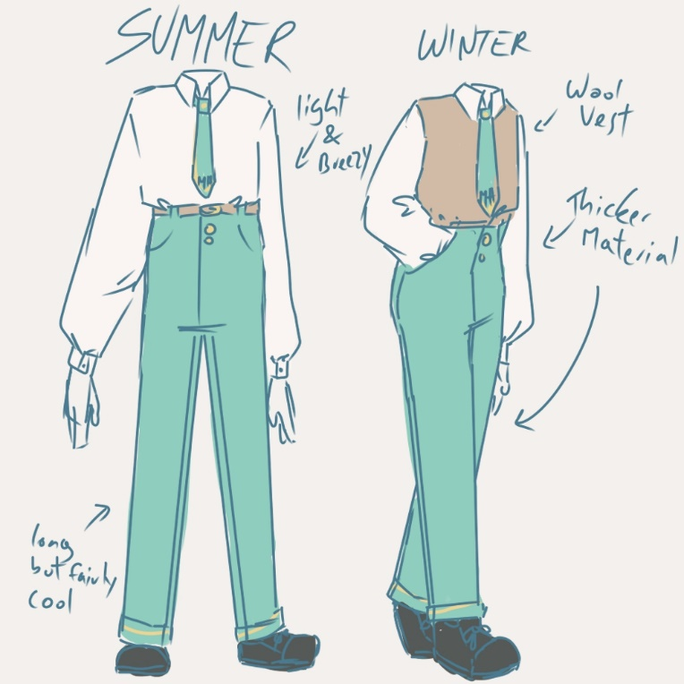
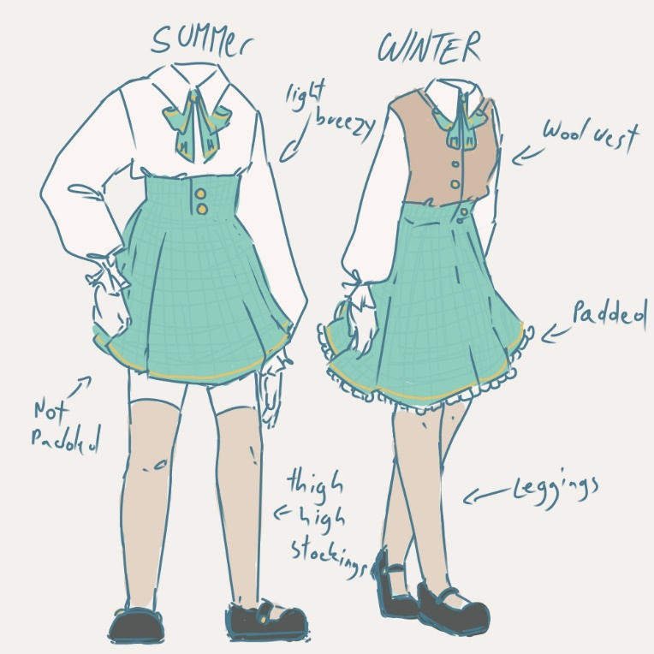
The uniforms this school has are very high quality.
Male, female or other students are allowed to choose which uniform they'd rather have. The reason behind this is that some female students may feel more comfortable wearing pants instead of skirts, some non-binary students might enjoy wearing skirts or pants, or they would like to switch between the two. Bows and ties can also be switched up but they are a must because they have the schools initals on them.
The shoes are the students responsibillity, they can choose which shoes they'd like to wear as long as they don't stain the floors of the school.
Both uniforms have high quality, white, silk blouses, as silk is quite a light and comfortable material to wear, especially during summer.
The bows and ties are also made out of fine silk but in the colors of light teal and gold. On the ties and bows are the schools initals very neatly embroidered into the fabric. M. H.
Pants and skirts are made out of crepe de chine a very fine and comfortable fabric, in the same color as the bows and ties except the skirts have a very slight and hardly noticable checkered pattern.
The small buttons that keep the piece of clothing in place are made out of pure gold.
The brown belts to hold up the pants are made out of full-grain leather.
And the leggings and thigh-high stockings are made out of very fine, light brown, linen.
In the winter the only additional things are the brown, comfortable, wool, vests and the white, soft, warm, wool or crepe de chine, under-skirts.

2:
Personally I never cared much for the clothing at school. Everyone has their own style and can dress however they want. I think that's pretty cool and helps the students at our school feel more comfortable with themselves. Plus, you don't even have to think much about what you're putting on but when you have a uniform you got to remember to always put it on. Though I'm pretty sure people can get used to that quickly and it just becomes a habit.

I think sweatpants are okay to wear. I don't know why they got banned. I mean sure it can be awkward for guys but is it my fault that they wore sweatpants? Nah, they can deal with it. I think all clothing is fine as long as it isn't too skimpy or just stand out-ish.

I think having school uniforms would be very interesting. I'd love to see the design and what our school would come up with. Uniforms are great in a sense that people would know where you're from and you wouldn't get bullied for your fashion sense, but on the other hand having to wear the same thing every day can get boring and if someone was out there to get you they'd know where to look. On a less morbid note they would be helpful in a sense but still fairly annoying. But I guess personally I would wear one, if I was more confident in and comfortable with myself.

