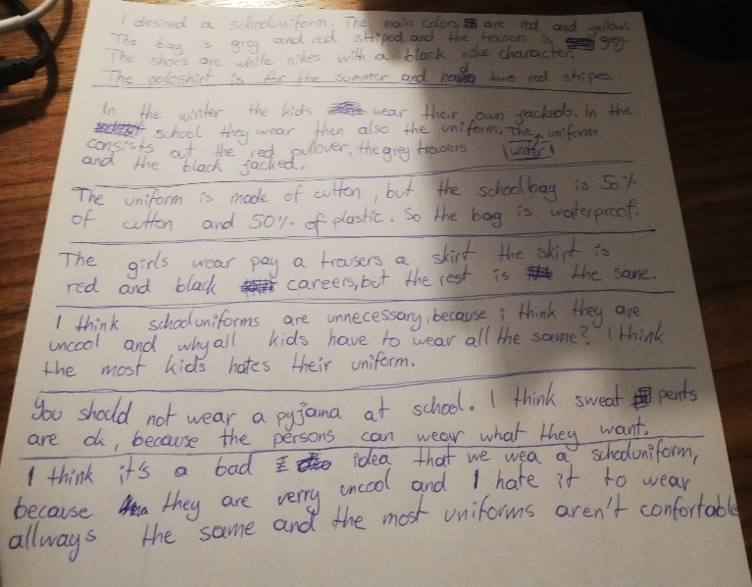
I designed
striped grey and red
the trousers are (trousers, jeans, shorts….. sind immer in der Mehrzahl! (Alles was 2 Beine hat))
Nike logo?
has two... => general – present tense
In winter… in school (no article)
they also wear their uniforms
consists of out
the schoolbag is made of a 50% cotton and 50% polyester mix, so the bag is….
The girls wear either a pair of trousers or a skirt. The red and black skirt is chequered …
Why should all kids have to…. / I think most kids hate(!)
Vor “you should not wear a pyjama” brauchst du einen ÜBergang von einem Gedanken zum anderen. zB I agree if teachers say that you should be dressed properly in school. Of course you should not …but I think that I believe / I reckon / In my opinion (schreib nicht immer „think“, du kennst andere Phrasen) it would be a bad idea to introduce school uniforms because they are very (!) uncool and I would hate to wear the same clothes every day. What’s more, most school uniforms

