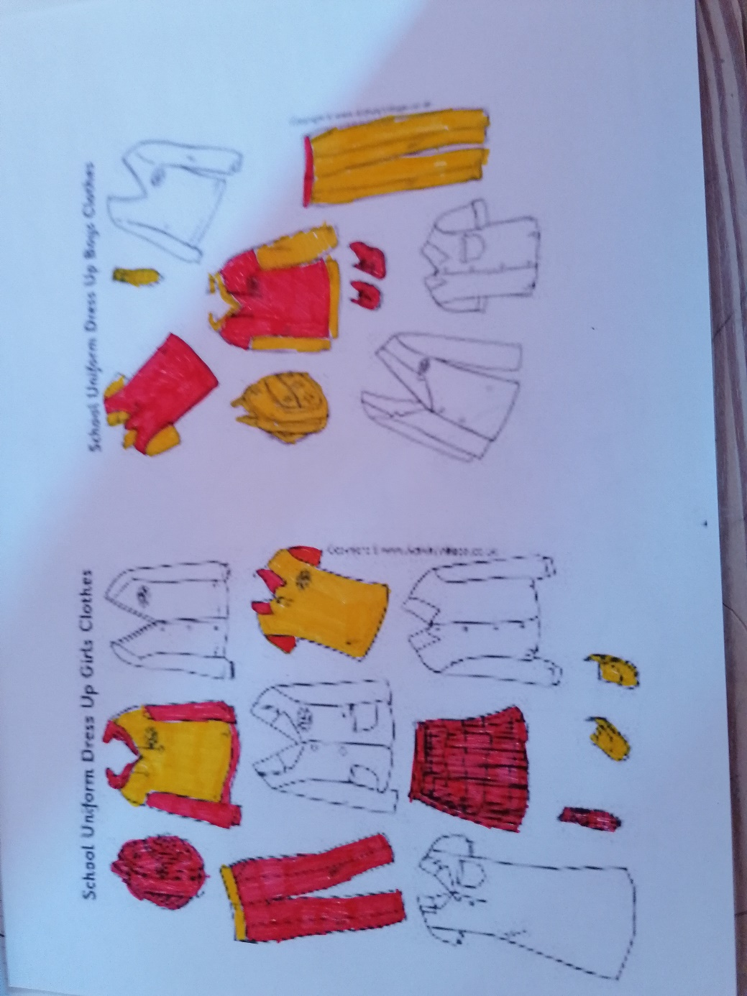
Now I desinged my own school uniform, and I think it is pretty cool.
In summer you wear shoes, a t-shirt, trousers, a tie and of course you take a school bag. In winter you wear the same things, but you need at least a hoodie. If you need a jacket, you can bring it yourself. They are all made of cotton, because I love cotton, and cotton is an environmentally friendly material, and of course it is soft.
And all clothes are red and yellow, because these are very cool colours and I love them. Boys and girls are not dressed same, because if you look exactly, you can see that the trousers of the boys are yellow, and the trousers of the girls are red. The same with the t-shirts. They are not dressed same because, so everyone knows if this is a boy or a girl.
I think at the primary school it’s not good to have uniforms, because the kids are too young for this, but at the secondary school it is okay.
If I had to wear a school uniform, I would hate it, because I think if I had to go to school with the same clothes every day, it would not be very cool.
I think in school you don’t have to wear what you want, but I think sometimes sweats pants are okay, but not every day, because school is not at home, so you can’t wear a pyjama or something like that there.

