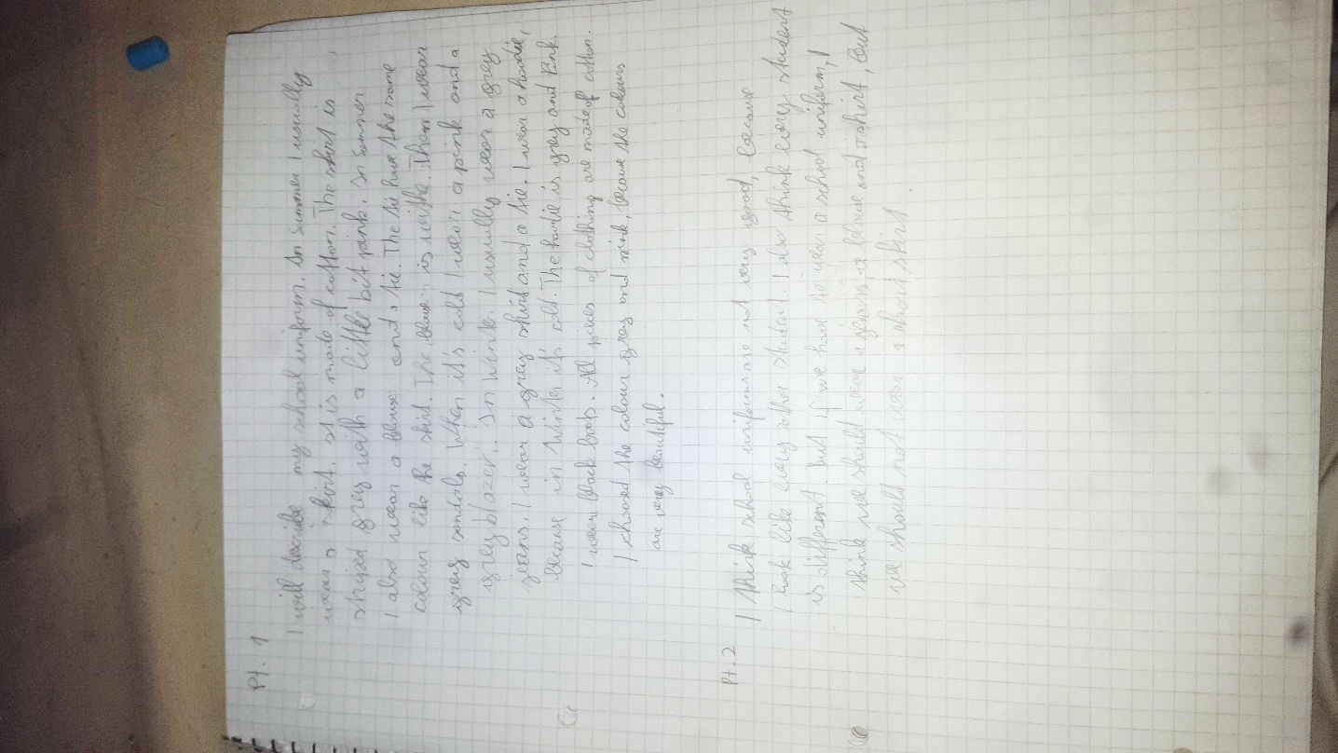

The tie has the same colour as the skirt.
I usually wear grey jeans (no “a” – jeans are always in the plural)
winter
chose / these colours

because then I would look ….
But if we had to wear school uniforms
should wear jeans

Do you mean that boy and girls should wear the same clothes and girls should not be forced to wear skirts? In England girls are often allowed to choose whether they want to wear a skirt or trousers and boys have to wear trousers.

