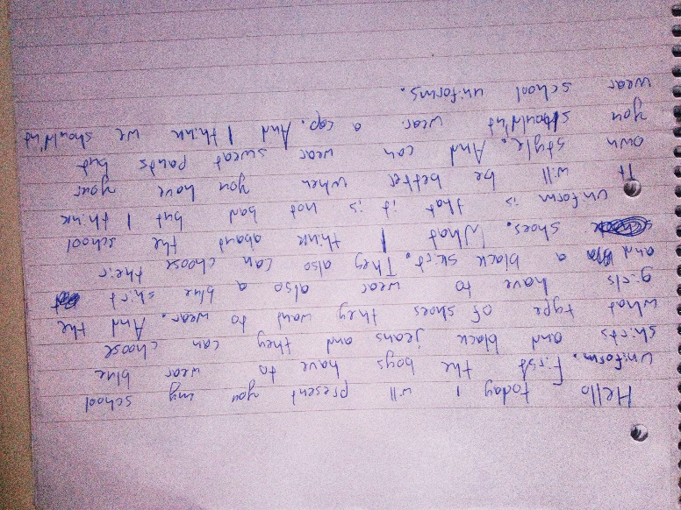
I’m going to present my school uniform.

The girls also have to …
Start a new paragraph for giving your opinion
What I think about – das ist sehr holprig. Verwende Phrasen aus der discussion competition z.B. In my opinion....
I think (I believe) it would be better if you had (eher: if you were allowed to express your own style in the way you dress)
Worauf bezieht sich: “and you can….”? Auf die jetzige Situation oder darauf was besser wäre?? Das ist unklar – versuche das klarer auszudrücken
Du kannst mit: All in all I think that we …. enden.

You did not describe the uniform in detail (materials, patterns…)

