Teenzshop
Dear Tim,
I have recently won a voucher for 30 pounds at the Teenzshop
Before I got the voucher, I thought Teenzshop was a little shop with no cool things, but then, when I looked around the shop, I saw some very cool things they sell.
The best thing about this shop is that everything is cheaper than normal.
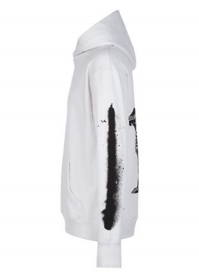
I found some really cool things in this shop. Let me describe them to you.
Now, I compared three products, a white hoodie, a black cap and a cool bracelet. The product I like best is the white hoodie for 14.99 pounds. It’s more expensive than the other two, but it is much better. I prefer it because it’s made of cotton and cotton is my favourite material. And the Sphinx on the back and the black print on the left side are very cool, and I like black and white.
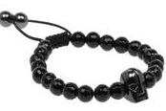
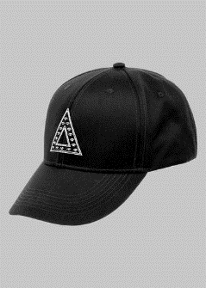
The other two things are also very cool. The cap has a cool triangle design on the front, and it’s very sleek. I love it too, because now on some days the sun is shining brightly and for that the cap is very good. And it is less expensive.
Last but not least I want to tell you something about the bracelet. It is very cool to wear a bracelet especially this one, because it looks nice, it’s not very expensive (it’s the cheapest of these three things), and it has a skull with a helmet on it.
But I think, if I wear all the three things at the same time, then it is better than if I wear only one because, they are all black or white, and this is a combination I like quite a lot.
Maybe you can find something cool stuff in this shop as well. Let me know if you find a cool cloth.
All the best
Elias

