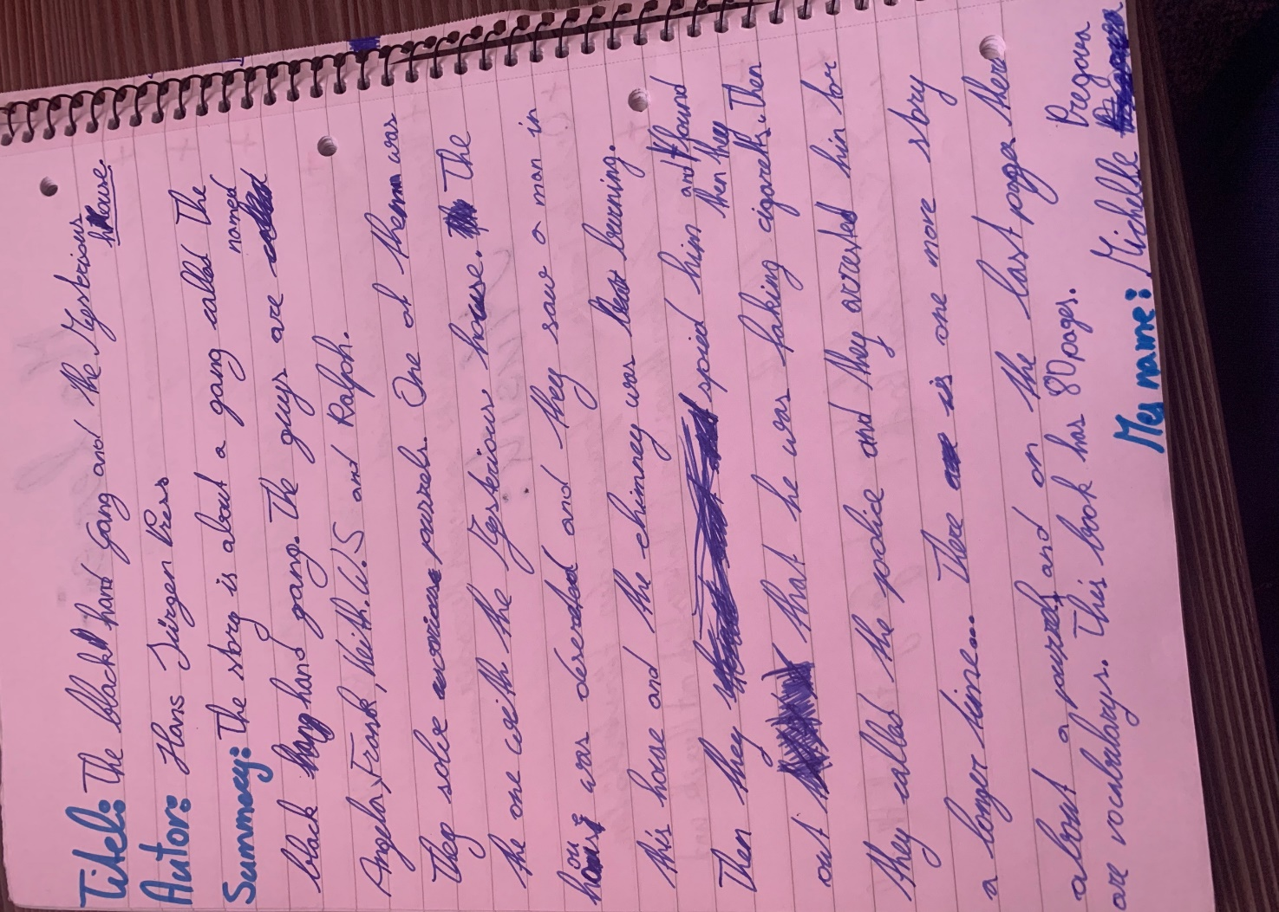

Why are they called the black hand gang?

and => but

spied on him

What do you mean by “faking cigarettes”?

