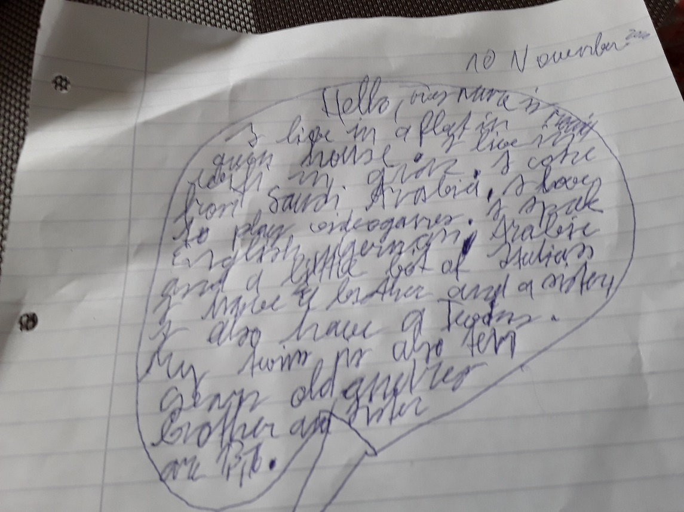
Hello, my name is Moaid. I am ten years old. I live in a flat in a green house in Graz.
I come from Saudi Arabia. I speak English, German, Arabic and a bit Italian. I have a brother and a sister.I also have a twin. My twin is also ten years old and my other brother and my sister are 1 and 3 years old.
I love to play video games.

