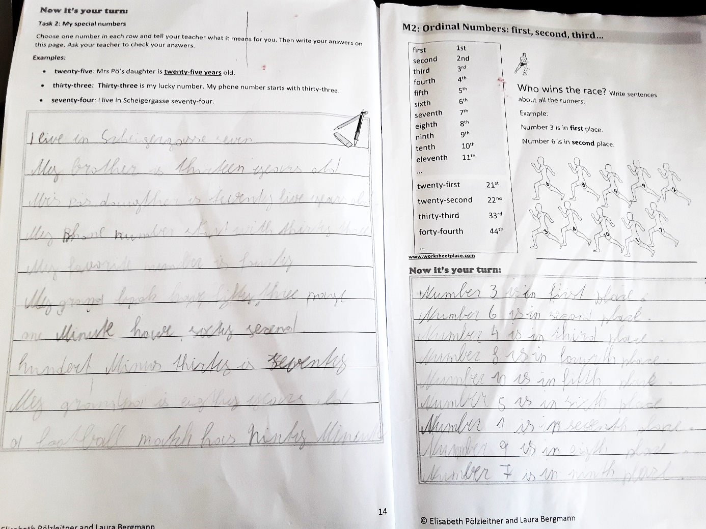

starts

? has pages
m has seconds
m

m

