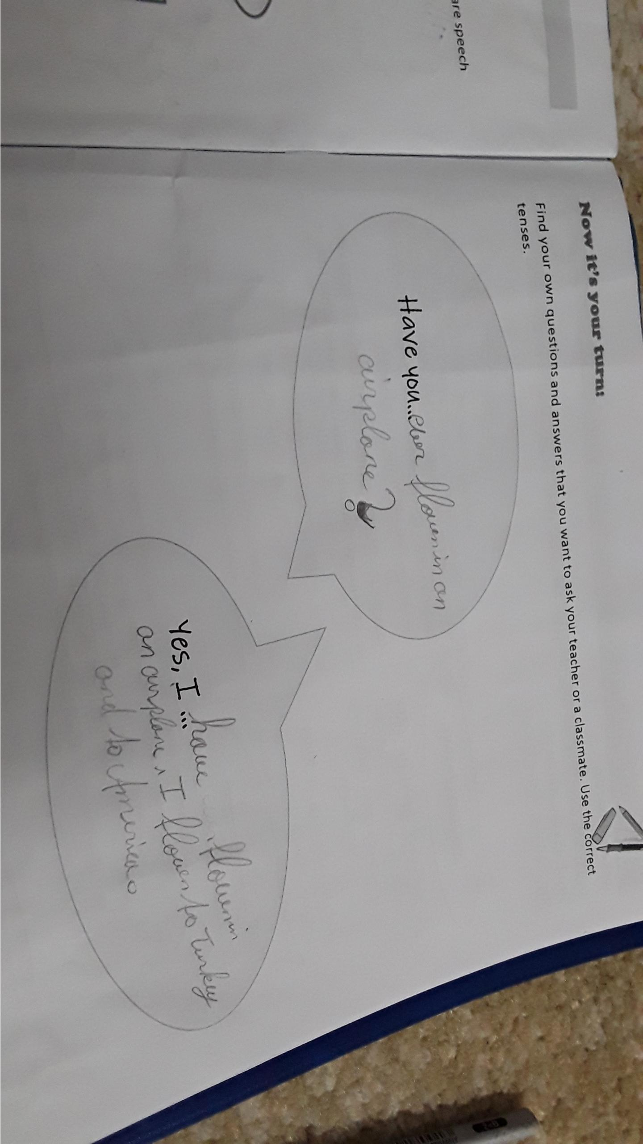
I have flown to Turkey and to America?
=> you are talking about your life experiences in general (Dinge, die du in deinem Leben schon erlebt hast), so you use have+ last form

In the box below, you want to know the DETAILS about ONE EVENT in the past (e.g. your journey to America), so you use the past tense
e.g.
Really, when did you go to America?
Did you like it?
What did you do there? I went to America ….
I …..
First …. then … after that…..

