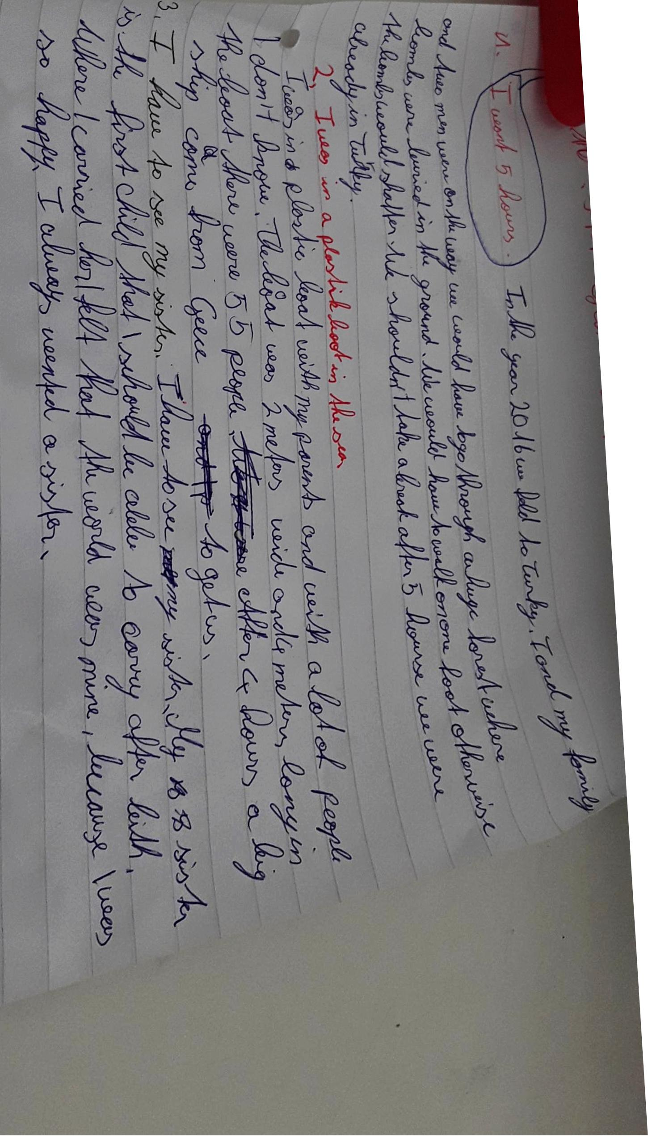
This is a scary story! I am glad that you got through the wood safely!!
Be careful with the tenses:
Experience (etwas was ich in meinem Leben schon gemacht habe): I have walked for five hours without stopping - have + 3rd form
Details/Event – past tense: we fled to Turkey. My family and I
We had to go through a huge forest where bombs….
We had to walk on one foot ? – Do you mean: We had to walk carefully and only put one foot on the ground at a time, otherwise….

We could not take a break but after 5 hours …
Again – I am really glad that you were not hurt!!
Experience (etwas was ich in meinem Leben schon gemacht habe): I have been out on the sea in a plastic boat - have + 3rd form
Details/Event – past tense: with a lot of people I didn’t know

I don’t understand this last text. Do you mean “I have looked after my sister?”
Then it would be
Experience (etwas was ich in meinem Leben schon gemacht habe): I have looked after my sister - have + 3rd form
Details/Event – past tense: I was allowed to carry my sister around after her birth. She was the first child that I was allowed to carry! When I carried her, I felt that the world was mine, because I was so happy.
All my life – have + 3rd form: I have always wanted to have a sister.

