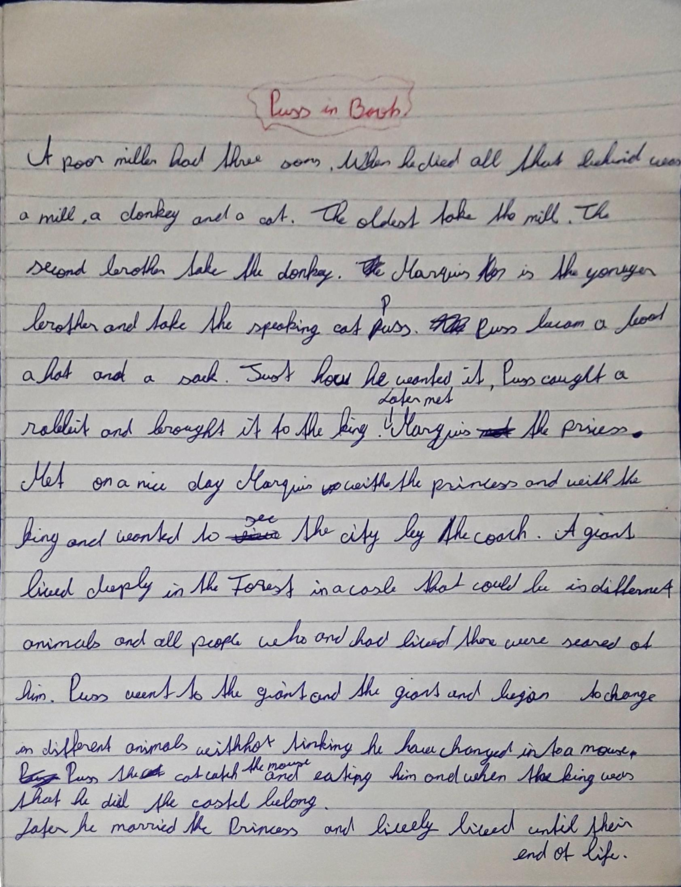

all that he left behind
took
took
was the youngest brother and took
dieses Wort kann ich nicht lesen?
Puss got/had(?) boots, a hat and….
Later Marvis met the princess.
On a nice day, Marvis met with the princess and the king and …
castle
could turn into different animals
thinking / he changed into…
Puss the cat caught the mouse and ate him.
Den SAtz “when the king was that he did the castle belong” verstehe ich nicht. Versuche das noch anders zu zu sagen.

