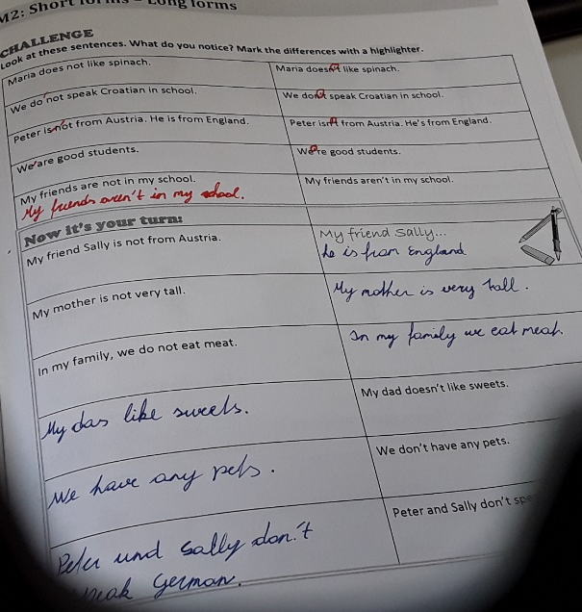

My friend Sally is not from Austria.
My friend Sally isn’t from Austria.

My mother is not very tall
My mother isn’t very tall.

