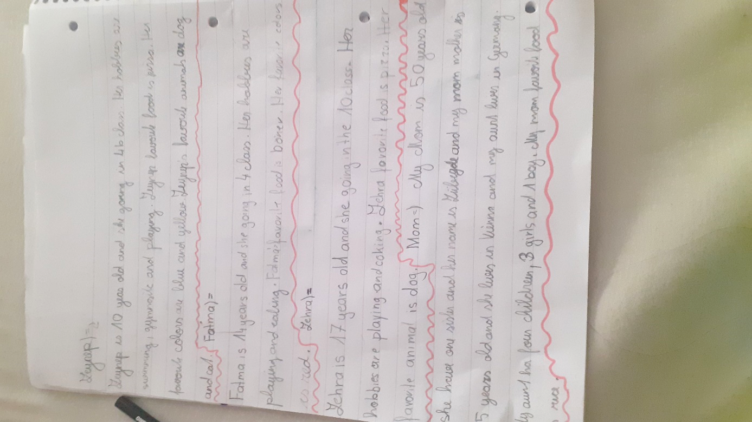
Zeynep:
Tell us: Who is Zeynep?
What languages does she speak? Where is she from and where does she live?
What does she like and what doesn’t she like?

She goes to 4th form of primary school (=Volksschule).
Zeynep’s favourite food….

Fatima / Zehra
Tell us: Who is Fatima? Who is Zehra
What languages do they speak? Where are they from and where do they live?
What do they like and what don’t they like?

She has one …. my mom’s mother
Tell me more about your mom!

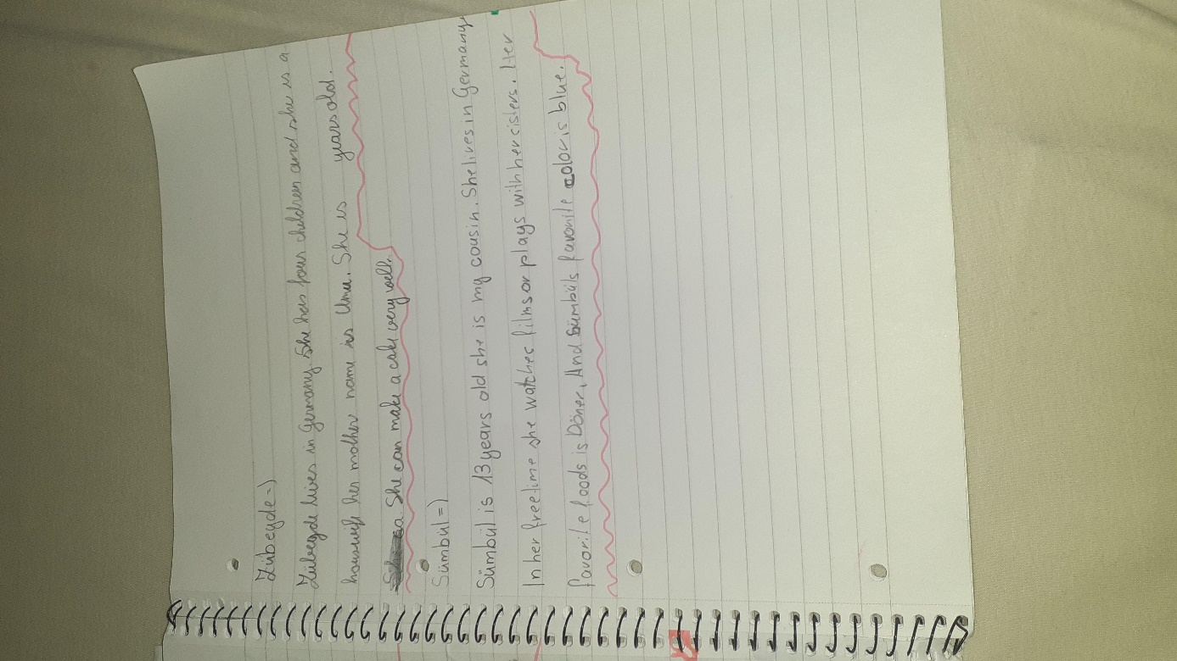
Who is Zubeyde?
What languages does she speak? Where is she from and where does she live?
What does she like and what doesn’t she like?

Where is she from?
What languages does she speak?

