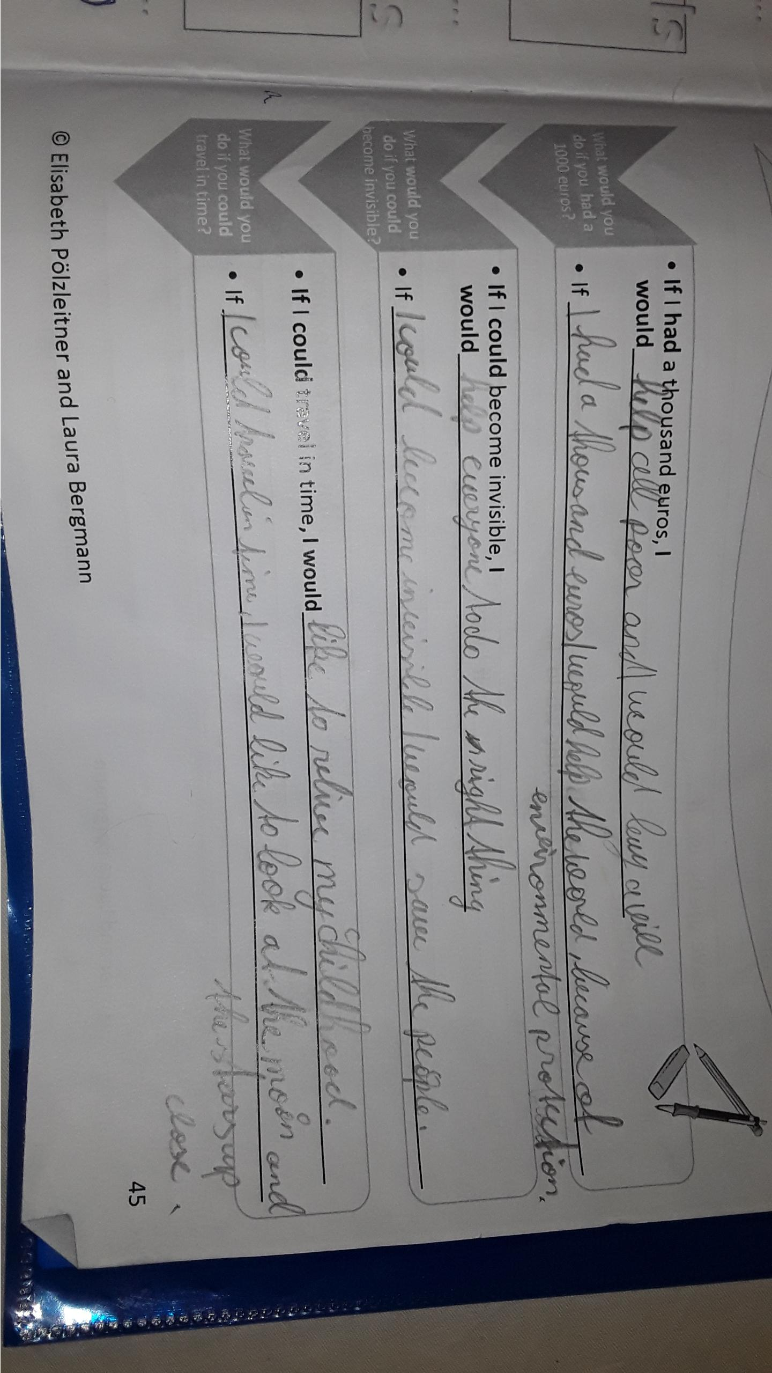
… all poor people and I would buy a ?? villa??
… I would help the world by protecting the environment / by donating (=spenden) it to an organisation that protects the environment.

If I could travel in space, I would like to see the moon and the stars up close.

