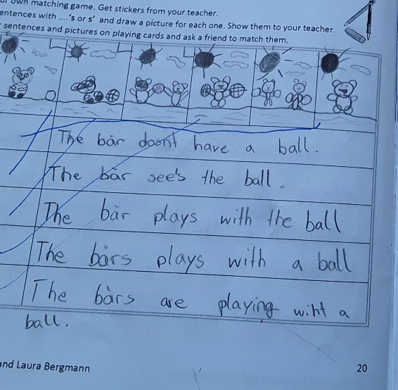
BÄR = bear => überall ausbessern
sentence 1 – The bear doesn’t have a ball
line two/three: What can you see in the picture? You can see “the bear’s ball” => ändere bitte eines der Bilder
line 4: What can you see in the picture? You can see “the _____’_ ball__” => complete the sentence
line 5 => What can you see in the picture? You can see “the _____’_ ball__” => complete the sentence

