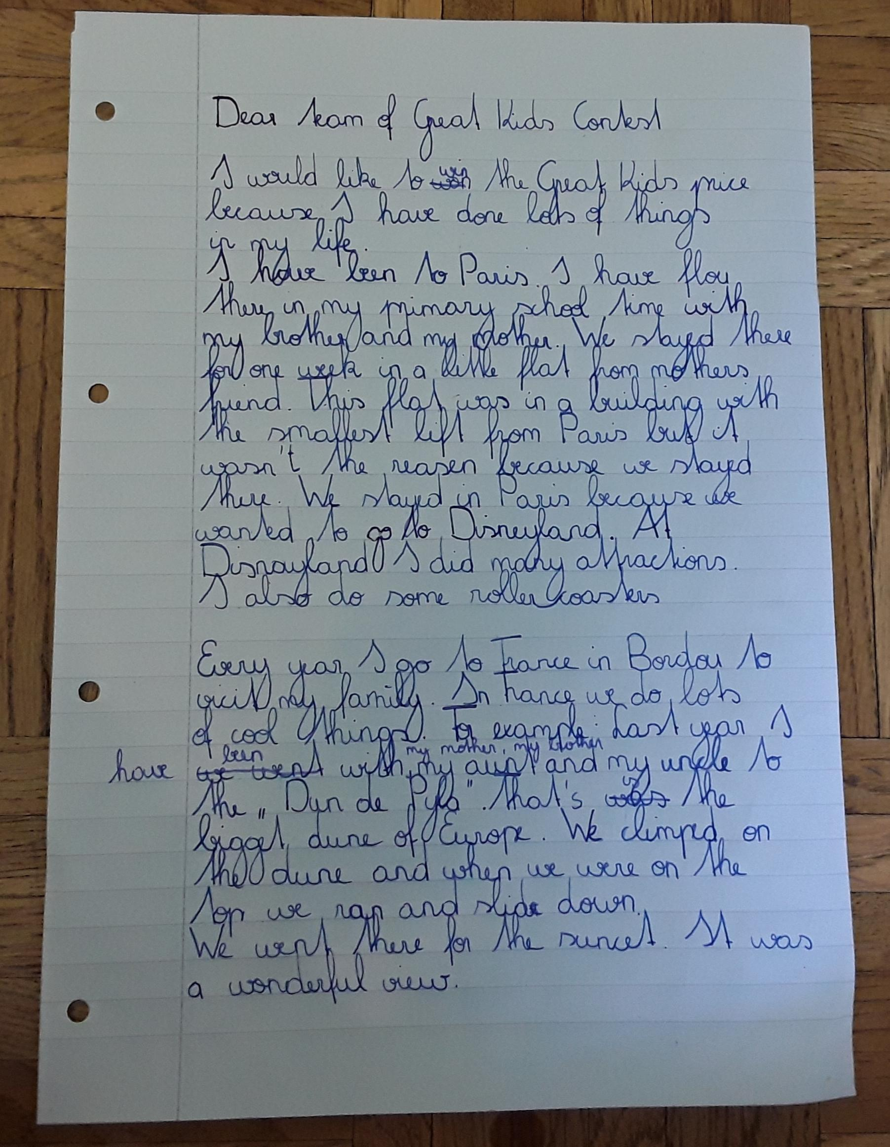
Wenn du einen Zeitpunkt angibst (zB in my primary school time) dann gilt das schon als Detail bzw. als ein spezifisches Ereignis in der Vergangenheit und dann verwendet man das past tense.
I flew there when I was in primary school.
in a little flat that belonged to my mother’s friend
smallest lift of Paris
that wasn’t the reason why we…
rode some rollercoasters

Last year – du sprichst von einem speziellen Ereignis – daher „we went“ (so wie du es hattest)
climbed

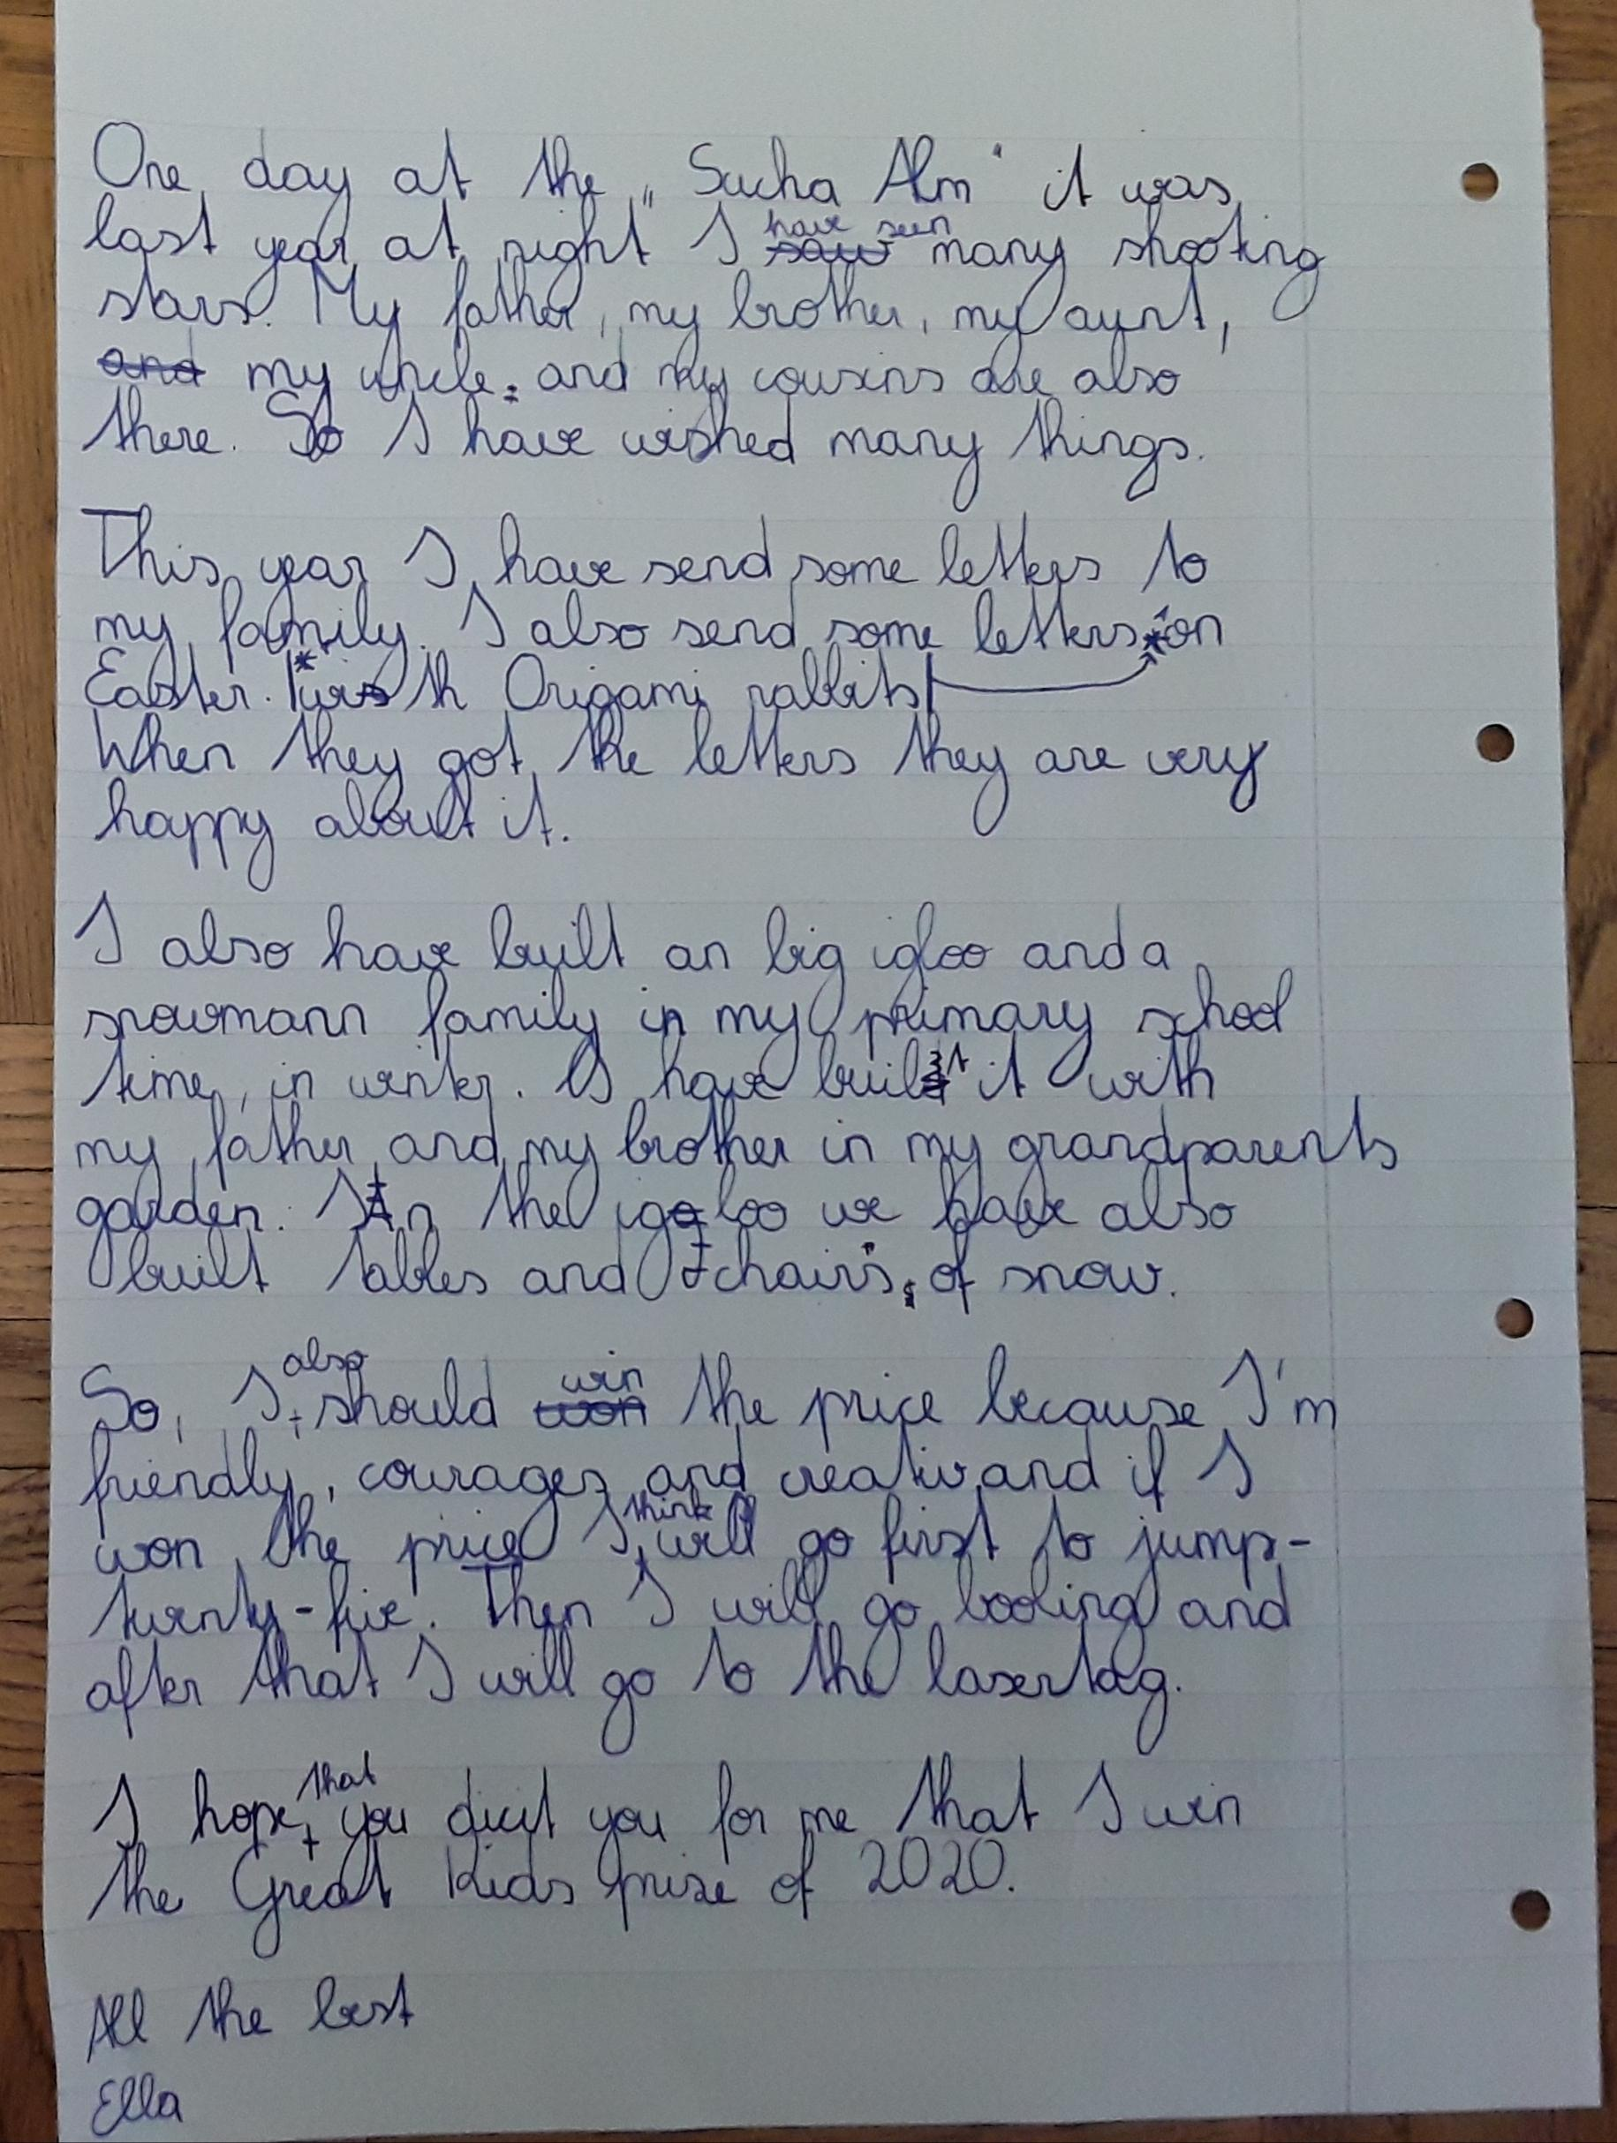
Hier könntest du das so schreiben:
I have seen many shooting stars. One day last year we were on “Sacha Alm” and at night we saw more than 5 (?) shooting stars. So I wished for many things.
I also sent some
they were very happy

lass das “in my primary school time” weg, dann redest du allgemein über dein Leben und es passt.

If I won the price I would go to… then I would go bowling and after that I would play lasertag.
decide for me and that I will win….

