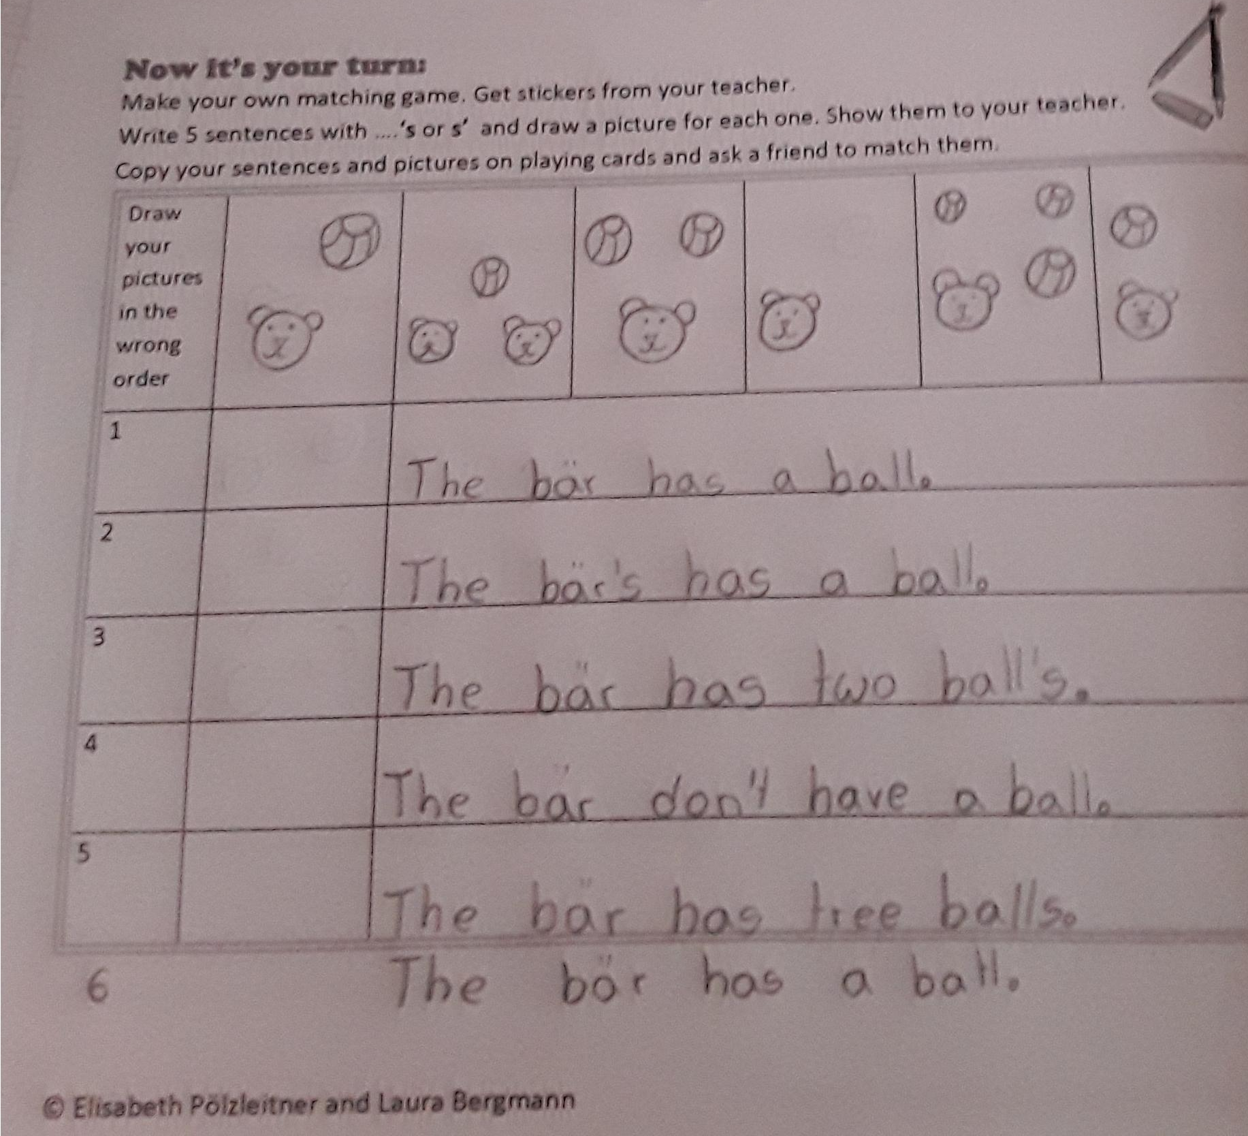
Picture 1 – ok – but BÄR = bear
Picture two: What can you see in the picture? You can see “the bears’ ball”
Picture three: What can you see in the picture? You can see “the _____’_ ball__” => complete the sentence
Picture 4 => we are talking about ONE other person (or in this case animal) => we do NOT use don’t but we use _________________?
picture 5 = picture 3
What is missing is: 2 bears + 2 balls

Picture six: What can you see in the picture? You can see “the _____’_ ball” => complete the sentence

