
M3: Asking Questions in English

The new English teacher…
Mrs. Bergmann meets the new English teacher at her school.
She asks him lots of questions.
Do you like Great Britain?
Where do you come from?
Where do you live?
What languages do you speak?
Do you go to school by bike?
How do you get to school?
When do you get up?
Do you drink coffee?
Why don’t you drink coffee?
Do you have a pet?

How do your classmates study vocabulary?
How does your best friend get to school?
https://pixabay.com/de/fragezeichen-hinweis-duplikat-2110767/
Questions, questions, questions
Mrs. Pölzleitner wants to know everything about the new teacher. She texts Ms Bergmann.

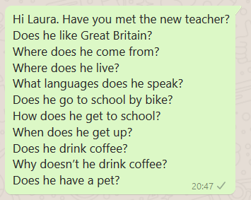


Challenge
What do you notice? (Was fällt dir auf?)
Man kann für Fragen Fragewörter verwenden. Schreibe die Fragewörter auf:

………………………………………………………………………………………………………………………………………………...

Man bildet Fragen häufig mit ………………………………….. oder ………………………………………………….
Does verwendet man wenn man über …………………………………………………………………………spricht.

Das verb (z.B……………………………………………………………………………………………..) verändert sich nicht.

Now it’s your turn:


Write your own questions
Write 5 questions you want to ask your teacher.

Write 5 questions about one of your classmates. Ask your teacher. How many questions can your teacher answer? _______________

M3: More questions: Interview a student teacher
Make a questionnaire (Fragebogen)
Write a lot of questions to interview guests and student-teachers.
When we have guests in class, talk to them and ask them all your questions.

M3: Negation in English


Challenge
Mrs. Bergmann has a problem. She needs Mrs. Pölzleitner’s help.
Read the text. What do you notice?
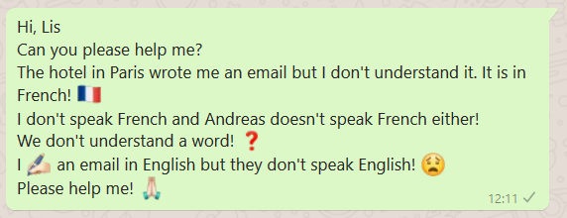

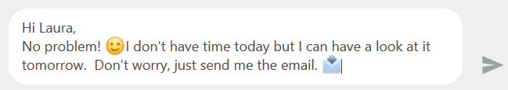

What do you notice? (Was fällt dir auf?)
- In der Verneinung verwendet man ___________ oder _____________ vor dem Verb (z.B. speak, like, eat)
- Doesn‘t verwendet man wenn man über ________________________________________spricht.
- Das verb (z.B. ___________________________________________________) verändert sich nicht.

Now it’s your turn.
Say what people DON’T do! Write your own examples. Start your sentences like this:
I…
My best friend…
My teacher…
My cat/dog/ _________
My parents…
My friends…
We…

M4: Telling the time

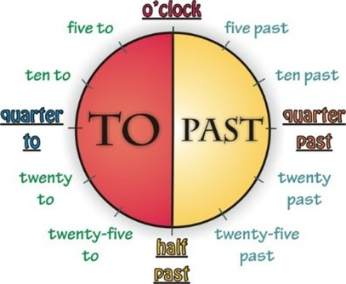
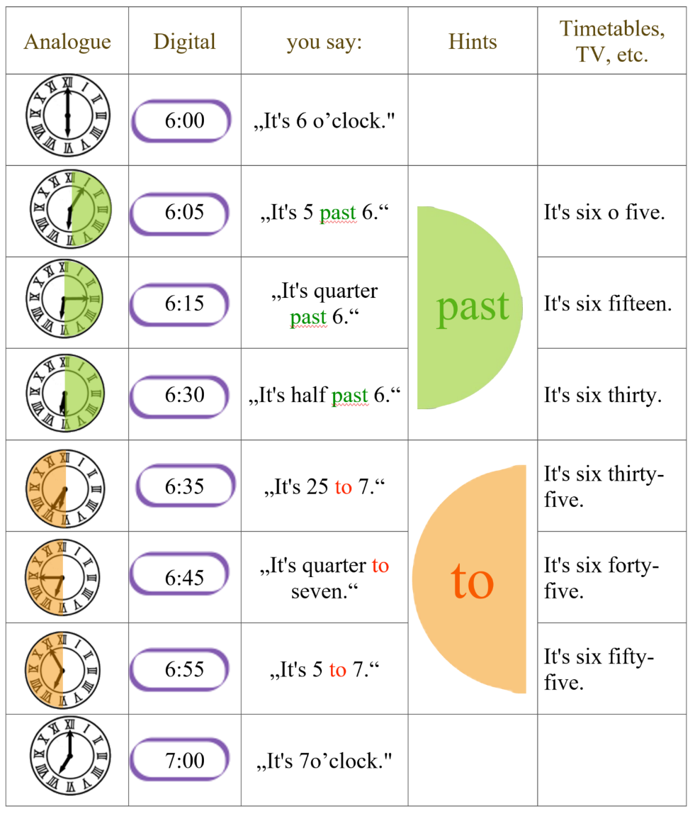

Now it’s your turn:

Answer the following questions. Write complete sentences.

What time is it right now?
What time do you usually get up in the morning?
What time does school start?
What time do you have lunch in the school cafeteria?
What time does school finish?
What time do you usually study vocabulary?
What time do you go to bed in the evening?

