

Flexi English
by Elisabeth Pölzleitner
and
Laura Bergmann

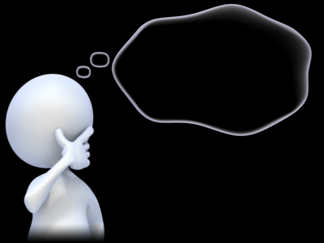
My Personal Grammarbook
for all the important grammar rules

Name: …………………………………………………..

This is your personal grammar book for Flexi 1 and 2. You can always use it to look up how the English language works.

Therefore, ALL the language in this book MUST be correct.
Always write your answers in pencil so you can easily correct them. Then ask a teacher to check your answers.
Das ist dein persönliches Grammatikbuch für Flexi 1 und 2. Du kannst immer nachschlagen wenn du Fragen bezüglich der englischen Grammatik hast.
Aus diesem Grund muss hier alles GANZ RICHTIG sein. Schreibe deine Antworten immer mit Bleistift , sodass du sie leicht ausbessern kannst. Bitte deine Lehrer deine Sätze zu korrigieren.

The printing of this book has been sponsored by:

Table of Contents
M1: a or an 3
M1: BIG LETTERS – small letters 4
M1: To be: am – is – are 5
M2: I speak – She speaks – I live – He lives 6
M2: Short forms – Long forms 8
M2: Personal Pronouns: I, you, he, she, it, we, you, they 9
M2: Numbers 11
M2: Ordinal Numbers: first, second, third… 13
M2: Days of the week and months 14
M2: Giving the date in English 15
M2: Plural: many things 16
M3: Possessive Pronouns: my, your, his, her, our, their 17
M3: Peter’s cat and Maria’s dog… 18
M3: Whose things are these? 19
M3: Asking Questions in English 20
M3: More questions: Interview a student teacher 22
M3: Negation in English 23
M4: Telling the time 24
M4: Routines 25
M5: Routines versus Present activities 26
M5: There is --- There are 27
M5: asking questions with there is—there are 28
M5: Where things are: Prepositions of place 29
M-A (June) : Future: making plans: going to 30
M7: Past tense: Irregular Verb forms 1 31
M7: Past tense, Irregular forms 32
M7: Past tense: Regular Verb forms 33
M7: Past tense - Negation 33
M7: Past tense – Questions 35
M7: Irregular Verb Forms (in groups) 36
M7: Irregular Verbs in alphabetical order 37
M8: Comparing 38
M9: Talking about the Future 40
M10: Talking about experiences: Have you ever ….. 42
M10: My exciting life: I have done lots of cool things 44
M10: Wishful Thinking: Life could be even cooler. 45
M11: one or ones --- this or these 48
Grammar for year 3 and 4 54
Colorful and detailed descriptions 54
Describing people and things: What are they like? 55
Describing how people do things 56
How did they do it? 57
Describing the setting and atmosphere 58
and talking about events that happened in a story. 58
New rules: Everything’s different now – relative pronouns 60
New rules – modal verbs 61
If things had been normal … 62
If they had given up easily, they wouldn’t be as famous today. 63
DURATION: How long have you...? 64
How long have you... 66
Fake News: Reporting unbelievable things that someone said 67
The Reporting Circle 69
Reporting neutral information that someone said in the past – 73
thinking back to the conversation 73
Reporting – what do YOU want to express? 75
Reporting what someone asked me to do 76
Reporting Questions 77

M1: a or an

Challenge 1

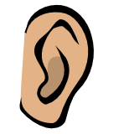
Look at the two boxes below. What do you notice? When do we use a and when do we use an in front of a word? SAY the words and LISTEN carefully.
an apple  an English book  an ice-cream | an orange  an ugly duck  an interesting book | a boy  a girl  a chair | a dog  a garden  a school

My rule
Wenn ich am Beginn eines Wortes …………………………………………………höre
verwende ich an.

Now it’s your turn
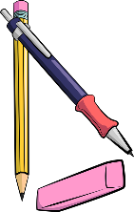
Write the words in the correct boxes. (Schreibe die Wörter in den richtigen Kreis.)
tiger, banana, book, exercise book, pencil, eraser, door, old man, internet-café,
English teacher, blackboard, window, American film, elephant
an
a

Challenge 2 for pros:


a or an? Scan the QR code and listen VERY carefully. What sounds do you hear at the beginning of these words? In which of the two circles do they go: a or an?
____university, ____uniform, ____unicorn, ____unit in my coursebook
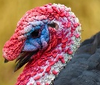
____mp3-player, ____XL-pullover,


____uncle, ____umbrella , ____ugly bird

Do we need a or an here? Write in the words, then listen to the words again.
My rule
Ich sage _____ unicorn, ______unicycle, weil …………………………………………………
Ich sage _____ mp3 player, _____XL-pullover, weil ………………………………………

M1: BIG LETTERS – small letters

In English we use big letters for
- I (I am happy.)
- names (Paula, Thomas),
- countries (England, Austria, Croatia)
- cities (Vienna, Graz, London, Paris)
- languages (German, Croatian, English)
- and at the beginning of sentences.

In the English lessons we speak English. Elisabeth and Selina are talking about London and England but I am reading a book about America.

Now it’s your turn:

Write 3-5 sentences and mark the BIG LETTERS. Ask your teacher to check.

M1: To be: am – is – are

Look at these examples:
My name is …………………….  I am a student at PraxisNMS.  I am ten years old.  I am not in class 4b. | 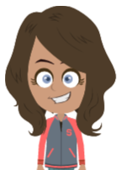  How old are you?  You are a very nice person.  You are my best friend. |   Anton is not in my class.  He is in NMS Kepler.  He is funny.

Sally is a student in England.
She is very nice.
She is not very tall.
  We are also happy.  We are not sad. |   Mary and Peter are good friends.  They are very happy.  They are not from Austria.

Now it’s your turn:

Write 10 sentences with
am | am not | is | is not | are | are not

Write true sentences about yourself, your friends, your classmates and teachers and your
family members or pets. Write a first draft on a piece of paper.
Schreibe immer wahre, sinnvolle Sätze. Schreibe einige der korrigierten Sätze hier auf:

M2: I speak – She speaks – I live – He lives

Challenge1: Find the rule
This is Mrs. Pölzleitner.
She lives in a blue house in Graz. She is an English teacher. She loves reading books and learning languages. She speaks English, German, French, Italian and Greek. She also likes sports. In winter she goes skiing and in summer she goes jogging. She rides her bike to school every day. Her favorite food is Indian curry. She is vegetarian, so she does not eat meat.
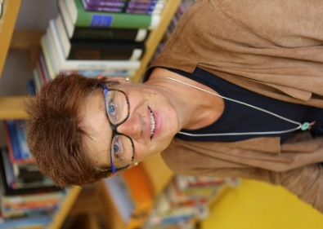
Hello, I am Mrs. Pölzleitner.
I live in a blue house in Graz. I am an English teacher. I love reading books and learning languages. I speak English, German, French, Italian and Greek. I also like sports. In winter I go skiing and in summer I go jogging. I ride my bike to school every day. My favorite food is Indian curry. I am vegetarian, so I do not eat meat.

What do you notice?


Challenge: Read the texts and find a rule!

These are Naomi and Michael.
They live in a small white house in Graz. They love riding their bikes and watching animals. They also like gardening. In summer they go swimming in their little pool and they read lots of books. They have three guinea-pigs.
Hello, we are Naomi and Michael.
We live in a small white house in Graz. We love riding our bikes and watching animals. We also like gardening. In summer we go swimming in our little pool and read lots of books. We have three guinea-pigs.

My rule:
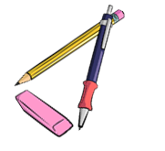
Wenn ich über EINE andere Person spreche/schreibe....

Wenn ich über MEHRERE Personen spreche/schreibe...

Now it's your turn

Step 1: Write a text about yourself. Hand it in to your teacher.

Step2: Get a speech bubble from your teacher and write your text on it. Put it on the pin board.
This is ...
NAME
Step 3: Find a speech bubble from a classmate on the pin board or get one from your teacher. Then write about your classmate. Hand your text in to your teacher.
(Write YOUR NAME on the sheet, too.)
Step 4: Write the corrected text from step 3 in the box .
Step 5: Copy your speech bubble in the bubble below

This is ...

M2: Short forms – Long forms

CHALLENGE
Look at these sentences. What do you notice? Mark the differences with a highlighter.
Maria does not like spinach. | Maria doesn’t like spinach.
We do not speak Croatian in school. | We don’t speak Croatian in school.
Peter is not from Austria. He is from England. | Peter isn’t from Austria. He’s from England.
We are good students. | We’re good students.
My friends are not in my school. | My friends aren’t in my school.

Now it’s your turn:
My friend Sally is not from Austria. | My friend Sally…
My mother is not very tall.
In my family, we do not eat meat.
I am happy.
 | My dad doesn’t like sweets.
 | We don’t have any pets.
 | Peter and Sally don’t speak German.
 | We’re not twins.
 | He’s my best friend.

M2: Personal Pronouns: I, you, he, she, it, we, you, they

 | 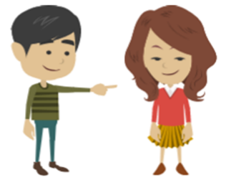 |  |  | 
I  I live in London.  I am 10 years old.  I like chocolate. | you  You are my best friend.  I like you.  Do you like cats? | he  He is called Peter.  He is 10 years old.  He likes pizza. | she  She is called Mary.  She is from Austria.  She likes ice-cream. | it  It is called Toby.  It likes carrots.  It is really cute.

 |  | 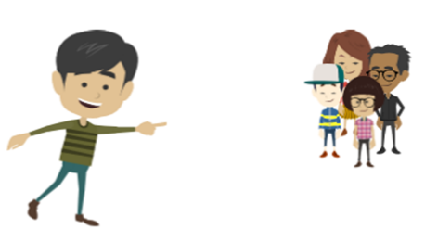
we  We go to the same class.  We speak English and German.  We like our new school. | you  Do you speak English?  You are my friends.  Do you want to work in my group? | they  They are very nice people.  They are from America.  They speak English but they do not speak German.

Now it’s your turn:
Now write similar (ähnliche) sentences about your friends and family.
Use ALL the pronouns.
I, you, he, she, it, we, you, they
Ask your teacher to check.

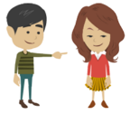







M2: Numbers
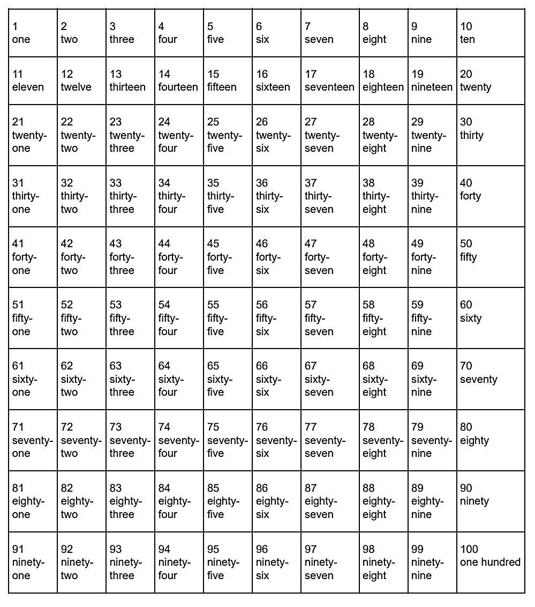
Now it’s your turn:
Number the pages of your ME-book. Write numbers and words: 1 -one, 2 – two 3—three…..

Now it’s your turn:
My special numbers
Choose one number in each row and colour it. Tell your teacher what it means for you. Then write your answers on this page. Ask your teacher to check your answers.
Examples:
- twenty-five: Mrs Pö’s daughter is twenty-five years old.
- thirty-three: Thirty-three is my lucky number. My phone number starts with thirty-three.
- seventy-four: I live in Scheigergasse seventy-four.

M2: Ordinal Numbers: first, second, third…
Who wins the race? Write sentences about all the runners:
Example:
Tom is in first place.
Tim is in second place.

first 1st
second 2nd
third 3rd
fourth 4th
fifth 5th
sixth 6th
seventh 7th
eighth 8th
ninth 9th
tenth 10th
eleventh 11th
…
twenty-first 21st
twenty-second 22nd
thirty-third 33rd
forty-fourth 44th
…


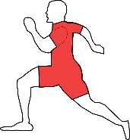
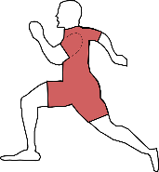
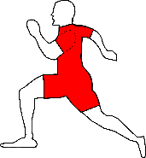

Boris
Gordon
Leo
Mike
Tim
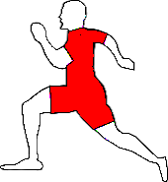
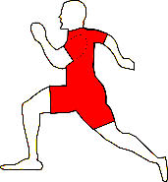
Alan
Andi
Tom
Jim
Sam
Bild von Clker-Free-Vector-Images auf Pixabay

Now it’s your turn:
Alan …

M2: Days of the week and months
Examples:

On Monday we have English.
On Tuesday I always play soccer.
On Saturday and Sunday I sleep in.

In winter I go skiing.
In summer I go swimming.
In spring there are lots of flowers.
In autumn the trees are very colorful.

School starts in September.
Christmas is in December.
In May there are lots of long weekends.
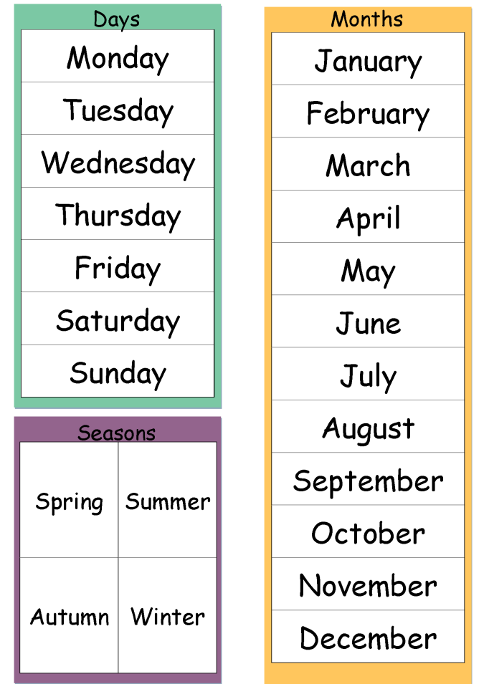
autumn
winter
summer
springhttp://www.polzleitner.com/epep/0-NMS/ErasmusGOALproject/Projektwoche.pptx

Now it’s your turn:

What is your favorite season?
What is your favorite month? Tell us why.
In which months do you go swimming?
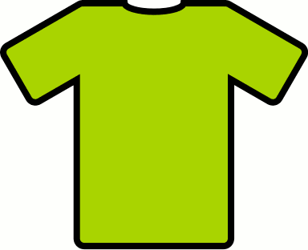
In which months do you wear short sleeves?
What is your favorite day of the week? Tell us why.
What is your least favorite ☹ day of the week? Tell us why.

M2: Giving the date in English

GIVING THE DATE
British:
1st October 2021
2nd November 2021
American:
December 3rd, 2021
January 4th, 2022
February 5th, 2022
Example:
When is your birthday?

You write: My birthday is on August 22nd.

You say:
My birthday is on the 22nd of August.

Now it’s your turn.

When is your birthday?
You write: My birthday is on ………………………………………………………………………………………..
You say: ………………………………………………………………………………………………………………………….
When do the holidays start?
You write: The holidays start on …………………………………………………………………………………………..
You say: ………………………………………………………………………………………………………………………………………………
When is Christmas?
You write: Christmas is on ……………………………………………………………………………….
You say: ………………………………………………………………………………………………………………………………………………
When does Ramadan start this year?
You write: It starts on ……………………………………………………………………………………..
You say: …………………………………………………………..…………………………………………………………………………………
On which floor is the teachers’ office?
You say and write: It’s on the …………………………………………………………………………………………

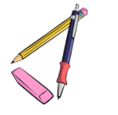
M2: Plural: many things
Plural 1
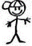  one boy | 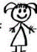  one girl | 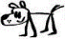  one dog | one desk
two boys | two girls | 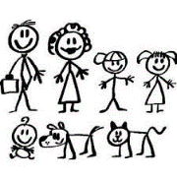  two dogs | two desks
one pencil | one erasor | one window | one book
two ……………….. | two ……………….. | two……………….. | two ………………..
one student | one teacher | one door | one schoolbag
two……………….. | two ……………….. | two ……………….. | two ………………..

How do we form the plural in English?


Plural 2: tricky words
Why not this?
Listen and speak!

- boxs
- buss
- kisss
- wishs
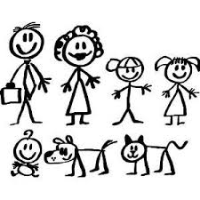  one baby  two babies | one box  two boxes
one country  two …………………… | one bus  two ………………..
one pony  two ……………………. | one kiss  two ………………..
one story  two ……………………. | one wish  two …………………
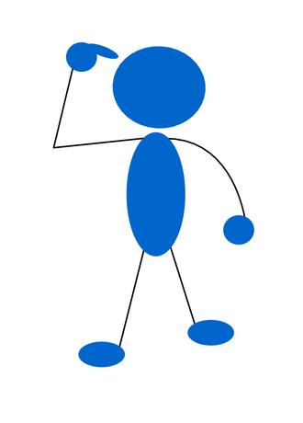
Plural 3: more tricky words: add more words later
one child.  two children. | one man  two men | one woman  two women
one mouse
two mice

M3: Possessive Pronouns: my, your, his, her, our, their
Wem gehören diese Dinge?
Look at Mr and Ms Brown and their children. They are really cute.
Yes, these are our children.
Yes, these are our children.
Are these your children?
Is this your dog, Tom?


Yes, it is my dog.
Yes, this is his dog.

Is this Susan’s cat?
Yes, this is her cat.


Whose dog is it?
Draw a leash (Leine).

Is this the dog‘s ball?
Yes, the dog loves its ball.

More examples:
Thomas has a sister. His sister is called Mary.
Mrs. Pölzleitner goes to school by bike. Her bike is white.
Mrs. Bergmann has three children. Her children are called Martina, Julia and Matthias.
We have a very nice classroom. Our classroom is the best.
Some children from my old school go to a “Gymnasium”. Their school is not as cool as ours.

Now it’s your turn:

Write 6 TRUE sentences about yourself and your friends and family.
Use: my, your, his, her, our, their

M3: Peter’s cat and Maria’s dog…


Challenge:
Peter’s brother is called Thomas.
Andrea’s sister is very funny.
My mom’s favorite food is pizza.
My dad’s mom is my grandmother.
My aunt’s dog is really big.

’s
What does it mean?

My rule:
Ich schreibe ein ‘s …......

Now it’s your turn:
Write 5 similar (ähnliche) sentences.
Remember: Always write TRUE and meaningful sentences.

M3: Whose things are these?

My parents’ bedroom is very big.  My friends’ houses are beautiful.  The girls’ umbrellas are colorful.  s‘s | 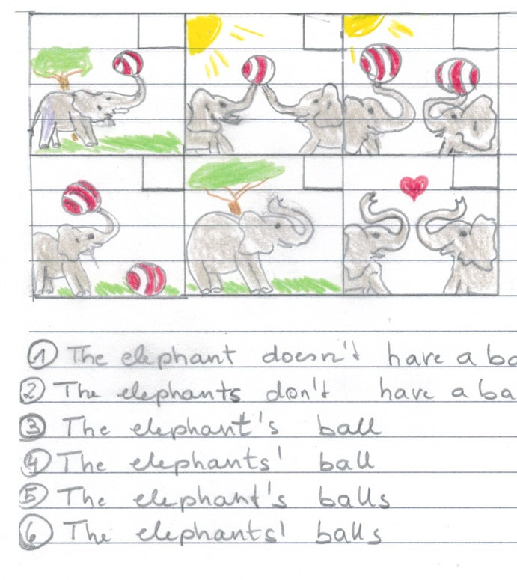  Match the pictures and the sentences. Write the numbers into the pictures.  1: The elephant doesn’t have a ball.  2: The elephants don’t have a ball.  3: The elephant has a ball. This is the elephant’s ball.  4: The elephants have a ball. This is the elephants’ ball.  5: The elephant has two balls. These are the elephant’s balls.  6: The elephants have two balls. These are the elephants’ balls.

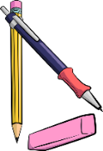
Now it’s your turn:
Make your own matching game. Get stickers and playing cards from your teacher.
Write 5 sentences with ….‘s or s’ and draw a picture for each one. Show them to your teacher.
Copy your sentences and pictures on playing cards and ask a friend to match them.
Draw your pictures in the wrong order
1
2
3
4
5


M3: Asking Questions in English

The new English teacher…
Mrs. Bergmann meets the new English teacher at her school.
She asks him lots of questions.
Do you like Great Britain?
Where do you come from?
Where do you live?
What languages do you speak?
Do you go to school by bike?
How do you get to school?
When do you get up?
Do you drink coffee?
Why don’t you drink coffee?
Do you have a pet?

How do your classmates study vocabulary?
How does your best friend get to school?
Questions, questions, questions
Mrs. Pölzleitner wants to know everything about the new teacher. She texts Ms Bergmann.

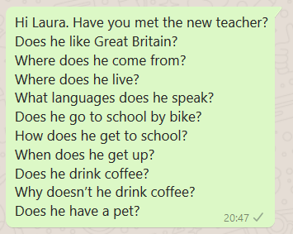

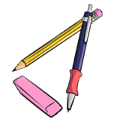
Challenge
What do you notice? (Was fällt dir auf?)
Man kann für Fragen Fragewörter verwenden. Schreibe die Fragewörter auf:

………………………………………………………………………………………………………………………………………………...

Man bildet Fragen häufig mit ………………………………….. oder ………………………………………………….
Does verwendet man wenn man über …………………………………………………………………………spricht.

Das verb (z.B……………………………………………………………………………………………..) verändert sich nicht.

Now it’s your turn:

Write your own questions
Write 5 questions you want to ask your teacher.

Write 5 questions about one of your classmates. Ask your teacher. How many questions can your teacher answer? _______________

M3: More questions: Interview a student teacher
Make a questionnaire (Fragebogen)
Write a lot of questions to interview guests and student-teachers.
When we have guests in class, talk to them and ask them all your questions.

M3: Negation in English


Challenge
Mrs. Bergmann has a problem. She needs Mrs. Pölzleitner’s help.
Read the text. What do you notice?
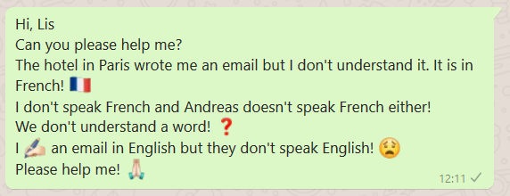

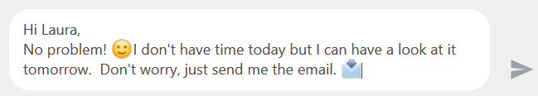

What do you notice? (Was fällt dir auf?)
- In der Verneinung verwendet man ___________ oder _____________ vor dem Verb (z.B. speak, like, eat)
- Doesn‘t verwendet man wenn man über ________________________________________spricht.
- Das verb (z.B. ___________________________________________________) verändert sich nicht.

Now it’s your turn.
Say what people DON’T do! Write your own examples. Start your sentences like this:
I…
My best friend…
My teacher…
My cat/dog/ _________
My parents…
My friends…
We…

M4: Telling the time

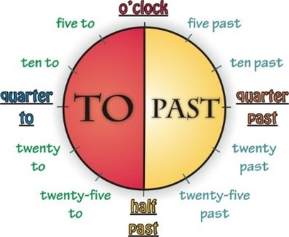
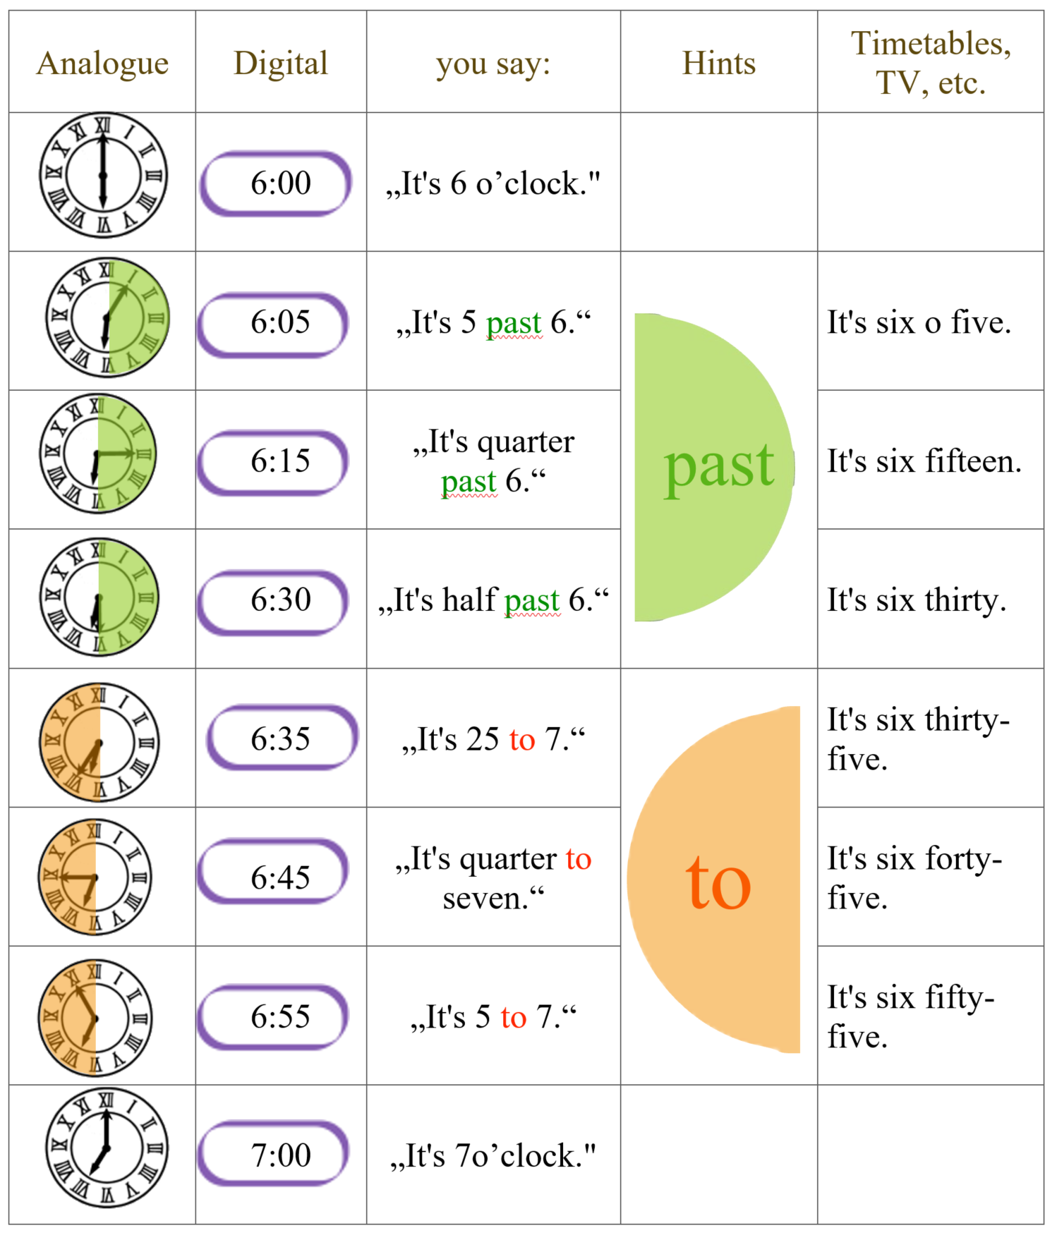

Now it’s your turn:

Answer the following questions. Write complete sentences.

What time is it right now?
What time do you usually get up in the morning?
What time does school start?
What time do you have lunch in the school cafeteria?
What time does school finish?
What time do you usually study vocabulary?
What time do you go to bed in the evening?

M4: Routines

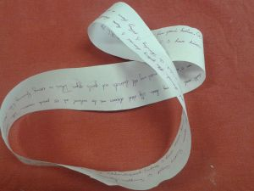 | Maria usually gets up at half past six. Then she takes a shower and gets dressed. At seven o’clock she has breakfast with her family. She eats bread, butter and jam and she drinks a cup of hot chocolate. Then she goes to school by bus. She arrives at school at half past seven. She goes to her locker to change her shoes and to hang up her coat or jacket. School starts at quarter to eight….
xxxx

Here we are talking about ………………………………………………………………………………………………………
We use the present simple (get up, take, have, go…).

Now it’s your turn:

My daily routines
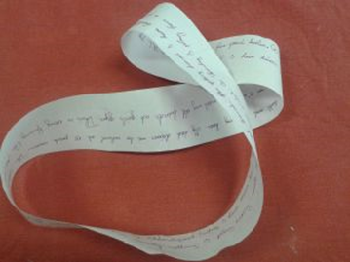
Ask your teacher for a Moebius strip. Then write down all the things you do every day – and every week.
Write as much as you can. Fill all the paper.
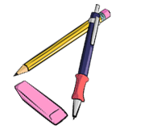
Read your text to your teacher and two a friend.
Then put it into an envelope and glue it on this page.



M5: Routines versus Present activities

Challenge:
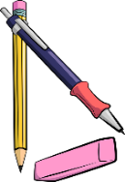
Look at examples on page 25 and here. What’s the difference?
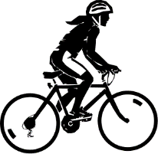  The girl is riding her bike. |   The girl is dancing. | 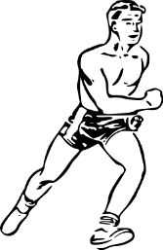  The boy is running.
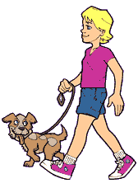  The boy is walking his dog. |   The person is swimming. | 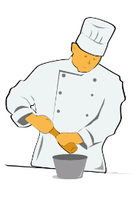  The cook is cooking.
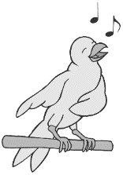  The bird is singing | 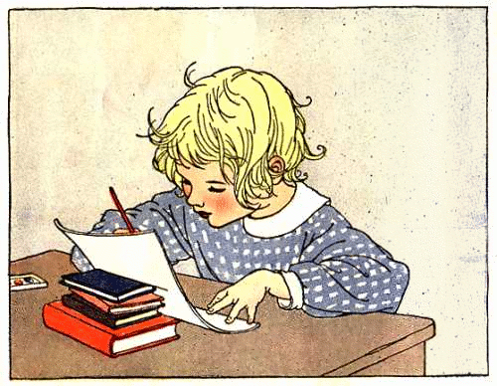  The child is doing homework. | 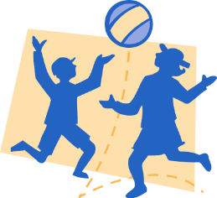  The children are playing with a ball.

Here we are describing what……………………………………………………………
We use the present continuous form (singing, riding, dancing).

Be a detective: What is going on in your class and your school?
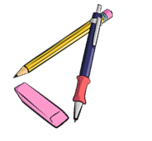
Look around the classroom and write 10 true sentences on a sheet of paper.
What are your classmates doing right now? Show your sentences to your teacher,
then correct your sentences. Write the 5 most interesting things on this page.

1
2
3
4
5

M5: There is --- There are
Describing what you see and what is there: Einen Ort beschreiben

In our classroom there are 22 children.
There are also 22 chairs and many tables.
There is a computer under the teacher’s desk and there is a projector on the ceiling.
There are two big cupboards at the back of the classroom and there is a big green board on the front wall. Next to the door there is a washbasin and three garbage bins.

Explain: When do we use there is? When do we use there are?

My rule:

We say THERE IS….

We say THERE ARE…

Now it’s your turn:

Write five sentences about your room. Use there is and there are

M5: asking questions with there is—there are

Is there | a | sofa | in your classroom?
Is there | an | orange | in your classroom?
Are there | any | laptops | in your classroom?

Yes, there is.  No, there isn’t. | Yes, there are.  No, there aren’t.

There is a | sofa | in/on/under/next to/in front of/behind/between…..the
There are some | posters | in/on/under/next to/in front of/behind/between…..the

Now it’s your turn:
Work with a partner. Ask your partner 5 questions about his/her room.
Then write your questions and your partner’s answers.

M5: Where things are: Prepositions of place
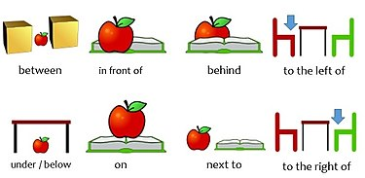

above

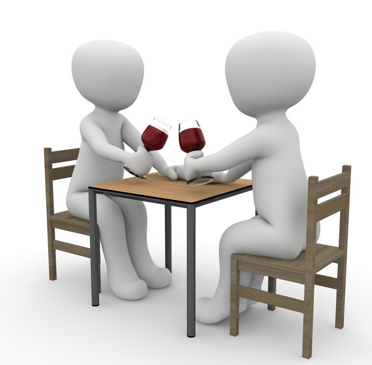

By MarcoRoe, creativecommons.org/licenses/by-sa/3.0
* opposite
They are sitting opposite each other.

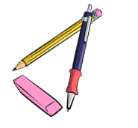
Now it’s your turn:

Write 8 true sentences about your classroom, or your room.
Show your sentences to your teacher.
Correct your sentences.

M-A (June) : Future: making plans: going to

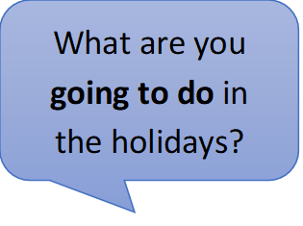
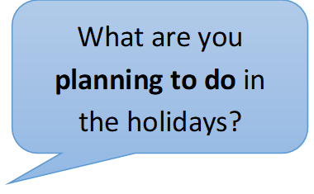
Talking about plans: GOING TO

Write 3 sentences about your holiday plans
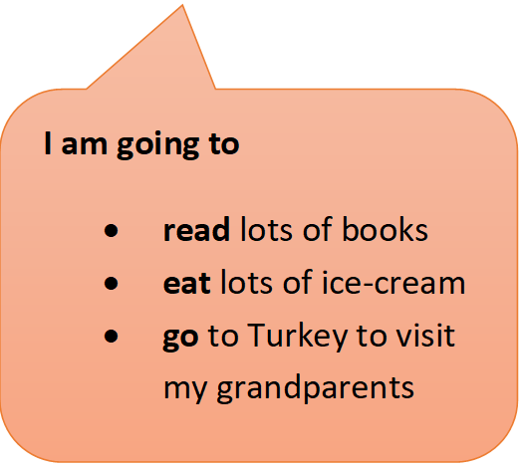
and
3 sentences about your friend’s holiday plans
and
We are going to
- visit our family
- play a lot of games
- go swimming
3 sentences about your teachers’
holiday plans.

Now it’s your turn:

My holiday plans
I am going to
I…
I…

My friend’s holiday plans
Name………….. is going to…

My teacher’s holiday plans
Name………….. is going to…

M7: Past tense: Irregular Verb forms 1

Usually, .. |  | Yesterday …
I | am happy. | I | was sad.
We | are happy. | We | were sad.
I | do my homework. | I | did my math exercises.
I | go to school by bus. | I | went to school by bike.
I | spend 6 hours in school. | I | spent 7 hours in school.
I | have breakfast with my mom. | I | had breakfast with my dad.
I | fly to America. | I | flew to England.
I | take a shower. | I | took a bath.
I | come home at 5 o’clock. | I | came home at 7 o’clock.
I | read a book in bed. | I | read a newspaper.
I | speak with my friends. | I | spoke with my sister.
I | drink water. | I | drank Coke.
I | get up at 6 o’clock. | I | got up at 7 o’clock.
We | drive to my grandmother’s house. | We | drove to my aunt’s house.
I | say funny things. | I | said sad things.
I | eat dinner with my family. | I | ate dinner at my grandmother’s.
We | stand up when a teacher comes in. | We | stood up when Frau Wagner came in.
We | buy our food at SPAR. | We | bought our food at BILLA.
I | write a shopping list | I | wrote an e-mail to my teacher.
I | buy a bottle of water. | I | bought a bottle of Coke.

M7: Past tense, Irregular forms

Now it’s our turn:

Choose 10 verbs from page 31 and write true and meaningful sentences about yourself, your friends and family.
What DID YOU DO (yesterday, in the holidays, last weekend….)?

M7: Past tense: Regular Verb forms
Usually, .. |  | Yesterday … / In summer...
I | visit my grandparents every Saturday. | I | visited my aunt.
I | play soccer in the afternoon. | I | played soccer in the morning.
We | stay in a hotel. | We | stayed with friends.
I | watch TV in the evening. | I | watched TV all day long.

M7: Past tense - Negation

I can say what I did and what I did not do in the holidays.
Examples:
I did not go to America, but | I went to Turkey.
I did not eat any Sauerkraut, but | I ate lots of ice-cream.
I did not buy any souvenirs, but | I bought a new t-shirt.
I did not take an airplane, but | I took a bus and a train.
I did not play chess, but | I played soccer with my friends.

Now it’s your turn:


Write 10 sentences on a sheet of paper. Show your sentences to your teacher. Then write the correct sentences on this page.
Examples:
I did not go to Greece this summer, but I went to Turkey.
I did not read many books this summer, but I watched lots of movies.


Challenge:
What do you notice about the verb forms? Tell your teacher. Then write your rule in this box.

M7: Past tense – Questions

Yes, I did.
Did you go swimming in the holidays?

Did you speak English in the holidays?
No, I didn’t.
Did you visit your grandmother?

Did you like your hotel?

Now it’s your turn:

Write 5 more questions that you would like to ask your teacher. What did your teachers do in the holidays? Then talk to your teacher and ask your questions.

Did you…
Did you…

M7: Irregular Verb Forms (in groups)
There are about 185 irregular verbs in English. You will need only need these 90. Study them carefully
Base form | Past form | Last form | German | Base form | Past form | Last form | German
All forms different |  |  |  | Past form and last form end in [d]
be (is/was) | was / were | been | sein | find | found | found | finden
become | became | become | werden | have | had | had | haben
come | came | come | kommen | hear | heard | heard | hören
do | did | done | tun | hold | held | held | halten
go | went | gone | gehen | lay | laid | laid | legen
run | ran | run | laufen | make | made | made | machen
see | saw | seen | sehen | pay | paid | paid | zahlen
show | showed | shown | zeigen | read [ri:d] | read [red] | read [red] | lesen
 |  |  |  | say | said | said | sagen
All forms the same |  |  |  | sell | sold | sold | verkaufen
cost | cost | cost | kosten (Preis) | stand | stood | stood | stehen
cut | cut | cut | schneiden | understand | understood | understood | verstehen
hit | hit | hit | schlagen | tell | told | told | erzählen
hurt | hurt | hurt | verletzen
let | let | let | lassen | Same sound patterns
put | put | put | stellen/legen | bring | brought | brought | bringen
set | set | set |  | buy | bought | bought | kaufen
shut | shut | shut | schließen | fight | fought | fought | kämpfen
 |  |  |  | think | thought | thought | denken
Past form and last form the same |  |  |  | catch | caught | caught | fangen
dig | dug | dug | graben | teach | taught | taught | lehren
win | won | won | gewinnen
 |  |  |  | sing | sang | sung | singen
Past form and last form end in [t] |  |  |  | swim | swam | swum | schwimmen
build | built | built | bauen | begin | began | begun | beginnen
burn | burnt | burnt | (ver)brennen | drink | drank | drunk | trinken
creep | crept | crept | kriechen | ring | rang | rung | läuten
feel | felt | felt | fühlen
keep | kept | kept | behalten | freeze | froze | frozen | frieren
leave | left | left | verlassen | steal | stole | stolen | stehlen
light | lit | lit | anzünden | break | broke | broken | brechen
lend | lent | lent | borgen | wake | woke | woken | aufwecken
mean | meant | meant | meinen | choose | chose | chosen | auswählen
meet | met | met | treffen | drive | drove | driven | fahren, lenken
send | sent | sent | schicken | write | wrote | written | schreiben
shoot | shot | shot | schießen
sleep | slept | slept | schlafen | beat | beat | beaten | schlagen
smell | smelt | smelt | riechen | bite | bit | bitten | beißen
spend | spent | spent | ausgeben | eat | ate | eaten | essen
spill | spilt | spilt | ausschütten | fall | fell | fallen | Fallen
spoil | spoilt | spoilt | verwöhnen | forget | forgot | forgotten | vergessen
get | got | got | bekommen | forgive | forgave | forgiven | verzeihen
lose | lost | lost | verlieren | give | gave | given | geben
sit | sat | sat | sitzen | hide | hid | hidden | verstecken
sweep | swept | swept | kehren | shake | shook | shaken | schütteln
 |  |  |  | take | took | taken | nehmen
Same sound pattern |  |  |  | tear | tore | torn | zerreißen
grow | grew | grown | wachsen | wear | wore | worn | tragen(Kleider)
fly | flew | flown | fliegen
know | knew | known | wissen
throw | threw | thrown | werfen

M7: Irregular Verbs in alphabetical order
be | was/were | been
beat | beat | beaten
become | became | become
begin | began | begun
bend | bent | bent
bet | bet | bet
bind | bound | bound
bite | bit | bitten
blow | blew | blown
break | broke | broken
bring | brought | brought
build | built | built
buy | bought | bought
can | could | … (been able)
catch | caught | caught
choose | chose | chosen
come | came | come
cost | cost | cost
creep | crept | crept
cut | cut | cut
dig | dug | dug
do | did | done
draw | drew | drawn
drink | drank | drunk
drive | drove | driven
eat | ate | eaten
fall | fell | fallen
feed | fed | fed
feel | felt | felt
fight | fought | fought
find | found | found
fly | flew | flown
forbid | forbade | forbidden
forget | forgot | forgotten
forgive | forgave | forgiven
freeze | froze | frozen
get | got | got
give | gave | given
go | went | gone
grow | grew | grown
hang | hung | hung
have | had | had
hear | heard | heard
hide | hid | hidden
hit | hit | hit
hold | held | held
hurt | hurt | hurt
keep | kept | kept
know | knew | known
lay | laid | laid
lead | led | led
leave | left | left
lend | lent | lent
lie (in bed) | lay | lain
lie (lügen) | lied | lied
lose | lost | lost
make | made | made
mean | meant | meant
meet | met | met
must | had to | …
pay | paid | paid
put | put | put
read | read | read
ride | rode | ridden
ring | rang | rung
rise | rose | risen
run | ran | run
say | said | said
see | saw | seen
sell | sold | sold
send | sent | sent
set | set | set
shake | shook | shaken
shine | shone | shone
shoot | shot | shot
show | showed | shown
shrink | shrank | shrunk
shut | shut | shut
sing | sang | sung
sink | sank | sunk
sit | sat | sat
sleep | slept | slept
slide | slid | slid
smell | smelt | smelt
speak | spoke | spoken
spend | spent | spent
spit | spat | spat
spread | spread | spread
stand | stood | stood
steal | stole | stolen
stick | stuck | stuck
sting | stung | stung
stink | stank | stunk
strike | struck | struck
swear | swore | sworn
swim | swam | swum
swing | swung | swung
take | took | taken
teach | taught | taught
tear | tore | torn
tell | told | told
think | thought | thought
throw | threw | thrown
wake | woke | woken
wear | wore | worn
weep | wept | wept
win | won | won
wind | wound | wound
write | wrote | written

M8: Comparing

1. Read the descriptions of these exotic animals and highlight all the comparisons (Vergleiche). Then match them with the pictures. Draw lines.
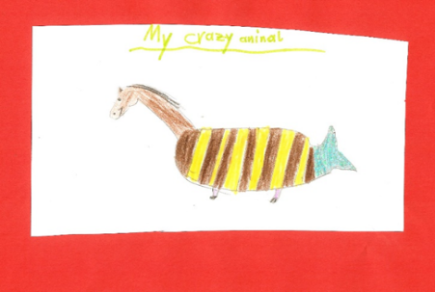
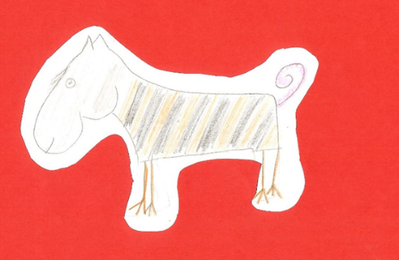
Horsotigopigchick
The horsotoigopigchick has the body of a tiger, the head of a horse, the tail of a pig and the feet of a chicken. Its head is bigger than a tiger’s head and a lot heavier. The horsotigopigchick’s legs are much thinner than a tiger’s legs and it slower than a tiger. It has a thin pink tail and it is more peaceful than the Tigohorsophin. It is the friendliest of these animals and makes a perfect pet.
Crocosharkopeacock
The crocosharkopeacock is a very strange animal. It has a crocodile’s head, the body of a shark and the tail and feathers of a peacock. Its legs are as short as a crocodile’s and it cannot run very fast, but the crocosharkopeacock can fly faster than any other bird. It is the fastest animal in the world. It has very sharp teeth and it is one of the most dangerous animals in the world. It is more dangerous than a crocodile or a shark.
Tigohorsophin
The tigohorsophin is a lovely animal. It has the head and neck of a horse, the body of a fat tiger and the tail and fin of a dolphin. It has the smallest, shortest legs of all the exotic animals. Normally it doesn’t walk but it can swim. The tigohorsophin is the heaviest of the exotic animals and it is even slower than the horsotigopigchick but it is the most intelligent of all the exotic animals. It is more intelligent than a dog.

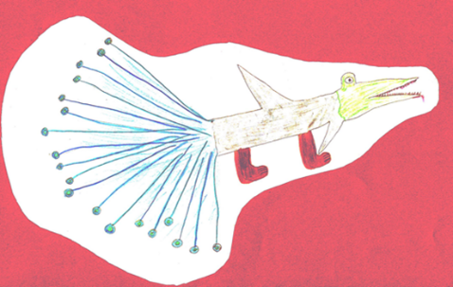

2. Are these sentences true or false? Tick the correct ones and correct the false ones.

Challenge:
Find the rule.
How do we compare adjectives?
How would you explain this to your mom?
Horsotigopigchicks are as fast as tigers.
Tigohorsophins are the heaviest and slowest animals in this group.
Tigohorsophins are the most intelligent of the exotic animals.
The crocosharkopeacock has shorter legs than the other animals.
The horsotigopigchick is more dangerous than the other animals.
The crocosharkopeacock is less dangerous than the horsotigopigchick.

Challenge:
Show that you can do this.
thin
kind
cold
intelligent
beautiful
interesting

Explain it!

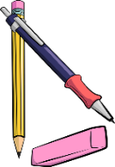
My rule:

Now it’s your turn:
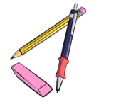
Choose two animals and compare them. Use a piece of paper for your first draft.
Write at least 5 sentences. Ask your teacher to check.
Then copy the corrected sentences into this box.

M9: Talking about the Future

Challenge:
Read the following examples where people talk about the future. Highlight all the verbs (Zeitwörter).
What do you notice? What is the difference between text A and text B? Tell your teacher what you have found out.
A
This weekend I am going to Klagenfurt to celebrate my grandmother’s birthday. All my cousins are also going to be there.
On Saturday evening we are going to watch all the Harry Potter movies together, my cousin Peter has them all on DVD.
On Sunday we are going to celebrate my grandmother’s birthday in a restaurant. There, I am going to order Wienerschnitzel, my favorite food.
I am really looking forward to this weekend.
What are you going to do on the upcoming weekend?


My Rule:
Here we are talking about ………..
We use the form ………………………

That sounds like fun. My weekend is going to be boring. I am going to study for Math, and I am going to work on my module in English. And then, I am going to clean up my room, it’s a real mess.

B
I’m not sure. I think I will live in a flat or in a house with my partner. Maybe I will have some children.
I’ll work in a big company and I’ll have a car of my own. It will probably be an electric car – or maybe I’ll go to work in a self-driving car.
What will your life be like in the year 2040?

Tip: Remember
I am = I’m
I will = I’ll

My Rule:
Here we are talking about ……………………………………

We use the form…………………………………………………..

Your weekend
Your teacher’s weekend
If …
Perhaps…
Maybe…


Perhaps, I’ll go to the bookstore and buy a new book.

Maybe, my sister will visit me. She is very busy, I don’t know if she has got time.



On Sunday I am going to sleep in and have a nice, long breakfast.
I am going to meet my friend Nancy on Saturday afternoon. We are going to have coffee and cake and chat about work.

On Sunday afternoon I am going to work for school. I have a long to-do list.
On Saturday morning I am going to do my grocery shopping for the week, and I am going to clean my house.
I’ll go jogging if the weather is good.

Now it’s your turn:
What are YOU going to do this upcoming weekend (or in the next holidiays)? Do you have any PLANS or VAGUE IDEAS?
Write them on the left side of the arrow.

M10: Talking about experiences: Have you ever …..

Grammar Challenge: Find out about your teacher…

- Step 1: Read the interview. Highlight the verbs. What are the differences in the round and square speech bubbles?

- Step 2: Find the rule and tell it to your teacher. Then write it in the box below.
- Step 3: Ask all your teachers. Who is the teacher who gave the interview?
Have you ever been to America?

Yes, I have been to America twice.

Where did you go?

The first time I went to California and stayed there for four weeks.
The second time I went to America on my honeymoon. My husband and I stayed in New York for a week.

Have you ever visited the White House.

No, I have never visited the White House

Have you ever touched a snake or a tarantula?
I have never touched a tarantula but I have touched a snake.

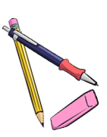

My rule

We use „have + 3rd form“ (present perfect tense) to talk about…
We use the past tense to talk about…
I went skydiving when I was twenty years old. It was fantastic. We went up to almost 4000 metres in a little plane and then we jumped down.
We loved it and wanted to do it again, but it was too expensive.
When did you go skydiving?
Did you like it?

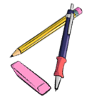
Now it’s your turn:

Find your own questions and answers that you want to ask your teacher or a classmate. Use the correct tenses. Ask until you get the answer: “Yes, I have.”
Tip:
Have a look at 10A+B in your handout
Yes, I have.
Have you ever …

Find out: when – where - why –who- how….

Write down the questions:

Write down the answers:

name: _________________


M10: My exciting life: I have done lots of cool things
Look at the example.
Step 1: Write about three interesting things you have experienced (erlebt). Use the speech bubbles.
Step 2: Give details in the box.

Step 3: Ask your teacher to check.
details

It happened a few years ago. I was at the beach in Caorle. Suddenly I saw a group of children. They were very excited because they had a baby shark in a bucket.
I took the shark and brought it back to the sea. It was very weak so I moved it around in the water. After some time it swam away.
experience
I have touched a shark.

when – where - why –who- how….

details
I have _______________
- - - - - - - - - - - - - - - - - - - - .

when – where - why –who- how….

experience



I h _ _ _ _______________
- - - - - - - - - - - - - - - - - - - - .

experience

when – where - why –who- how….


I ______ _______________
- - - - - - - - - - - - - - - - - - - - .

when – where - why –who- how….
experience

M10: Wishful Thinking: Life could be even cooler.

- if we had lots of money
- if we had a lot of time
- if we could do magic
Step 1: Read about Mrs. Bergmann’s dreams.
Step 2: Underline all verbs. The first one has been done for you. What do you notice?
Step 3: What would you do if …. ? Write at least 2 sentences per topic.
If I had a superpower and could become invisible, I would go to Buckingham Palace and watch the Royal family.
I would also go to a film set of Dr Who. If I was invisible, I would go to a spa in the evening when it is closed and be there all on my own.

Well, if I won a thousand Euros in the lottery, I would book a flight to Great Britain or to Ireland and spend a wonderful week there. Of course, I would take my family with me.
If I won a million Euros, I would buy a house or a castle in Scotland where I would spend the summer. I would have a butler, of course.

If I could travel in time, I would visit many interesting times. I would go to Scotland in the 17th century and visit the Scottish Clans. Then I would go to the 19th century and meet Sissi. Then I would go to the 20th century and take a picture with Albert Einstein. And if I could travel in time, I would also go to the future and meet my great-grandchildren.

Now it’s your turn

Step 1: Read the sentences and look at the underlined words.

If I had a bike, I would go to school by bike every day.
If I was invisible, I could find out all my friends’ secrets.
If I could play the guitar, I would join a band.
I would go for a walk every day if I had a dog.
I would stay in bed all day, if I did not have a test today.

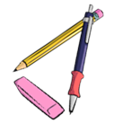
Now it’s your turn.

Use the same structure to complete the sentences
If I had a pet, …
If I had 50 euros, I …
I would go to America if …
If I could fly, I …
If I had a twin sister/ brother, I …
If I could travel in time, …
I would not leave the house, if …
If I was super strong, I
If I could speak every language in the world, I…
I would …………………………………………………., if I was…
I would ……………………………………….………………………………, if I didn’t have to go to school.
I would …………………………………………………………………………, if it wasn’t so expensive.
If I ………

It’s your turn

What are your wishes and dreams? What would you do if they came true?
I would like to be 16 years old.
If I was 16, I could stay out really late.

I would like to …
If I ……

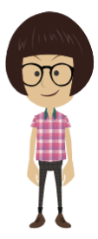


Write at least 5 wishes and dreams of your own.
Use the same structures.

M11: one or ones --- this or these

Challenge 1
Look at the two dialogues below and highlight “one” and “ones”. What do you notice?
When do we use one and when do we use ones and this and these?

Shop assistant: Good morning. How can I help you?
Customer: I’m looking for a woolen sweater.
S: How about the red one in the corner over there?
C: I don’t like red… Do you have any grey ones?
S: Yes, over there. Come with me. Do you like this one?
C: Yes, this one is really nice.
S: What size do you wear?
C: Medium.
S: Ok, try this one
C: It’s too small. Do you have a larger one?
S: No, sorry. The large ones are sold out.

Shop assistant: Good afternoon. What can I do for you?
Customer: I’d like a pair of Converse.
S: What size do you wear?
C: I usually wear size 9. I’d like some golden ones.
S: Sorry, we don’t have any golden ones. But these silver ones are also quite fashionable, or these green ones. The green ones are very popular this year!
C: Can I try them on?
S: Sure.
C: They fit perfectly. How much are they?
S: 110 pounds.
C: That’s too expensive. I can’t afford that. What about the black ones?
S: They are on sale. They only cost 50 pounds right now.
C: Great, I’ll take the black ones!

My rule

We use THIS ONE for ….

We use THESE ONES for …..

M11: some or any

Challenge 1

What do your teachers have in their fridges? Read the texts and mark SOME and ANY in two different colours.

I’m a vegetarian, but Patrick eats meat. In our fridge, there are always some sausages. There is always some cheese, but we never have any milk. I usually have some oat milk in the fridge and we sometimes have some yogurt for Patrick.
There aren’t any eggs in our fridge. Sometimes, we have some tomatoes, and we usually have some carrots and some salad.

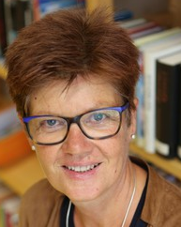
In my family we are all vegetarian. We don’t eat any meat or fish. Therefore, we never have any meat or sausages or fish in our fridge.
We always have some yogurt, because we eat yogurt with fruit for breakfast every day. We always have some milk in our fridge, and we love cheese. There is always some cheese in our fridge.
We eat lots of vegetables and salad, so there are usually some zucchini, some tomatoes and some carrots in our fridge.
Challenge 2
What’s in your teachers’ fridges? Draw the things in the correct fridge and label the picture!
Mrs Pö’s fridge:
Mrs Loitsch’s fridge:

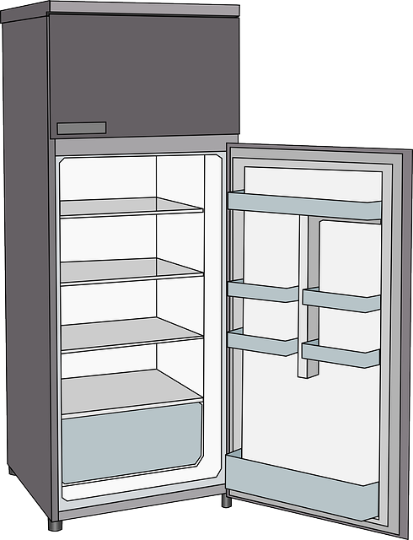

some carrots



Challenge 2
What do your teachers not have in their fridge? Write sentences!
My rule

Ms Loitsch never has any milk in her fridge.
Mrs Pö never…
Challenge 3
???
Look at these questions. What is the difference? Why does the speaker use some or any?

Mrs. Pölzleitner, do you know some good English books that I could read? | Mr. Grasser, do you know any good English books that I could read?
Mrs. Bergmann, I know your family likes chicken. Do you have some good chicken recipies? | Mrs. Pölzleitner, I know you are vegetarian, but do you know any good chicken recipies?
Ms. Loitsch, I see you always put oat milk in your coffee. Could I try some, please? | Is there any oat milk in the teachers’ fridge at school?
Ms. Loitsch, can I have some colored paper for my Me-book, please? | Felix, do you happen to have any non-permanent markers that I could use?
 | 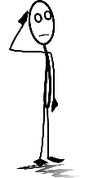

Challenge 4

Now it’s your turn! What do you never/sometimes/usually/always have in your fridge?

Draw the things that you have in your fridge! Then write 7 sentences. Use some and any.

M 11: much, many, a lot of, lots of

Challenge 5

Look at the examples. Guess how many there are.

here you can say: many or a lot of or lots of | How many do you think there are? Guess !
In the teachers’ office there are many books and many folders. | I think there are 50 books and 20 folders.
How many brothers and sisters do you have?
There are too many kids in this room.
There were a lot of people at the concert.
I have a lot of friends
Valentina has many pets.
How many days are there till Christmas?
here you can only say: a lot of | What about these sentences?  Can you count these things?  How?
Bill Gates has got a lot of money.
In the holidays a spend a lot of time on the beach.
There is a lot of food in the fridge.
There is a lot of sand on the beach.
This winter we had a lot of snow in the mountains.

Sort the words into the two boxes:
dogs, apples, books, boys, children, time, minutes, money, euros, days, water, milk, butter, food, sand, snow, trees, air, love,
here you can use: many / a lot of / lots of | here you can only say: a lot of
My rule
We say many / a lot of/ lots of when ….
We can only say a lot of when …

Challenge 6

not many | not much // not a lot of
When I was little, I did not have many friends. | He doesn’t have a lot of hair. He is almost bald.    The old man doesn’t have much hair. He is almost bald.
Mrs. Pö has many books, but not many DVDs. | John doesn’t have a lot of money.  John doesn’t have much money.
Mr. Grasser does not have many English books. | We did not have much snow this winter.  We did not have a lot of snow this winter
There are not many Chinese children in Graz. | Hurry up, there is not much time left.
Mrs. Weinzettl does not know many famous soccer players, but she knows many famous singers. | There is not much food left in the fridge, we’ll have to go shopping.

My Rule
We say not many when….
We say not much or not a lot of when ….

Now it’s your turn

Write true and meaningful sentences about yourself, your family and friends.
Use much, many, a lot of, not much, not many,

many
many
a lot of
a lot of
not many
not many
not much
not much

Grammar for year 3 and 4

Colorful and detailed descriptions

Challenge
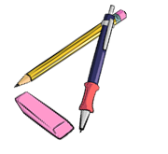
Use your vocabulary cards from this module and sort them into two groups.
Ask your teacher to check your cards, then write the sentences into the correct boxes below.
Group A: What people and things are like:

My Rule:
When we describe what something or someone is like we use ………………………………………………

Group B: How we DO things.

My Rule:
When we describe how we do things, we use ………………………………………………………………

Describing people and things: What are they like?

Read the following text about Willy the Vampire and underline all the adjectives.
ADJECTIVES describe WHAT THINGS ARE LIKE. The first ones have been done for you:
Willy the Vampire
When I went to elementary school, I had a classmate who was a bit strange. He was very small and thin, and his skin was very pale. He had short, light-blond hair and very long fingers and toes. Willy always sat in the last row. He seemed very tired and shy.
Willy was a good student. His math grades were always excellent, and he was a talented storyteller. He always got As for his stories in German. Willy liked to draw and paint, and we all liked his pictures. Our teacher often hung his pictures up in the hallways because they were so special.
Willy lived far from the school at the edge of our town. He lived in a large, very old house with his family. They were all as pale as Willy and they were all very shy.
There were lots of wild rumors about Willy and his family. Many people said that they had seen them walking the streets in the middle of the night. Others said that they had heard strange, howling noises in their house at full moon.
We never dared to ask Willy about these rumors, but even if he was a vampire, he was a nice and friendly classmate and he did not do any harm to anybody.

Now it’s your turn

Choose five interesting adjectives and write your own sentences with them. Make sure all your sentences are TRUE and tell us TRUE things about yourself, your family and friends.
Write the adjectives into column 1, then write your sentences into column 2
Adjectives | My TRUE sentences

Describing how people do things

Now read the text about Willy again. Some parts have been changed or added.
Use a new color and highlight all the words and phrases that show us HOW people DO things.
Example: How did Willy speak? He spoke very quietly.

Willy the Vampire
When I went to elementary school, I had a classmate who was a bit strange. He was very small and thin, and his skin was very pale. He had short, light-blond hair and very long fingers and toes. Willy always sat in the last row. He seemed very tired and shy.
When Willy spoke, he did it very quietly. He always looked around shyly and nervously and watched very carefully what his classmates were doing. In the breaks Willy quietly sat in a corner and read a book, while the other students were running around wildly and shouting loudly at each other.
Willy was a good student. He worked very carefully in all subjects and did very well on all tests. In German he loved to write stories and spent a lot of time planning them very carefully. Willy could draw and paint really well.
Willy lived far from the school at the edge of our town. He lived in a large, very old house with his family. They were all as pale as Willy and they were all very shy.
There were lots of wild rumors about Willy and his family. Many people said that they had seen them walking secretly in the streets in the middle of the night. Others said that they had heard the family howl loudly at the full moon, others had heard them whisper silently in the graveyard.
We never dared to ask Willy about these rumors, but even if he was a vampire, he was a nice and friendly classmate and he did not do any harm to anybody.
Now it’s your turn
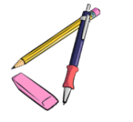
Choose five interesting adverbs (how they DO things) and write your own sentences. Make sure all your sentences are TRUE and tell us TRUE how you, your family and friends do things.
Write the adverbs into column 1, then write your sentences into column 2
Adverbs | My TRUE sentences

How did they do it?

How did they …

Think of things you or people around you did last week and write one true sentence with each of these adverbs. You can also write about your pets. Highlight the adverbs in your sentences.

happily | Elias smiled happily when Mr. Grasser praised him.
quietly
quickly
carefully
nervously
silently
politely
excitedly
patiently
impatiently
angrily
aggressively
noisily
loudly
sadly

Describing the setting and atmosphere

and talking about events that happened in a story.

Challenge:
1- Read the following mini-story. Where does the writer describe the setting and atmosphere?
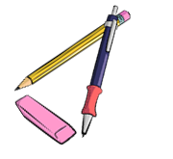
Where does the writer talk about events that happened that night. Use a red and a green color pencil and color the parts that describe events red and the setting and atmosphere passages green.
It was a cold night in October. The moon was shining but dark clouds were moving across the sky.
A storm was howling and the branches of the trees were moving in the wind.
Lots of leaves were flying through the air.
I was walking along the dark street and listened to the rustling of the leaves under my feet. I could hear an owl hooting and a dog was barking nearby.
Suddenly…
a cat rushed out of a side-street and stopped in front of me. It looked at me with burning green eyes and growled.
I screamed in shock and hid behind the nearest car.
My heart was pounding and I was really scared. I heard the cat moving around silently. It was still growling – not like a little housecat, but more like a tiger. The cat’s green eyes were shining in the dark.
The cat crossed the street and came towards me.
With each step it grew bigger and bigger and the growling got louder and louder.
That’s when I remembered the magic coin in my pocket. I took it out, held it up in the air towards the cat and hoped…
Yes, … it worked. The cat saw the shining coin,
froze – and then turned around and ran away.

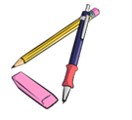
My rule:
When we describe the atmosphere and the background in a story,
we use the …………………………………………

When we talk about events and things that happen in the story,
we use the …………………………………………….

Now it’s your turn:
Write a similar mini story. Write about 5 sentences that describe the setting and atmosphere and about 5 sentences showing what happens in the story.


Ask your teacher to check your sentences. Then use your text to make a flip-flap story and record your story on Flipgrid.
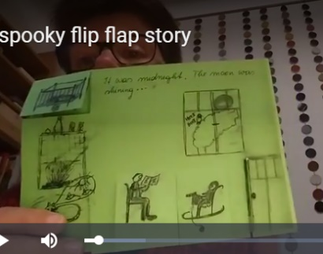


It was a ….

Suddenly…

New rules: Everything’s different now – relative pronouns

A lot of things have changed in Corona times. Many things are more difficult, but some things are quite nice. This is what students and teachers have said:
The subject that is most difficult right now is ………………………..
The thing that I like most about home-schooling, is sleeping in in the morning.

The video conferences that our teachers organize for us are very helpful.
The thing that I like least about home-schooling, is that I cannot see my friends.

The program that we use for our video meetings is called Zoom.
The thing that I miss most during the Corona crisis is………………………………….

The children who do not have a computer at home can borrow a tablet from school.
The students who work hard even during the crisis, will get really good grades at the end of the year.

The person who worries most about Corona is ……………………….. because…………

The people who have to work most during this crisis are doctors, nurses and people who work in supermarkets.

Challenge: Find the rule
We use who, when we talk about _______________________
We use that when we talk about _______________________


Your Turn:
Write true and meaningful sentences about yourself, your family and your friends.
Use WHO (5x) and THAT (5x)

New rules – modal verbs
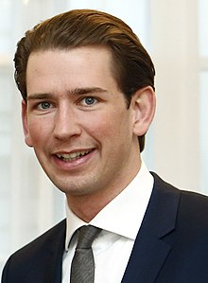
A lot of things have changed because of Covid-19.
We must try to stop the virus because it is very dangerous. So people should stay at home as much as possible. You are not allowed to leave you house unless you have to work or need to go shopping. If you go shopping, you have to wear a mask. It doesn’t have to be a medical mask, you can make one yourself. You don’t have to wear gloves, but it is a good idea.
You are allowed to go for a walk but you are not allowed to go to a playground.
You must keep your distance from people who do not live in your house and you mustn’t invite people to visit you. I know that this is hard. I had to spend Easter without my parents, too and if someone of my staff gets ill, I will have to stay in quarantine in the ministry.
You can come to school, but you shouldn’t. You have to take part in the online lessons.
I hope we will soon be able to go back to our normal lives and you will be allowed to meet your friends.

Challenge: Find the correct meaning
Read Kurz’s statement and find out what the words in bold mean. Write them into the correct box.
wir müssen (weil wir das wollen):  ___________________________ | du darfst nicht (2x)  __________________________  __________________________ | Leute sollen:  _________________________
du musst (weil es ein Gesetz ist):  __________________________ | du musst nicht (es ist kein Gesetz)  __________________________ | du solltest nicht:  __________________________
es muss nicht ...sein  __________________________ | ich musste:  ___________________________ | du kannst / du darfst:  __________________________
du musst/es ist notwendig, dass du:  _________________________ | ich werde ... müssen:  _________________________ | du wirst dürfen:  __________________________

Your turn:
Use these words to write sentences about the rules at home and in school.
Write 10 sentences – use a different verb in each sentence.
(I always have to …/ I don’t have… / Last week I had to… to count as three different verbs)

If things had been normal …

In March 2020 schools closed due to the Corona crisis. During the Easter break visits to friends and family were not allowed, all hotels were closed and you could not go to another country. All shops – except for food stores – were closed as well.
When the teachers meet after Easter, they talk about their holidays. Guess who is talking and write the names next to speech bubble.
I spent the holidays with my kids and my husband. If there had not been a Corona outbreak, the whole family would have met in the garden for a huge Easter celebration.

I spent the holidays with my wife and my daughter’s family. It was my granddaughter’s first Easter. If we had not had a Corona crisis, I would have gone to Italy in my camper.

I spent the holidays at home with my husband. It was not a lot of fun because there was a building site next to our house. If we had been allowed to travel, I would have flown to Greece.

I spent the holidays with my husband and my son Jakob. We stayed in our flat all the time. If we had not been afraid to get ill, we would have gone to the playground with Jakob!

My rule:
Look at the words in bold letters. If you talk about how things in the past
could have been different (but you cannot change them any more) you use:
If I _had + __________________, I would + _________+___________

Your turn:
What would you have done in the Easter holidays if there had not been a Corona outbreak?
What would your friends and family have done?
Write 5 sentences.

If they had given up easily, they wouldn’t be as famous today.

Who are these famous people who all failed miserably, but did not give up?
Match the life stories with the names.
Steve Jobs, Steven Spielberg, The tower of Pisa, Henry Ford, Thomas Edison, The Beatles, Walt Disney, Bill Gates, Michael Jordan, J K Rowling, Albert Einstein, Charly Chaplin

Then watch the video and check your answers. Be careful. Not all examples in the video have been used.
If he had given up after being fired from his basketball team, he would not have become the most famous basketball player of all times.
If they had stopped playing music with their band after several record labels told them that guitar music was not cool, they would not have become the most famous band of all times.
If he had given up drawing cartoons because nobody wanted to hire him as an artist, he would not have created the most famous cartoon figure in the world.
If he had given up his dream of building computers after dropping out of university, he would not have become one of the richest men on Earth.
If she had stopped writing because several publishers rejected (=did not want) her first book, she would not have become one of the most famous authors of children’s books and the second-richest female entertainer.
If he had listened to his teachers who told him that he “would never amount to much”, he would not have won the Nobel prize in physics.
If he had given up after being fired from three computer companies, he would not have become one of the richest men and the owner of one of the most famous industrial designers in the world.
If he had given up his dream after going bankrupt five times, he would not have become one of the most successful car producers of the USA.
If he had given up when his teachers told him that he was “too stupid to learn anything”, he would not have invented the light bulb.
If he had listened to the Hollywood studio chiefs, who said that his acts were too stupid and nonsensical, he would not have become one of the most famous English comic actors of all times.
If he had given up after being rejected from film-school, he would not have become one of the most famous film directors of our times.
If this tower wasn’t leaning to the side, it would certainly not be as famous.
https://www.youtube.com/watch?v=5cZh6tYVM2w

DURATION: How long have you...?
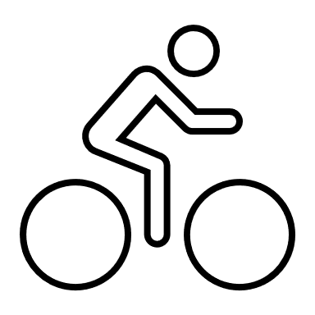


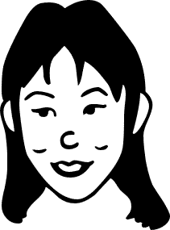
I’ve had my bike for five years.
I have known my friend Sally for 8 years.
I’ve had this T-shirt for ages.
Mrs. Pö has been an English teacher for more than 25 years.

Your turn: How long have you had ....?

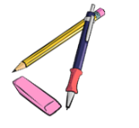
We are going to find the oldest items that you have brought to school today. Check your stuff in your schoolbag and in your lockers and choose the oldest item that you have with you today.
Write five true sentences about this item. Be prepared to present your old item.

I've had my____________________for ____________________________ years/months/days.
I've had my ____________________since ____________ last year//my birthday//May//June..//I was born…
Any other info about your item:

Old friends and relationships
How long have you all known each other? How long have you known your oldest friends.
Think of an old friend who is still around and complete the following sentences.


I've known this person for
I've often _____________________________________with___________________
We've often
I’ve never


My rule:
Duration (Dauer)
When we talk about how long we have had something, or how long we have been doing something we use the ……………………………………………... tense.
Do you remember?
We have used this tense before. Do you remember what we have used it for?
Check your personal grammar book, part 1.
For and Since

Work with a partner. Use all the phrases from the box to write true sentences about yourself and the people around.
since 2017… for three years… since September…. for more than xxx years… since Monday… for three days… for many years… since Christmas… for almost an hour… since 7.40

Example: I have been a student at Praxismittelschule since 20_ _.


Find a rule: Look at the above sentences again. When do we use for, when do we use since?
My rule:
We use for when …
We use since …

How long have you...
How well do you know your partner?

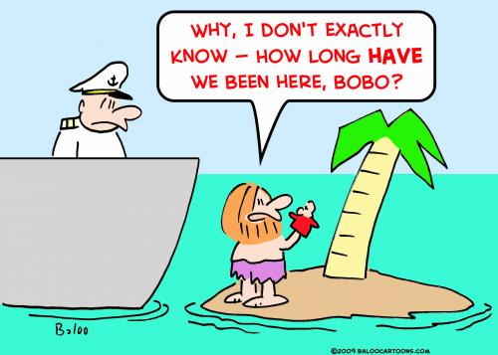
Work with a partner.
Step 1: Answer the questions below truthfully and guess your partner’s answers.
Step 2: Then talk to your partner to find out whether your guesses are correct.
Example:
Student A: “I think you have played the violin for three years, is that correct?”
Student B: “Yes, that’s right.” OR “No, I have only played it for one year.” OR “No, I do not play the violin, but I play the piano. I have played the piano for about 5 years.”
Now it’s your turn:
Question “How long have you…” | You | Your partner (guess!)
known your best friend?
lived in your house?
owned your pet?
practiced your favorite sport?
been at this school?
your grandparents been married?
played the guitar/piano/drums/…or any other instrument
have you had your favourite lucky charm?
have you had your computer?
known your neighbour?

Use your spiral notebook to write down your partner’s answers in full sentences. Always write two sentences. Look at the examples.
Examples:
Max lives in a blue house. He has lived in this house for 12 years.
Maria has a dog. She has had her dog for 2 years.
Tim plays soccer at SC-Andritz. He has played in this club for 3 years.

Fake News: Reporting unbelievable things that someone said

Flying penguins? Watch the BBC video. Watch the video
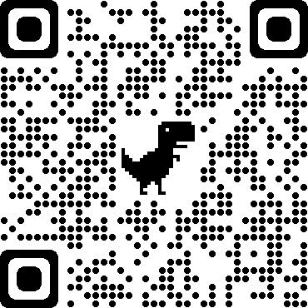
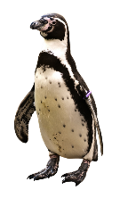
This is what the explorer said This is what Tom told his friends

I saw a cool video on youtube the other day. It was about penguins that can fly!
It was a BBC documentary but it can’t be true! The reporter said that they had recently discovered a colony of penguins that was unlike any other. He claimed that they could fly and actually flew south every winter and spent the cold season in warmer regions.
He showed the video and you could see the penguins flying! He said that they didn’t need to huddle together to keep warm because they could fly to the South.

“This recently discovered colony of penguins is unlike any other.”

“These little fellas can do something no other penguins can.”

“They fly thousands of miles to the rainforests of South America where they spend the winter basking in the tropical sun.”

“They don’t need to huddle together every winter for protection against the bitter cold.”
They didn’t need to huddle together every winter for protection against the bitter cold.

Now it’s your turn:
STEP1: Look at the words in bold. What do you notice?

Then read what Maxi and his brother said about it.
Maxi is announcing some cool news | Robert is reporting fake news
 | 
“Wow, you won’t believe what they have discovered in Madagascar.  I saw a BBC video where an explorer showed some flying penguins. I didn’t know they can do that. I thought penguins were too heavy to fly, but the video really showed flying penguins. How amazing.  The explorer explained that they are unlike any other penguins in the world. They don’t spend the winter in the ice, and they don’t need to huddle together to protect themselves against the cold. They fly south to warmer countries, just like other birds. He said that they can fly thousands of miles and spend the winter in the tropical sun. Isn’t this amazing? I would really like to see these flying penguins myself.” | “Have you seen the BBC video about flying penguins? It went viral on all the social media. It showed an explorer in Madagascar and he said that he had discovered a colony of penguins that was unlike any other in the world. He said that these penguins didn’t spend the winter in the ice – huddling together against the cold, but that they could fly. He explained that these special penguins would fly to warmer regions and spend the winter there, just like other birds do. In the video you could see the penguins running and then starting to lift off. Then the video showed lots of black birds flying in the sky. At first it seemed very convincing – but then I noticed that it was published on April 1st. So, the whole thing is obviously a hoax. Of course, penguins do not fly.

What do you notice?
Both Maxi and his brother Robert are talking about the same video. Why are they using different tenses here?
Maxi uses the _____________________ because….
Robert uses the ___________________ because …

The Reporting Circle
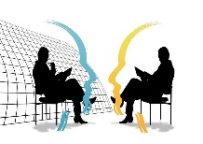
FAKE NEWS!
T E N S E
I don’t quite believe this.
I don’t trust this.
I don’t care. It’s just a fact.
TENSE
ME
HERE
NOW
WOW! This is interesting!
This is so real and so relevant for us….
yesterday, last week, five years ago, in 1875…
Thinking back to the interview


Let’s explain:
Announcing interesting news | Reporting fake information
Maxi is announcing cool news. He thinks this is great and wants to tell us about these cool animals.  Therefore, he is using the ……………………………….. tense. | Robart knows that penguins are too heavy to fly, and he does not believe that the information is correct. He thinks this is fake news.  Robart is reporting the news in the ………………….. tense.
In everyday situations we often use the present tense to talk about interesting news or facts that we have heard of or read.  We use the present tense, because these facts seem important and relevant to us now.  “I have some good news for you all. We will buy a new basketball hoop for the schoolyard.”  Mrs. Wagner said that we will get a new basketball hoop for our schoolyard.  Your Turn  What did the teachers actually say?  “We …  Our teacher told us that we are going to visit the Zotter chocolate factory next week.  Cool, isn’t it?  Mrs. Pö said that we can take part in the GOAL project and write our own online story books with our international friends.  Mrs. Bergmann promised that we will watch a film in the next lesson. | When we report fake news or things that are no longer true, we report these in the ………………….. tense.  We use the ……………………………tense to “push the information away from us” – that means – to show that we do not trust it.  The phrase he/she claimed that – also shows that we do not trust the information that we are reporting.  Your Turn  What did the people actually say?  Mary claimed that the Corona virus was a hoax and did not exist.  Trump announced that he would build a wall at the border to Mexico.  Mrs. Bergmann promised that we would watch a film but then we had to do a grammar exercise!

More examples of reporting fake news
Last week I met an old friend of mine and we got into a really weird conversation. Mark said that the Corona pandemic was a hoax and the Corona tests that we are doing in school were dangerous and they would infect us with harmful bacteria. He even said that the swabs would hurt our brains and that the masks were full of poisonous chemicals that would make us sick. He told me that Bill Gates was behind the whole Corona pandemic because he owned some big drug companies and wanted to make a huge profit.
I was really shocked that my friend Mark believes all these things. But then it got even worse. He actually claimed that our government had invented the whole Corona pandemic. He said that they just wanted to gain more power and take away our freedom to travel and move around freely.
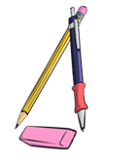
I tried to reassure him, but he didn’t want to hear my arguments. He told me to read the warnings on Facebook and Telegram and he promised to send me some links to shocking videos. Mark seemed really scared – I don’t know where he got all the fake news from.
What were Mark’s exact words?

He said: “I am sure that the Corona pandemic …………… a hoax. The tests that you ………… doing in school …………… really dangerous. They ……………………….. you with harmful bacteria.
The swabs …………………. your brains and the masks ………………….. full of poisonous chemicals. They …………………….really bad for you. And you know what, Bill Gates ………………… behind all of this. He …………………. some big drug companies, and he ……………………. a huge profit. Bill Gates …………….. behind all of this – I ……………. sure about it.
And you know it is not only Bill Gates. Our government ……………… behind it too. They have invented the whole Corona pandemic because they ………………. to gain more power and they ……………….. to take away our rights. They ……………….. to lock us in and close the borders.
I’ll send you some links so you can watch the shocking information yourself. You won’t believe it – it’s really scary what they are trying to do to us. “

Now it’s your turn.
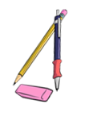
Here are a few examples of recent fake-news headlines. Report in 1 sentence what the articles or videos said.
Research Team taught Gorilla to Knit
The article said that ……………………………………………………………….. but ………………………………………………………..
Boy saw UFO over Vienna
The boy claimed that he ………………………………………………………….……. but …………………….……………………………
Facebook: The Corona Virus does not exist
I saw a comment on Facebook. The writer claimed that ………………..………………………………………..……….. but
………………………………………………………………………………………………………………………………………………………………..
Now add 3 more examples of fake news that you have come across.
__________________________________________________________________________________________
__________________________________________________________________________________________
__________________________________________________________________________________________
Let’s recap:

We report in the past tense (or the past perfect tense) to show that we are distancing ourselves from
fake news or information that we doubt (anzweifeln)
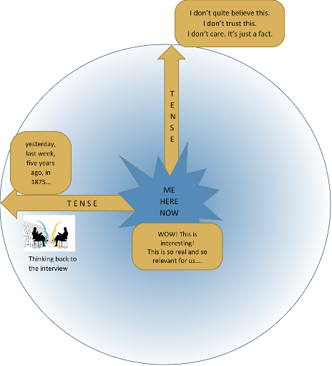
The phrase he/she claimed that – also shows that we do not trust
the information that we are reporting.

“Bill Gates is behind the pandemic.” He claimed that Bill Gates was behind the pandemic.
“The masks are poisonous.” He said that the masks were poisonous.
“I have discovered flying penguins.” The explorer explained that he had discovered flying penguins.

But, we can use the present tense to announce important, interesting or relevant information that we have heard or read.
Our teachers promised that we will soon get a new basketball hoop for our schoolyard.
Mom told us that she is going to have another baby. I am so excited.

Reporting neutral information that someone said in the past –

thinking back to the conversation
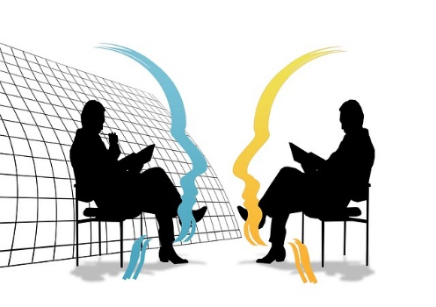

Yesterday I met the new Math teacher during the big break.

Hello, are you the new Math teacher?  Yes, it’s my first day here at your school.  Where did you teach before?  The last 3 years I taught at a school in Vienna,  and before that I taught at a school in Salzburg.  Why did you come to Graz?  I decided to move to Graz because my wife got a good job here and my parents live here as well.  Do you also teach any other subjects?  Yes, I also teach Geography, but I prefer Math. | We had a little chat. He seems quite nice.  He told me that it was his first day here at our school.  He said that he (had) taught in Vienna before and before that he had taught at a school in Salzburg.  When I asked him why he came to Graz he told me that his wife got a good job here and that his parents lived here as well.  He is also a Geography teacher, but he told me that he liked teaching Math more. That’s strange. Math is much more difficult than Geography.

Let’s recap:
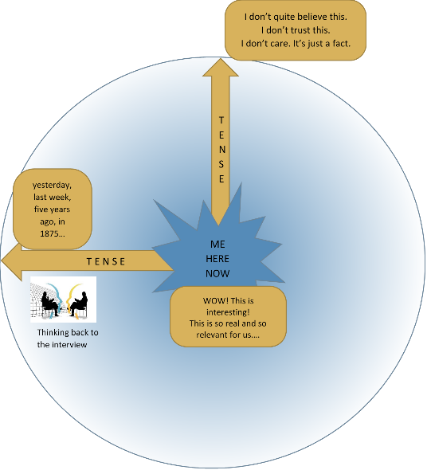
We report in the past tense (or the past perfect tense) to show that we are thinking about the past and reporting what other people said in that situation.

- neutral facts that someone else said in the past
- a situation that is past and no longer true

In last week’s interview, the actress said that she was working on a new film.
Last night the minister of education said in the news that all students would get free laptop computers.
I knew she would not show up for the date. She is too shy.
He promised he would come to the party and bring some food, but he didn’t even show up.
In the Middle Ages they believed that the Earth was flat.
Your Turn
What did they actually say?
“I …

She said she could speak five languages.

The reporter asked the actress if she had ever played in a movie with Daniel Radcliffe.

The witness said that he was looking (or had been looking) out of his window when the accident happened. He told the police that he saw (or had seen) the red car racing down the street.

Sokrates said he could not teach anybody anything. He could only make them think.

Einstein said that he had no special talent. He was only passionately curious.

Churchill said the best argument against democracy was a five-minute conversation with the average voter..

Reporting – what do YOU want to express?

How would you say this? Tick your preferred sentence.
Mrs. Pö said that we could take part in the GOAL project and write our own online storybooks with our international friends.
Mrs. Pö said that we can take part in the GOAL project and write our own online storybooks with our international friends.
Explain your choice
___________________________________________________________________________________________
Mrs. Bergmann told us that she had a cat.
Mrs. Bergmann told us that she has a cat.
Explain your choice
___________________________________________________________________________________________
Mr Grasser said that math in my new school would be easy for me.
Mr Grasser said that math in my new school will be easy for me.
Explain your choice
___________________________________________________________________________________________
Ms Bergmann mentioned that the BBC produced a hoax every year for April 1st.
Ms Bergmann mentioned that BBC produces a hoax every year for April 1st.
Explain your choice
___________________________________________________________________________________________
Ms Walch said we will not get our report cards if we don’t return all the books to the library.
Ms Walch said we would not get our report cards if we didn’t return all the books to the library.
Explain your choice
___________________________________________________________________________________________
Ms Dauphin said she would phone my parents and tell them that I skipped school.
Ms Dauphin said she will phone my parents and tell them that I skipped school.

Explain your choice
___________________________________________________________________________________________
Ms Pö said she would phone my parents and tell them that I skipped school.
Ms Pö said she will phone my parents and tell them that I skipped school.
Explain your choice
___________________________________________________________________________________________

Reporting what someone asked me to do

So much to do! This is what This is what you tell your friend
Ms Bergmann told us last week
Last Monday, our teacher was quite strict. She told us to hand in our vocab books on Monday and to show our tests to our parents. She also told us to complete the text and to bring it to class the next day.
Don’t forget to hand in your vocab books tomorrow and show your test to your parents. Complete the text at home and bring it to class tomorrow.
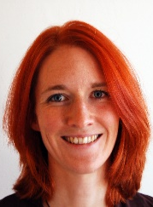

If everybody finishes their project by Friday, I will show you a film in the next lesson.
Friday,
Then she promised to show us a film.

She asked us to bring some cookies and popcorn.
Can you bring some cookies and popcorn, so that we have a real cinema experience.
Friday,

Your turn:
Now find your own examples. Report what your teachers, parents, friends, brothers and sisters asked you to do and told you to do last week?
________________________________________________________________________________________
________________________________________________________________________________________
________________________________________________________________________________________
________________________________________________________________________________________
________________________________________________________________________________________
________________________________________________________________________________________
________________________________________________________________________________________
________________________________________________________________________________________

Reporting Questions

Nosy parents! You spent the weekend This is what you tell your
with a friend. Your parents want to know friend
everything!
My mother wanted to know everything!
She asked me if we went to the park.
She wanted to know if we had a picknick.
She asked me if we drank alcohol!
She wanted to know if we met other friends.


Did you go to the park?
Did you have a picknick?
Did you drink alcohol?
Did you meet other friends?

Where did you go afterward.
When did you come home?
Why are your clothes dirty?
What did you do all day?
My father asked me where we went afterwards.
He wanted to know when I came home.
He wanted to know why my clothes were dirty.
He asked me what we did all day.
HE


Your turn:
Now find your own examples. What did teachers, parents, friends, brothers and sisters ask you last week?

________________________________________________________________________________________
________________________________________________________________________________________
________________________________________________________________________________________
________________________________________________________________________________________
________________________________________________________________________________________
________________________________________________________________________________________
________________________________________________________________________________________
________________________________________________________________________________________

