Flexi English
by Elisabeth Pölzleitner
and
Laura Bergmann

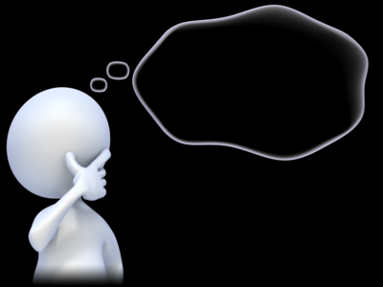
My Personal Grammar Book
Part 2
for all the important grammar rules

Name: …………………………………………………..

This is your personal grammar book for Flexi 3 and 4. You can always use it to look up how the English language works.
Therefore, ALL the language in this book MUST be correct.
Always write your answers in pencil or use an erasable pen.
Then ask a teacher to check your answers and correct them carefully.

Das ist dein persönliches Grammatikbuch für Flexi 3 und 4. Du kannst immer nachschlagen wenn du Fragen bezüglich der englischen Grammatik hast.
Aus diesem Grund muss hier alles GANZ RICHTIG sein. Schreibe deine Antworten immer mit Bleistift oder löschbarem Stift.
Bitte deine Lehrer deine Sätze zu überprüfen und korrigiere sie dann sorgfältig.

Table of Contents
Colorful and detailed descriptions 4
Describing people and things: What are they like? 5
Describing how people do things 6
How did they do it? 7
Describing the setting and atmosphere 8
and talking about events that happened in a story. 8
New rules: Everything’s different now – relative pronouns 10
New rules – modal verbs 11
If things had been normal … 12
If they had given up easily, they wouldn’t be as famous today. 13
DURATION: How long have you...? 15
Reporting fake news………………………………………………………………………………………………………………………………….18

Colorful and detailed descriptions

Challenge
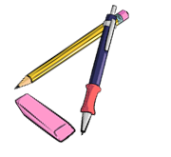
Use your vocabulary cards from this module and sort them into two groups.
Ask your teacher to check your cards, then write the sentences into the correct boxes below.
Group A: What people and things are like:

My Rule:
When we describe what something or someone is like we use ………………………………………………

Group B: How we DO things.

My Rule:
When we describe how we do things, we use ………………………………………………………………

Describing people and things: What are they like?

Read the following text about Willy the Vampire and underline all the adjectives.
ADJECTIVES describe WHAT THINGS ARE LIKE. The first ones have been done for you:
Willy the Vampire
When I went to elementary school, I had a classmate who was a bit strange. He was very small and thin, and his skin was very pale. He had short, light-blond hair and very long fingers and toes. Willy always sat in the last row. He seemed very tired and shy.
Willy was a good student. His math grades were always excellent, and he was a talented storyteller. He always got As for his stories in German. Willy liked to draw and paint, and we all liked his pictures. Our teacher often hung his pictures up in the hallways because they were so special.
Willy lived far from the school at the edge of our town. He lived in a large, very old house with his family. They were all as pale as Willy and they were all very shy.
There were lots of wild rumors about Willy and his family. Many people said that they had seen them walking the streets in the middle of the night. Others said that they had heard strange, howling noises in their house at full moon.
We never dared to ask Willy about these rumors, but even if he was a vampire, he was a nice and friendly classmate and he did not do any harm to anybody.

Now it’s your turn

Choose five interesting adjectives and write your own sentences with them. Make sure all your sentences are TRUE and tell us TRUE things about yourself, your family and friends.
Write the adjectives into column 1, then write your sentences into column 2
Adjectives | My TRUE sentences

Describing how people do things

Now read the text about Willy again. Some parts have been changed or added.
Use a new color and highlight all the words and phrases that show us HOW people DO things.
Example: How did Willy speak? He spoke very quietly.

Willy the Vampire
When I went to elementary school, I had a classmate who was a bit strange. He was very small and thin, and his skin was very pale. He had short, light-blond hair and very long fingers and toes. Willy always sat in the last row. He seemed very tired and shy.
When Willy spoke, he did it very quietly. He always looked around shyly and nervously and watched very carefully what his classmates were doing. In the breaks Willy quietly sat in a corner and read a book, while the other students were running around wildly and shouting loudly at each other.
Willy was a good student. He worked very carefully in all subjects and did very well on all tests. In German he loved to write stories and spent a lot of time planning them very carefully. Willy could draw and paint really well.
Willy lived far from the school at the edge of our town. He lived in a large, very old house with his family. They were all as pale as Willy and they were all very shy.
There were lots of wild rumors about Willy and his family. Many people said that they had seen them walking secretly in the streets in the middle of the night. Others said that they had heard the family howl loudly at the full moon, others had heard them whisper silently in the graveyard.
We never dared to ask Willy about these rumors, but even if he was a vampire, he was a nice and friendly classmate and he did not do any harm to anybody.
Now it’s your turn

Choose five interesting adverbs (how they DO things) and write your own sentences. Make sure all your sentences are TRUE and tell us TRUE how you, your family and friends do things.
Write the adverbs into column 1, then write your sentences into column 2
Adverbs | My TRUE sentences

How did they do it?

How did they …

Think of things you or people around you did last week and write one true sentence with each of these adverbs. You can also write about your pets. Highlight the adverbs in your sentences.

happily | Elias smiled happily when Mr. Grasser praised him.
quietly
quickly
carefully
nervously
silently
politely
excitedly
patiently
impatiently
angrily
aggressively
noisily
loudly
sadly

Describing the setting and atmosphere

and talking about events that happened in a story.

Challenge:
1- Read the following mini-story. Where does the writer describe the setting and atmosphere?
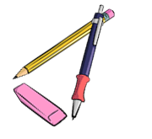
Where does the writer talk about events that happened that night. Use a red and a green color pencil and color the parts that describe events red and the setting and atmosphere passages green.
It was a cold night in October. The moon was shining but dark clouds were moving across the sky.
A storm was howling and the branches of the trees were moving in the wind.
Lots of leaves were flying through the air.
I was walking along the dark street and listened to the rustling of the leaves under my feet. I could hear an owl hooting and a dog was barking nearby.
Suddenly…
a cat rushed out of a side-street and stopped in front of me. It looked at me with burning green eyes and growled.
I screamed in shock and hid behind the nearest car.
My heart was pounding and I was really scared. I heard the cat moving around silently. It was still growling – not like a little housecat, but more like a tiger. The cat’s green eyes were shining in the dark.
The cat crossed the street and came towards me.
With each step it grew bigger and bigger and the growling got louder and louder.
That’s when I remembered the magic coin in my pocket. I took it out, held it up in the air towards the cat and hoped…
Yes, … it worked. The cat saw the shining coin,
froze – and then turned around and ran away.


My rule:
When we describe the atmosphere and the background in a story,
we use the …………………………………………

When we talk about events and things that happen in the story,
we use the …………………………………………….

Now it’s your turn:
Write a similar mini story. Write about 5 sentences that describe the setting and atmosphere and about 5 sentences showing what happens in the story.


Ask your teacher to check your sentences. Then use your text to make a flip-flap story and record your story on Flipgrid.
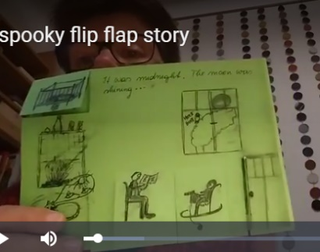


It was a ….

Suddenly…

New rules: Everything’s different now – relative pronouns

A lot of things have changed in Corona times. Many things are more difficult, but some things are quite nice. This is what students and teachers have said:
The subject that is most difficult right now is ………………………..
The thing that I like most about home-schooling, is sleeping in in the morning.

The video conferences that our teachers organize for us are very helpful.
The thing that I like least about home-schooling, is that I cannot see my friends.

The program that we use for our video meetings is called Zoom.
The thing that I miss most during the Corona crisis is………………………………….

The children who do not have a computer at home can borrow a tablet from school.
The students who work hard even during the crisis, will get really good grades at the end of the year.

The person who worries most about Corona is ……………………….. because…………

The people who have to work most during this crisis are doctors, nurses and people who work in supermarkets.

Challenge: Find the rule
We use who, when we talk about _______________________
We use that when we talk about _______________________


Your Turn:
Write true and meaningful sentences about yourself, your family and your friends.
Use WHO (5x) and THAT (5x)


New rules – modal verbs
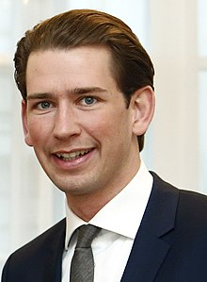
A lot of things have changed because of Covid-19.
We must try to stop the virus because it is very dangerous. So people should stay at home as much as possible. You are not allowed to leave you house unless you have to work or need to go shopping. If you go shopping, you have to wear a mask. It doesn’t have to be a medical mask, you can make one yourself. You don’t have to wear gloves, but it is a good idea.
You are allowed to go for a walk but you are not allowed to go to a playground.
You must keep your distance from people who do not live in your house and you mustn’t invite people to visit you. I know that this is hard. I had to spend Easter without my parents, too and if someone of my staff gets ill, I will have to stay in quarantine in the ministry.
You can come to school, but you shouldn’t. You have to take part in the online lessons.
I hope we will soon be able to go back to our normal lives and you will be allowed to meet your friends.

Challenge: Find the correct meaning
Read Kurz’s statement and find out what the words in bold mean. Write them into the correct box.
wir müssen (weil wir das wollen):  ___________________________ | du darfst nicht (2x)  __________________________  __________________________ | Leute sollen:  _________________________
du musst (weil es ein Gesetz ist):  __________________________ | du musst nicht (es ist kein Gesetz)  __________________________ | du solltest nicht:  __________________________
es muss nicht ...sein  __________________________ | ich musste:  ___________________________ | du kannst / du darfst:  __________________________
du musst/es ist notwendig, dass du:  _________________________ | ich werde ... müssen:  _________________________ | du wirst dürfen:  __________________________

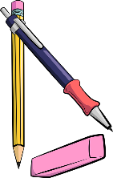
Your turn:
Use these words to write sentences about the rules at home and in school.
Write 10 sentences – use a different verb in each sentence.
(I always have to …/ I don’t have… / Last week I had to… to count as three different verbs)

If things had been normal …

In March 2020 schools closed due to the Corona crisis. During the Easter break visits to friends and family were not allowed, all hotels were closed and you could not go to another country. All shops – except for food stores – were closed as well.
When the teachers meet after Easter, they talk about their holidays. Guess who is talking and write the names next to speech bubble.
I spent the holidays with my kids and my husband. If there had not been a Corona outbreak, the whole family would have met in the garden for a huge Easter celebration.

I spent the holidays with my wife and my daughter’s family. It was my granddaughter’s first Easter. If we had not had a Corona crisis, I would have gone to Italy in my camper.

I spent the holidays at home with my husband. It was not a lot of fun because there was a building site next to our house. If we had been allowed to travel, I would have flown to Greece.

I spent the holidays with my husband and my son Jakob. We stayed in our flat all the time. If we had not been afraid to get ill, we would have gone to the playground with Jakob!

My rule:
Look at the words in bold letters. If you talk about how things in the past
could have been different (but you cannot change them any more) you use:
If I _had + __________________, I would + _________+___________

Your turn:
What would you have done in the Easter holidays if there had not been a Corona outbreak?
What would your friends and family have done?
Write 5 sentences.

If they had given up easily, they wouldn’t be as famous today.

Who are these famous people who all failed miserably, but did not give up?
Match the life stories with the names.
Steve Jobs, Steven Spielberg, The tower of Pisa, Henry Ford, Thomas Edison, The Beatles, Walt Disney, Bill Gates, Michael Jordan, J K Rowling, Albert Einstein, Charly Chaplin

Then watch the video and check your answers. Be careful. Not all examples in the video have been used.
If he had given up after being fired from his basketball team, he would not have become the most famous basketball player of all times.
If they had stopped playing music with their band after several record labels told them that guitar music was not cool, they would not have become the most famous band of all times.
If he had given up drawing cartoons because nobody wanted to hire him as an artist, he would not have created the most famous cartoon figure in the world.
If he had given up his dream of building computers after dropping out of university, he would not have become one of the richest men on Earth.
If she had stopped writing because several publishers rejected (=did not want) her first book, she would not have become one of the most famous authors of children’s books and the second-richest female entertainer.
If he had listened to his teachers who told him that he “would never amount to much”, he would not have won the Nobel prize in physics.
If he had given up after being fired from three computer companies, he would not have become one of the richest men and the owner of one of the most famous industrial designers in the world.
If he had given up his dream after going bankrupt five times, he would not have become one of the most successful car producers of the USA.
If he had given up when his teachers told him that he was “too stupid to learn anything”, he would not have invented the light bulb.
If he had listened to the Hollywood studio chiefs, who said that his acts were too stupid and nonsensical, he would not have become one of the most famous English comic actors of all times.
If he had given up after being rejected from film-school, he would not have become one of the most famous film directors of our times.
If this tower wasn’t leaning to the side, it would certainly not be as famous.

https://www.youtube.com/watch?v=5cZh6tYVM2w

Solutions:
If he had given up after being fired from his basketball team, he would not have become the most famous basketball player of all times. | Michael Jordan
If they had stopped playing music with their band after several record labels told them that guitar music was not cool, they would not have become the most famous band of all times. | The Beatles
If he had given up drawing cartoons because nobody wanted to hire him as an artist, he would not have created the most famous cartoon figure in the world. | Walt Disney
If he had given up his dream of building computers after dropping out of university, he would not have become one of the richest men on Earth. | Bill Gates
If she had stopped writing because several publishers rejected (=did not want) her first book, she would not have become one of the most famous authors of children’s books and the second-richest female entertainer. | J K Rowling
If he had listened to his teachers who told him that he “would never amount to much”, he would not have won the Nobel prize in physics. | Albert Einstein
If he had given up after being fired from three computer companies, he would not have become one of the richest men and the owner of one of the most famous industrial designers in the world. | Steve Jobs
If he had given up his dream after going bankrupt five times, he would not have become one of the most successful car producers of the USA. | Henry Ford
If he had given up when his teachers told him that he was “too stupid to learn anything”, he would not have invented the light bulb. | Thomas Edison
If he had listened to the Hollywood studio chiefs, who said that his acts were too stupid and nonsensical, he would not have become one of the most famous English comic actors of all times. | Charlie Chaplin
If he had given up after being rejected from film-school, he would not have become one of the most famous film directors of our times. | Steven Spielberg
If this tower wasn’t leaning to the side, it would certainly not be as famous. | The tower of Pisa

DURATION: How long have you...?
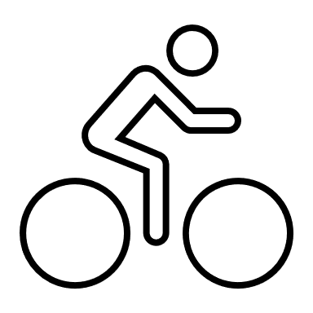


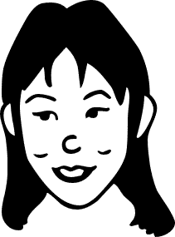
I’ve had my bike for five years.
I have known my friend Sally for 8 years.
I’ve had this T-shirt for ages.
Mrs. Pö has been an English teacher for more than 25 years.

Your turn: How long have you had ....?

We are going to find the oldest items that you have brought to school today. Check your stuff in your schoolbag and in your lockers and choose the oldest item that you have with you today.

Write five true sentences about this item.
Be prepared to present your old item.

I've had my____________________for ____________________________years/months/days.
I've had my ____________________since ____________ last year//my birthday//May//June..//I was born…
Any other info about your item:

Old friends and relationships
How long have you all known each other? How long have you known your oldest friends.
Think of an old friend who is still around and complete the following sentences.


I've known this person for
I've often _____________________________________with___________________
We've often
I’ve never


My rule:
Do you remember?
We have used this tense before. Do you remember what we have used it for?
Check your personal grammar book, part 1.
Duration (Dauer)
When we talk about how long we have had something, or how long we have been doing something we use the ……………………………………………... tense.

For and Since

Work with a partner. Use all the phrases from the box to write true sentences about yourself and the people around.
since 2017… for three years… since September…. for more than xxx years… since Monday… for three days… for many years… since Christmas… for almost an hour… since 7.40

Example: I have been a student at Praxismittelschule since 2017.


Find a rule: Look at the above sentences again. When do we use for, when do we use since?
My rule:
We use for when …
We use since …

“How long have you...”
How well do you know your partner?

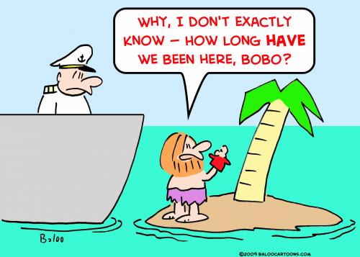
Work with a partner.
Step 1: Answer the questions below truthfully and guess your partner’s answers.
Step 2: Then talk to your partner to find out whether your guesses are correct.
Example:
Student A: “I think you have played the violin for three years, is that correct?”
Student B: “Yes, that’s right.” OR “No, I have only played it for one year.” OR “No, I do not play the violin, but I play the piano. I have played the piano for about 5 years.”
Now it’s your turn:
Question “How long have you…” | You | Your partner (guess!)
known your best friend?
lived in your house?
owned your pet?
practiced your favorite sport?
been at this school?
your grandparents been married?
played the guitar/piano/drums/…or any other instrument
have you had your favourite lucky charm?
have you had your computer?
known your neighbour?

Use your spiral notebook to write down your partner’s answers in full sentences. Always write two sentences. Look at the examples.
Examples:
Max lives in a blue house. He has lived in this house for 12 years.
Maria has a dog. She has had her dog for 2 years.
Tim plays soccer at SC-Andritz. He has played in this club for 3 years.

Fake News: Reporting unbelievable things that someone said

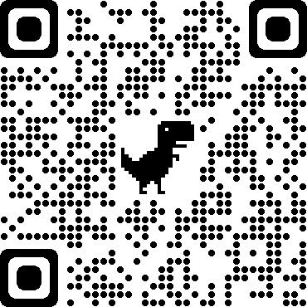
Flying penguins? Watch the BBC video. Watch the video
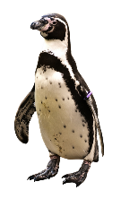
This is what the explorer said This is what Tom told his friends

“This recently discovered colony of penguins is unlike any other.”

I saw a cool video on youtube the other day. It was about penguins that can fly!
It was a BBC documentary but it can’t be true! The reporter said that they had recently discovered a colony of penguins that was unlike any other. He claimed that they could fly and actually flew south every winter and spent the cold season in warmer regions.
He showed the video and you could see the penguins flying! He said that they didn’t need to huddle together to keep warm because they could fly to the South.

“These little fellas can do something no other penguins can.”

“They fly thousands of miles to the rainforests of South America where they spend the winter basking in the tropical sun.”

“They don’t need to huddle together every winter for protection against the bitter cold.”
They didn’t need to huddle together every winter for protection against the bitter cold.

Now it’s your turn:
STEP1: Look at the words in bold. What do you notice?

Then read what Maxi and his brother said about it.
Maxi is announcing some cool news | Robert is reporting fake news
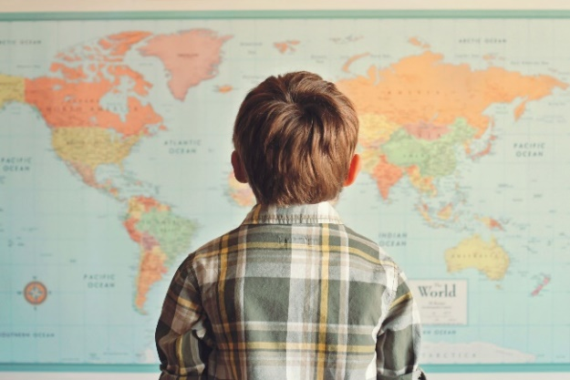 | 
“Wow, you won’t believe what they have discovered in Madagascar.  I saw a BBC video where an explorer showed some flying penguins. I didn’t know they can do that. I thought penguins were too heavy to fly, but the video really showed flying penguins. How amazing.  The explorer explained that they are unlike any other penguins in the world. They don’t spend the winter in the ice, and they don’t need to huddle together to protect themselves against the cold. They fly south to warmer countries, just like other birds. He said that they can fly thousands of miles and spend the winter in the tropical sun. Isn’t this amazing? I would really like to see these flying penguins myself.” | “Have you seen the BBC video about flying penguins? It went viral on all the social media. It showed an explorer in Madagascar and he said that he had discovered a colony of penguins that was unlike any other in the world. He said that these penguins didn’t spend the winter in the ice – huddling together against the cold, but that they could fly. He explained that these special penguins would fly to warmer regions and spend the winter there, just like other birds do. In the video you could see the penguins running and then starting to lift off. Then the video showed lots of black birds flying in the sky. At first it seemed very convincing – but then I noticed that it was published on April 1st. So, the whole thing is obviously a hoax. Of course, penguins do not fly.

What do you notice?
Both Maxi and his brother Robert are talking about the same video. Why are they using different tenses here?
Maxi uses the _____________________ because….
Robert uses the ___________________ because …

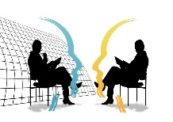
The Reporting Circle
T E N S E
I don’t quite believe this.
I don’t trust this.
I don’t care. It’s just a fact.
TENSE
ME
HERE
NOW
WOW! This is interesting!
This is so real and so relevant for us….
yesterday, last week, five years ago, in 1875…
Thinking back to the interview
FAKE NEWS!


Let’s explain:
Announcing interesting news | Reporting fake information
Maxi is announcing cool news. He thinks this is great and wants to tell us about these cool animals.  Therefore, he is using the ……………………………….. tense. | Robart knows that penguins are too heavy to fly, and he does not believe that the information is correct. He thinks this is fake news.  Robart is reporting the news in the ………………….. tense.
In everyday situations we often use the present tense to talk about interesting news or facts that we have heard of or read.  We use the present tense, because these facts seem important and relevant to us now.  “I have some good news for you all. We will buy a new basketball hoop for the schoolyard.”  Mrs. Wagner said that we will get a new basketball hoop for our schoolyard.  Your Turn  What did the teachers actually say?  “We …  Our teacher told us that we are going to visit the Zotter chocolate factory next week.  Cool, isn’t it?  Mrs. Pö said that we can take part in the GOAL project and write our own online story books with our international friends.  Mrs. Bergmann promised that we will watch a film in the next lesson. | When we report fake news or things that are no longer true, we report these in the ………………….. tense.  We use the ……………………………tense to “push the information away from us” – that means – to show that we do not trust it.  The phrase he/she claimed that – also shows that we do not trust the information that we are reporting.  Your Turn  What did the people actually say?  Some people claimed that the Corona virus was a hoax and did not exist.  Trump announced that he would build a wall at the border to Mexico.  Mrs. Bergmann promised that we would watch a film but then we had to do a grammar exercise!

More examples of reporting fake news
Last week I met an old friend of mine and we got into a really weird conversation. Mark said that the Corona pandemic was a hoax and the Corona tests that we are doing in school were dangerous and they would infect us with harmful bacteria. He even said that the swabs would hurt our brains and that the masks were full of poisonous chemicals that would make us sick. He told me that Bill Gates was behind the whole Corona pandemic because he owned some big drug companies and wanted to make a huge profit.
I was really shocked that my friend Mark believes all these things. But then it got even worse. He actually claimed that our government had invented the whole Corona pandemic. He said that they just wanted to gain more power and take away our freedom to travel and move around freely.
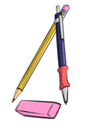
I tried to reassure him, but he didn’t want to hear my arguments. He told me to read the warnings on Facebook and Telegram and he promised to send me some links to shocking videos. Mark seemed really scared – I don’t know where he got all the fake news from.
What were Mark’s exact words?
He said: “I am sure that the Corona pandemic …………… a hoax. The tests that you ………… doing in school …………… really dangerous. They ……………………….. you with harmful bacteria.
The swabs …………………. your brains and the masks ………………….. full of poisonous chemicals. They …………………….really bad for you. And you know what, Bill Gates ………………… behind all of this. He …………………. some big drug companies, and he ……………………. a huge profit. Bill Gates …………….. behind all of this – I ……………. sure about it.
And you know it is not only Bill Gates. Our government ……………… behind it too. They have invented the whole Corona pandemic because they ………………. to gain more power and they ……………….. to take away our rights. They ……………….. to lock us in and close the borders.
I’ll send you some links so you can watch the shocking information yourself. You won’t believe it – it’s really scary what they are trying to do to us. “

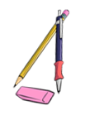
Now it’s your turn.
Here are a few examples of recent fake-news headlines. Report in 1 sentence what the articles or videos said.
Research Team taught Gorilla to Knit
The article said that ……………………………………………………………….. but ………………………………………………………..
Boy saw UFO over Vienna
The boy claimed that he ………………………………………………………….……. but ……………………………………………………….
Facebook: The Corona Virus does not exist
I saw a comment on Facebook. The writer claimed that ………………………………………………………..……….. but
……………………………………………………………………………………………………………………………………………………………..
Now add 3 more examples of fake news that you have come across.
______________________________________________________________________
______________________________________________________________________
______________________________________________________________________
Let’s recap:
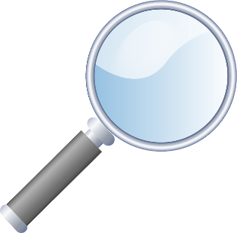
We report in the past tense (or the past perfect tense) to show that we are distancing ourselves from
fake news or information that we doubt (anzweifeln)
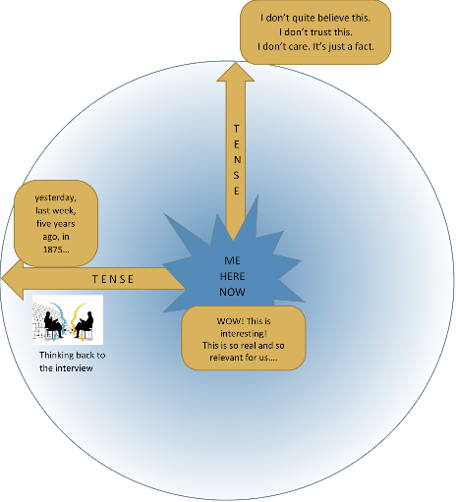
The phrase he/she claimed that – also shows that we do not trust
the information that we are reporting.

“Bill Gates is behind the pandemic.” He claimed that Bill Gates was behind the pandemic.
“The masks are poisonous.” He said that the masks were poisonous.
“I have discovered flying penguins.” The explorer explained that he had discovered flying penguins.

But, we can use the present tense to announce important, interesting or relevant information that we have heard or read.
Our teachers promised that we will soon get a new basketball hoop for our schoolyard.
Mom told us that she is going to have another baby. I am so excited.

Reporting neutral information that someone said in the past –

thinking back to the conversation
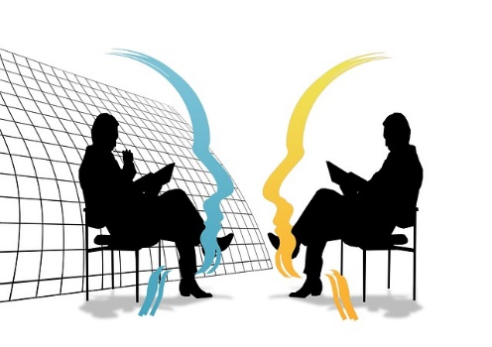

Yesterday I met the new Math teacher during the big break.

Hello, are you the new Math teacher?  Yes, it’s my first day here at your school.  Where did you teach before?  The last 3 years I taught at a school in Vienna,  and before that I taught at a school in Salzburg.  Why did you come to Graz?  I decided to move to Graz because my wife got a good job here and my parents live here as well.  Do you also teach any other subjects?  Yes, I also teach Geography, but I prefer Math. | We had a little chat. He seems quite nice.  He told me that it was his first day here at our school.  He said that he had taught in Vienna before and before that he had taught at a school in Salzburg.  When I asked him why he came to Graz he told me that his wife got a good job here and that his parents lived here as well.  He is also a Geography teacher, but he told me that he liked teaching Math more. That’s strange. Math is much more difficult than Geography.

Let’s recap:
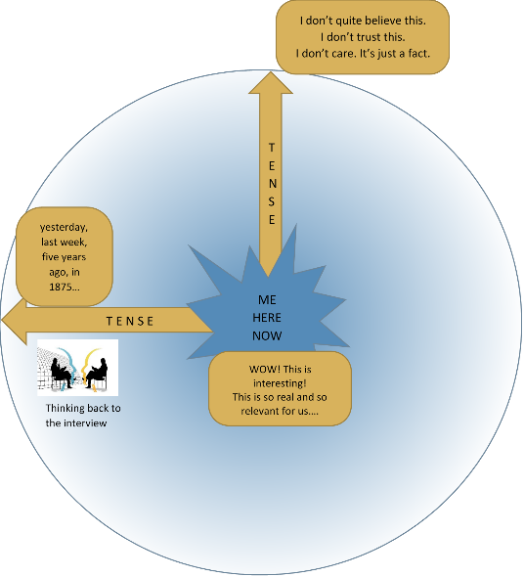
We report in the past tense (or the past perfect tense) to show that we are thinking about the past and reporting what other people said in that situation.

- neutral facts that someone else said in the past
- a situation that is past and no longer true

In last week’s interview, the actress said that she was working on a new film.
Last night the minister of education said in the news that all students would get free laptop computers.
I knew she would not show up for the date. She is too shy.
He promised he would come to the party and bring some food, but he didn’t even show up.
In the Middle Ages they believed that the Earth was flat.

Your Turn
What did they actually say?
“I …

She said she could speak five languages.

The reporter asked the actress if she had ever played in a movie with Daniel Radcliffe.

The witness said that he was looking (or had been looking) out of his window when the accident happened. He told the police that he saw (or had seen) the red car racing down the street.

Sokrates said he could not teach anybody anything. He could only make them think.

Einstein said that he had no special talent. He was only passionately curious.

Churchill said the best argument against democracy was a five-minute conversation with the average voter..

Reporting – what do YOU want to express?

How would you say this? Tick your preferred sentence.
Mrs. Pö said that we could take part in the GOAL project and write our own online storybooks with our international friends.
Mrs. Pö said that we can take part in the GOAL project and write our own online storybooks with our international friends.
Explain your choice
___________________________________________________________________________________________
Mrs. Bergmann told us that she had a cat.
Mrs. Bergmann told us that she has a cat.
Explain your choice
___________________________________________________________________________________________
Mr Grasser said that maths in my new school would be easy for me.
Mr Grasser said that maths in my new school will be easy for me.
Explain your choice
___________________________________________________________________________________________
Ms Bergmann mentioned that the BBC produced a hoax every year for April 1st.
Ms Bergmann mentioned that BBC produces a hoax every year for April 1st.
Explain your choice
___________________________________________________________________________________________
Ms Walch said we will not get our report cards if we don’t return all the books to the library.
Ms Walch said we would not get our report cards if we didn’t return all the books to the library.
Explain your choice
___________________________________________________________________________________________
Ms Dauphin said she would phone my parents and tell them that I skipped school.
Ms Dauphin said she will phone my parents and tell them that I skipped school.

Explain your choice
___________________________________________________________________________________________
Ms Pö said she would phone my parents and tell them that I skipped school.
Ms Pö said she will phone my parents and tell them that I skipped school.
Explain your choice
___________________________________________________________________________________________

Reporting what someone asked me to do

So much to do! This is what This is what you tell your friend
Ms Bergmann told us last week
Last Monday, our teacher was quite strict. She told us to hand in our vocab books on Monday and to show our tests to our parents. She also told us to complete the text and bring it to class the next day.
Don’t forget to hand in your vocab books tomorrow and show your test to your parents. Complete the text at home and bring it to class tomorrow.
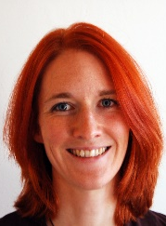

If everybody finishes their project by Friday, I will show you a film in the next lesson.
Friday,
Then she promised to show us a film.

She asked us to bring some cookies and popcorn.
Can you bring some cookies and popcorn, so that we have a real cinema experience.
Friday,

Your turn:
Now find your own examples. What did teachers, parents, friends, brothers and sisters ask you to do and tell you to do last week?
______________________________________________________________________
______________________________________________________________________
______________________________________________________________________
______________________________________________________________________
______________________________________________________________________
______________________________________________________________________
______________________________________________________________________
______________________________________________________________________

Reporting what someone asked me

Nosy parents! You spent the weekend This is what you tell your
with a friend. Your parents want to know friend
everything!
My mother wanted to know everything!
She asked me if we went to the park.
She wanted to know if we had a picknick.
She asked me if we drank alcohol!
She wanted to know if we met other friends.


Did you go to the park?
Did you have a picknick?
Did you drink alcohol?
Did you meet other friends?

Where did you go afterward.
When did you come home?
Why are your clothes dirty?
What did you do all day?
My father asked me where we went afterwards.
He wanted to know when I came home.
He wanted to know why my clothes were dirty.
He asked me what we did all day.
HE


Your turn:
Now find your own examples. What did teachers, parents, friends, brothers and sisters ask you last week?
______________________________________________________________________
______________________________________________________________________
______________________________________________________________________
______________________________________________________________________
______________________________________________________________________
______________________________________________________________________
______________________________________________________________________
______________________________________________________________________

