Flexi English
by Elisabeth Pölzleitner
and
Laura Bergmann

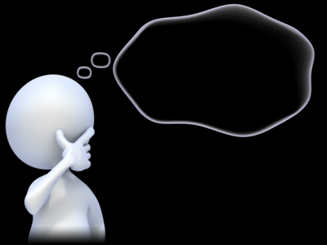
My Personal Grammarbook
for all the important grammar rules

Name: …………………………………………………..

This is your personal grammar book for Flexi 1 and 2. You can always use it to look up how the English language works.
Therefore, ALL the language in this book MUST be correct.
Always write your answers in pencil 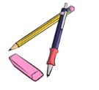so you can easily correct them. Then ask a teacher to check your answers.

Das ist dein persönliches Grammatikbuch für Flexi 1 und 2. Du kannst immer nachschlagen wenn du Fragen bezüglich der englischen Grammatik hast.
Aus diesem Grund muss hier alles GANZ RICHTIG sein. Schreibe deine Antworten immer mit Bleistift , sodass du sie leicht ausbessern kannst. Bitte deine Lehrer deine Sätze zu korrigieren.

Table of Contents
M1: a or an A1 4
M1: BIG LETTERS – small letters 5
M1: To be: am – is – are A1 6
M2: I speak – She speaks – I live – He lives A1 7
M2: Short forms – Long forms 9
M2: Personal Pronouns: I, you, he, she, it, we, you, they A1 10
M2: Plural: many things 12
M2: Numbers 13
M2: Ordinal Numbers: first, second, third… 15
M2: Days of the week and months 16
M2: Giving the date in English 17
M3: Possessive Pronouns: my, your, his, her, our, their 18
M3: Peter’s cat and Maria’s dog… 19
M3: Whose things are these? 20
M3: Asking Questions in English 21
M3: More questions: Interview a student teacher 23
M3: Negation in English 24
M4: Telling the time 25
M4: Routines 26
M5: Routines versus Present activities 27
M5: There is --- There are 28
M5: asking questions with there is—there are 29
M5: Where things are: Prepositions of place 30
M-A (June) : Future: making plans: going to 31
M7: Past tense: Irregular Verb forms 1 32
M7: Past tense, Irregular forms 33
M7: Past tense: Regular Verb forms 34
M7: Past tense - Negation 34
M7: Past tense – Questions 36
M7: Irregular Verb Forms (in groups) 37
M7: Irregular Verbs in alphabetical order 38
M8: Comparing 39
M9: Talking about the Future 41
M10: Talking about experiences: Have you ever ….. 43
M10: My exciting life: I have done lots of cool things 45
M10: Wishful Thinking: Life could be even cooler. 46
M11: one or ones --- this or these 49

M1: a or an A1

Challenge 1
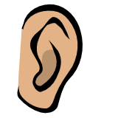
Look at the two boxes below. What do you notice? When do we use a and when do we use an in front of a word? SAY the words and LISTEN carefully.
an apple  an English book  an ice-cream | an orange  an ugly duck  an interesting book | a boy  a girl  a chair | a dog  a garden  a school

My rule
Wenn ich am Beginn eines Wortes …………………………………………………höre
verwende ich an.

Now it’s your turn
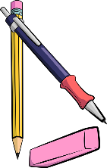
Write the words in the correct boxes. (Schreibe die Wörter in den richtigen Kreis.)
tiger, banana, book, exercise book, pencil, eraser, door, old man, internet-café,
English teacher, blackboard, window, American film, elephant
an
a

Challenge 2 for pros:

a or an? Scan the QR code and listen VERY carefully. What sounds do you hear at the beginning of these words? In which of the two circles do they go: a or an?
____university, ____uniform, ____unicorn, ____unit in my coursebook

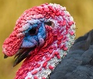
____mp3-player, ____XL-pullover,

____uncle, ____umbrella , ____ugly bird

Do we need a or an here? Write in the words, then listen to the words again.
My rule
Ich sage _____ unicorn, ______unicycle, weil …………………………………………………
Ich sage _____ mp3 player, _____XL-pullover, weil ………………………………………

M1: BIG LETTERS – small letters

In English we use big letters for
- I (I am happy.)
- names (Paula, Thomas),
- countries (England, Austria, Croatia)
- cities (Vienna, Graz, London, Paris)
- languages (German, Croatian, English)
- and at the beginning of sentences.

In the English lessons we speak English. Elisabeth and Selina are talking about London and England but I am reading a book about America.

Now it’s your turn:

Write 3-5 sentences and mark the BIG LETTERS. Ask your teacher to check.

M1: To be: am – is – are A1

Look at these examples:
My name is …………………….  I am a student at PraxisNMS.  I am ten years old.  I am not in class 4b. |   How old are you?  You are a very nice person.  You are my best friend. |   Anton is not in my class.  He is in NMS Kepler.  He is funny.

Sally is a student in England.
She is very nice.
She is not very tall.
  We are also happy.  We are not sad. |   Mary and Peter are good friends.  They are very happy.  They are not from Austria.

Now it’s your turn:

Write 10 sentences with
am | am not | is | is not | are | are not

Write true sentences about yourself, your friends, your classmates and teachers and your
family members or pets. Write a first draft on a piece of paper.
Schreibe immer wahre, sinnvolle Sätze. Schreibe einige der korrigierten Sätze hier auf:

M2: I speak – She speaks – I live – He lives A1

Challenge1: Find the rule
This is Mrs. Pölzleitner.
She lives in a blue house in Graz. She is an English teacher. She loves reading books and learning languages. She speaks English, German, French, Italian and Greek. She also likes sports. In winter she goes skiing and in summer she goes jogging. She rides her bike to school every day. Her favorite food is Indian curry. She is vegetarian, so she does not eat meat.
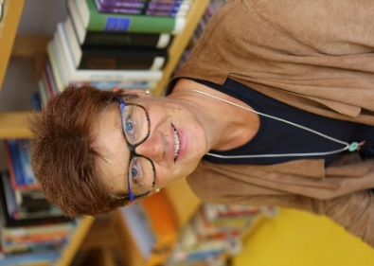
Hello, I am Mrs. Pölzleitner.
I live in a blue house in Graz. I am an English teacher. I love reading books and learning languages. I speak English, German, French, Italian and Greek. I also like sports. In winter I go skiing and in summer I go jogging. I ride my bike to school every day. My favorite food is Indian curry. I am vegetarian, so I do not eat meat.

What do you notice?


Challenge: Read the texts and find a rule!

These are Naomi and Michael.
They live in a small white house in Graz. They love riding their bikes and watching animals. They also like gardening. In summer they go swimming in their little pool and they read lots of books. They have three guinea-pigs.
Hello, we are Naomi and Michael.
We live in a small white house in Graz. We love riding our bikes and watching animals. We also like gardening. In summer we go swimming in our little pool and read lots of books. We have three guinea-pigs.

My rule:
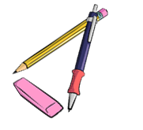
Wenn ich über EINE andere Person spreche/schreibe....

Wenn ich über MEHRERE Personen spreche/schreibe...

Now it's your turn

Step 1: Write a text about yourself. Hand it in to your teacher.

Step2: Get a speech bubble from your teacher and write your text on it. Put it on the pin board.
This is ...
NAME
Step 3: Find a speech bubble from a classmate on the pin board or get one from your teacher. Then write about your classmate. Hand your text in to your teacher.
(Write YOUR NAME on the sheet, too.)
Step 4: Write the corrected text from step 3 in the box .
Step 5: Copy your speech bubble in the bubble below

This is ...

M2: Short forms – Long forms

CHALLENGE
Look at these sentences. What do you notice? Mark the differences with a highlighter.
Maria does not like spinach. | Maria doesn’t like spinach.
We do not speak Croatian in school. | We don’t speak Croatian in school.
Peter is not from Austria. He is from England. | Peter isn’t from Austria. He’s from England.
We are good students. | We’re good students.
My friends are not in my school. | My friends aren’t in my school.

Now it’s your turn:
My friend Sally is not from Austria. | My friend Sally…
My mother is not very tall.
In my family, we do not eat meat.
I am happy.
 | My dad doesn’t like sweets.
 | We don’t have any pets.
 | Peter and Sally don’t speak German.
 | We’re not twins.
 | He’s my best friend.

M2: Personal Pronouns: I, you, he, she, it, we, you, they A1

 |  |  |  | 
I  I live in London.  I am 10 years old.  I like chocolate. | you  You are my best friend.  I like you.  Do you like cats? | he  He is called Peter.  He is 10 years old.  He likes pizza. | she  She is called Mary.  She is from Austria.  She likes ice-cream. | it  It is called Toby.  It likes carrots.  It is really cute.

 |  | 
we  We go to the same class.  We speak English and German.  We like our new school. | you  Do you speak English?  You are my friends.  Do you want to work in my group? | they  They are very nice people.  They are from America.  They speak English but they do not speak German.

Now it’s your turn:
Now write similar (ähnliche) sentences about your friends and family.
Use ALL the pronouns.
I, you, he, she, it, we, you, they
Ask your teacher to check.









M2: Numbers
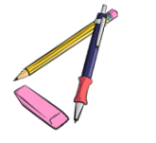
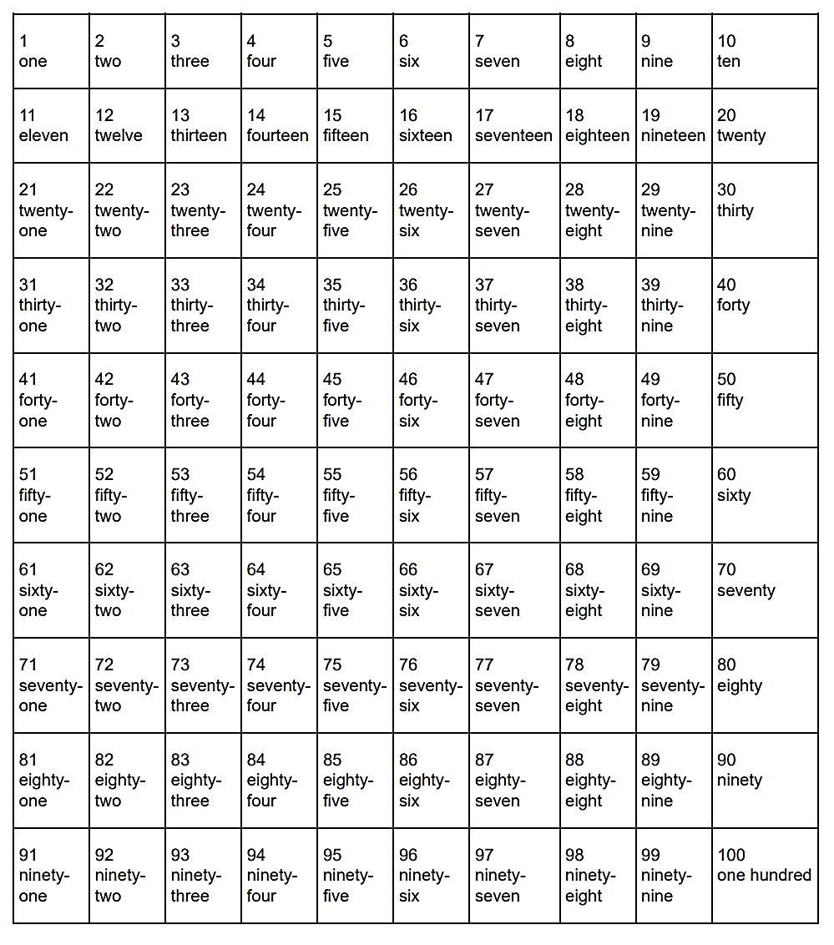
Now it’s your turn:
Task 1: Number the pages of your ME-book. Write numbers and words: 1 -one, 2 – two 3—three…..

Now it’s your turn:
Task 2: My special numbers
Choose one number in each row and colour it. Tell your teacher what it means for you. Then write your answers on this page. Ask your teacher to check your answers.
Examples:
- twenty-five: Mrs Pö’s daughter is twenty-five years old.
- thirty-three: Thirty-three is my lucky number. My phone number starts with thirty-three.
- seventy-four: I live in Scheigergasse seventy-four.

M2: Ordinal Numbers: first, second, third…
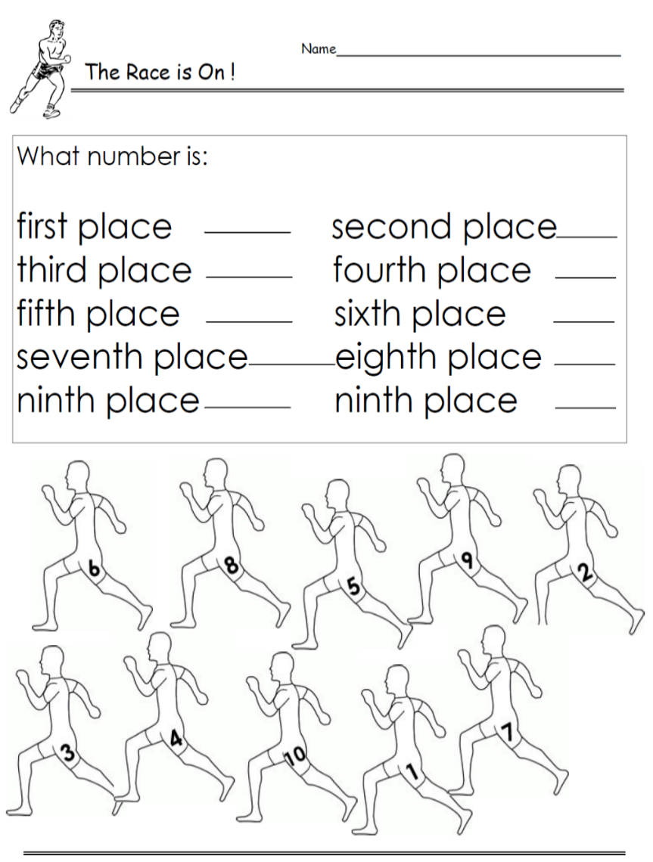
first 1st
second 2nd
third 3rd
fourth 4th
fifth 5th
sixth 6th
seventh 7th
eighth 8th
ninth 9th
tenth 10th
eleventh 11th
…
twenty-first 21st
twenty-second 22nd
thirty-third 33rd
forty-fourth 44th
…

Who wins the race? Write sentences about all the runners:
Example:
Tom is in first place.
Tim is in second place.

Boris
Gordon
Leo
Mike
Tim

Alan
Andi
Tom
Jim
Sam
www.worksheetplace.com

Now it’s your turn:
Andi …

M2: Days of the week and months
Examples:

On Monday we have English.
On Tuesday I always play soccer.
On Saturday and Sunday I sleep in.

In winter I go skiing.
In summer I go swimming.
In spring there are lots of flowers.
In autumn the trees are very colorful.

School starts in September.
Christmas is in December.
In May there are lots of long weekends.
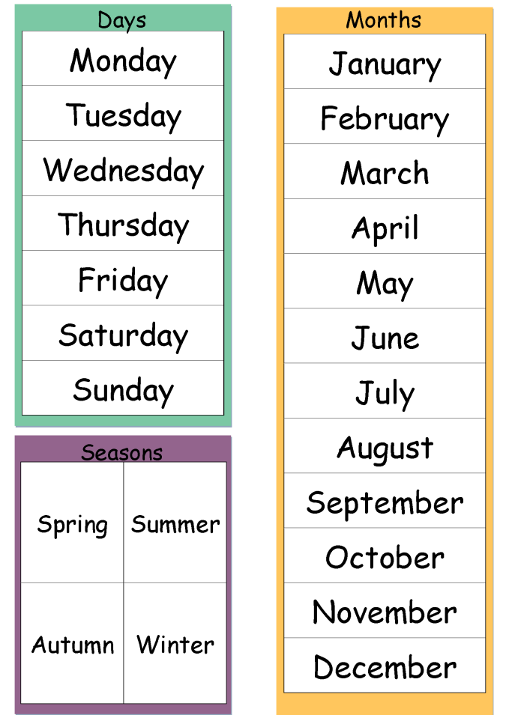
autumn
winter
summer
springhttp://www.polzleitner.com/epep/0-NMS/ErasmusGOALproject/Projektwoche.pptx

Now it’s your turn:

What is your favorite season?
What is your favorite month? Tell us why.
In which months do you go swimming?
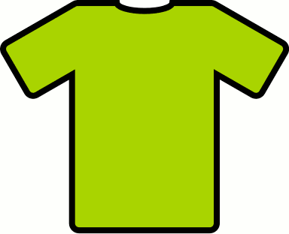
In which months do you wear short sleeves?
What is your favorite day of the week? Tell us why.
What is your least favorite ☹ day of the week? Tell us why.

M2: Giving the date in English

GIVING THE DATE
British:
1st October 2018
2nd November 2018
American:
December 3rd, 2018
January 4th, 2019
February 5th, 2019
Example:
When is your birthday?

You write: My birthday is on August 22nd.

You say:
My birthday is on the 22nd of August.

Now it’s your turn.

When is your birthday?
You write: My birthday is on ………………………………………………………………………………………..
You say: ………………………………………………………………………………………………………………………….
When do the holidays start?
You write: The holidays start on …………………………………………………………………………………………..
You say: ………………………………………………………………………………………………………………………………………………
When is Christmas?
You write: Christmas is on ……………………………………………………………………………….
You say: ………………………………………………………………………………………………………………………………………………
When does Ramadan start this year?
You write: It starts on ……………………………………………………………………………………..
You say: …………………………………………………………..…………………………………………………………………………………
On which floor is the teachers’ office?
You say and write: It’s on the …………………………………………………………………………………………

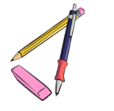
M2: Plural: many things
Plural 1
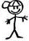  one boy | 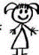  one girl | 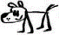  one dog | one desk
two boys | two girls | 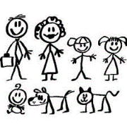  two dogs | two desks
one pencil | one erasor | one window | one book
two ……………….. | two ……………….. | two……………….. | two ………………..
one student | one teacher | one door | one schoolbag
two……………….. | two ……………….. | two ……………….. | two ………………..

How do we form the plural in English?

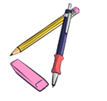
Plural 2: tricky words
Why not this?
Listen and speak!

- boxs
- buss
- kisss
- wishs
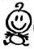  one baby  two babies | one box  two boxes
one country  two …………………… | one bus  two ………………..
one pony  two ……………………. | one kiss  two ………………..
one story  two ……………………. | one wish  two …………………
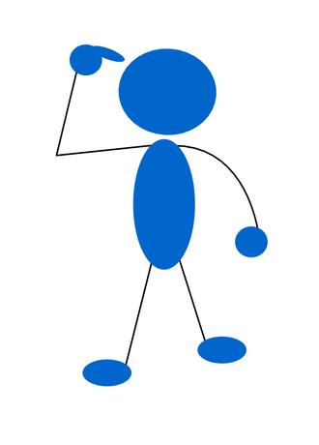
Plural 3: more tricky words: add more words later
one child.  two children. | one man  two men | one woman  two women
one mouse
two mice

M3: Possessive Pronouns: my, your, his, her, our, their
Wem gehören diese Dinge?
Look at Mr and Ms Brown and their children. They are really cute.
Yes, these are our children.
Yes, these are our children.
Are these your children?
Is this your dog, Tom?


Yes, it is my dog.
Yes, this is his dog.

Is this Susan’s cat?
Yes, this is her cat.


Whose dog is it?
Draw a leash (Leine).

Is this the dog‘s ball?
Yes, the dog loves its ball.

More examples:
Thomas has a sister. His sister is called Mary.
Mrs. Pölzleitner goes to school by bike. Her bike is white.
Mrs. Bergmann has three children. Her children are called Martina, Julia and Matthias.
We have a very nice classroom. Our classroom is the best.
Some children from my old school go to a “Gymnasium”. Their school is not as cool as ours.

Now it’s your turn:

Write 6 TRUE sentences about yourself and your friends and family.
Use: my, your, his, her, our, their

M3: Peter’s cat and Maria’s dog…


Challenge:
Peter’s brother is called Thomas.
Andrea’s sister is very funny.
My mom’s favorite food is pizza.
My dad’s mom is my grandmother.
My aunt’s dog is really big.

’s
What does it mean?

My rule:
Ich schreibe ein ‘s …......

Now it’s your turn:
Write 5 similar (ähnliche) sentences.
Remember: Always write TRUE and meaningful sentences.

M3: Whose things are these?

My parents’ bedroom is very big.  My friends’ houses are beautiful.  The girls’ umbrellas are colorful.  s‘s | 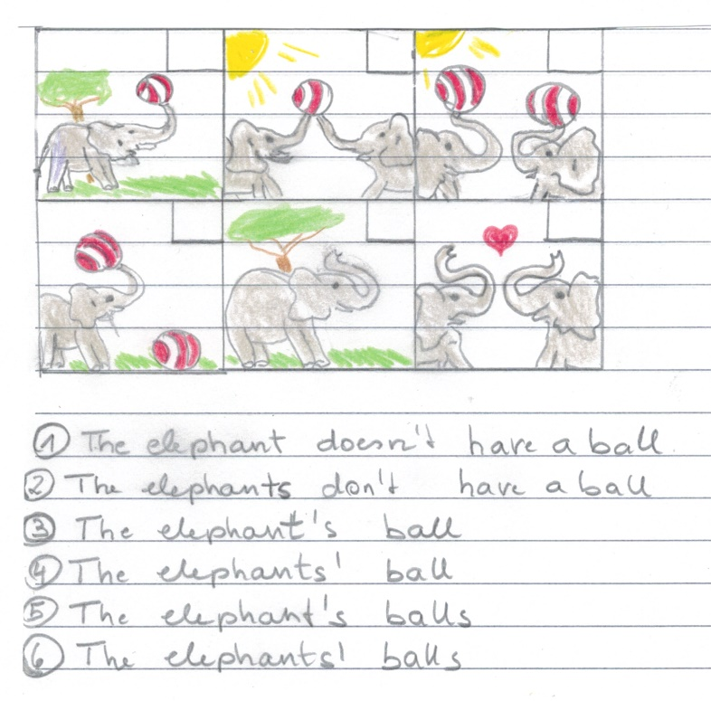  Match the pictures and the sentences. Write the numbers into the pictures.

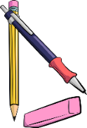
Now it’s your turn:
Make your own matching game. Get stickers from your teacher.
Write 5 sentences with ….‘s or s’ and draw a picture for each one. Show them to your teacher.
Copy your sentences and pictures on playing cards and ask a friend to match them.
Draw your pictures in the wrong order
1
2
3
4
5


M3: Asking Questions in English

The new English teacher…
Mrs. Bergmann meets the new English teacher at her school.
She asks him lots of questions.
Do you like Great Britain?
Where do you come from?
Where do you live?
What languages do you speak?
Do you go to school by bike?
How do you get to school?
When do you get up?
Do you drink coffee?
Why don’t you drink coffee?
Do you have a pet?

How do your classmates study vocabulary?
How does your best friend get to school?
https://pixabay.com/de/fragezeichen-hinweis-duplikat-2110767/
Questions, questions, questions
Mrs. Pölzleitner wants to know everything about the new teacher. She texts Ms Bergmann.

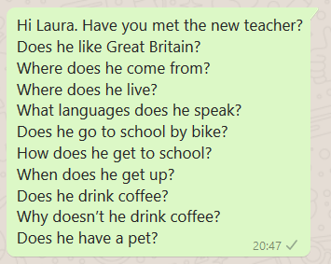

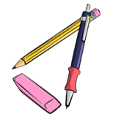
Challenge
What do you notice? (Was fällt dir auf?)
Man kann für Fragen Fragewörter verwenden. Schreibe die Fragewörter auf:

………………………………………………………………………………………………………………………………………………...

Man bildet Fragen häufig mit ………………………………….. oder ………………………………………………….
Does verwendet man wenn man über …………………………………………………………………………spricht.

Das verb (z.B……………………………………………………………………………………………..) verändert sich nicht.

Now it’s your turn:

Write your own questions
Write 5 questions you want to ask your teacher.

Write 5 questions about one of your classmates. Ask your teacher. How many questions can your teacher answer? _______________

M3: More questions: Interview a student teacher
Make a questionnaire (Fragebogen)
Write a lot of questions to interview guests and student-teachers.
When we have guests in class, talk to them and ask them all your questions.

M3: Negation in English


Challenge
Mrs. Bergmann has a problem. She needs Mrs. Pölzleitner’s help.
Read the text. What do you notice?
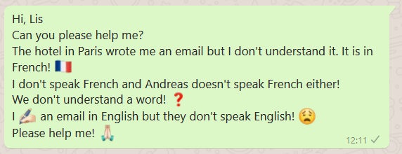

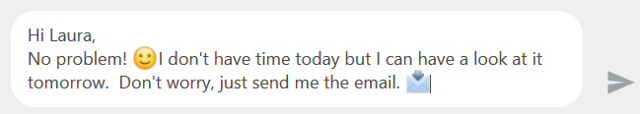

What do you notice? (Was fällt dir auf?)
- In der Verneinung verwendet man ___________ oder _____________ vor dem Verb (z.B. speak, like, eat)
- Doesn‘t verwendet man wenn man über ________________________________________spricht.
- Das verb (z.B. ___________________________________________________) verändert sich nicht.

Now it’s your turn.
Say what people DON’T do! Write your own examples. Start your sentences like this:
I…
My best friend…
My teacher…
My cat/dog/ _________
My parents…
My friends…
We…

M4: Telling the time

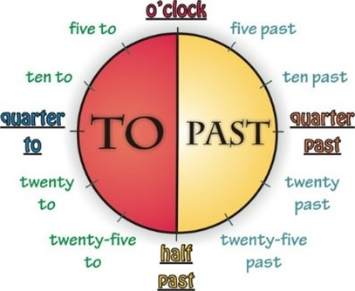
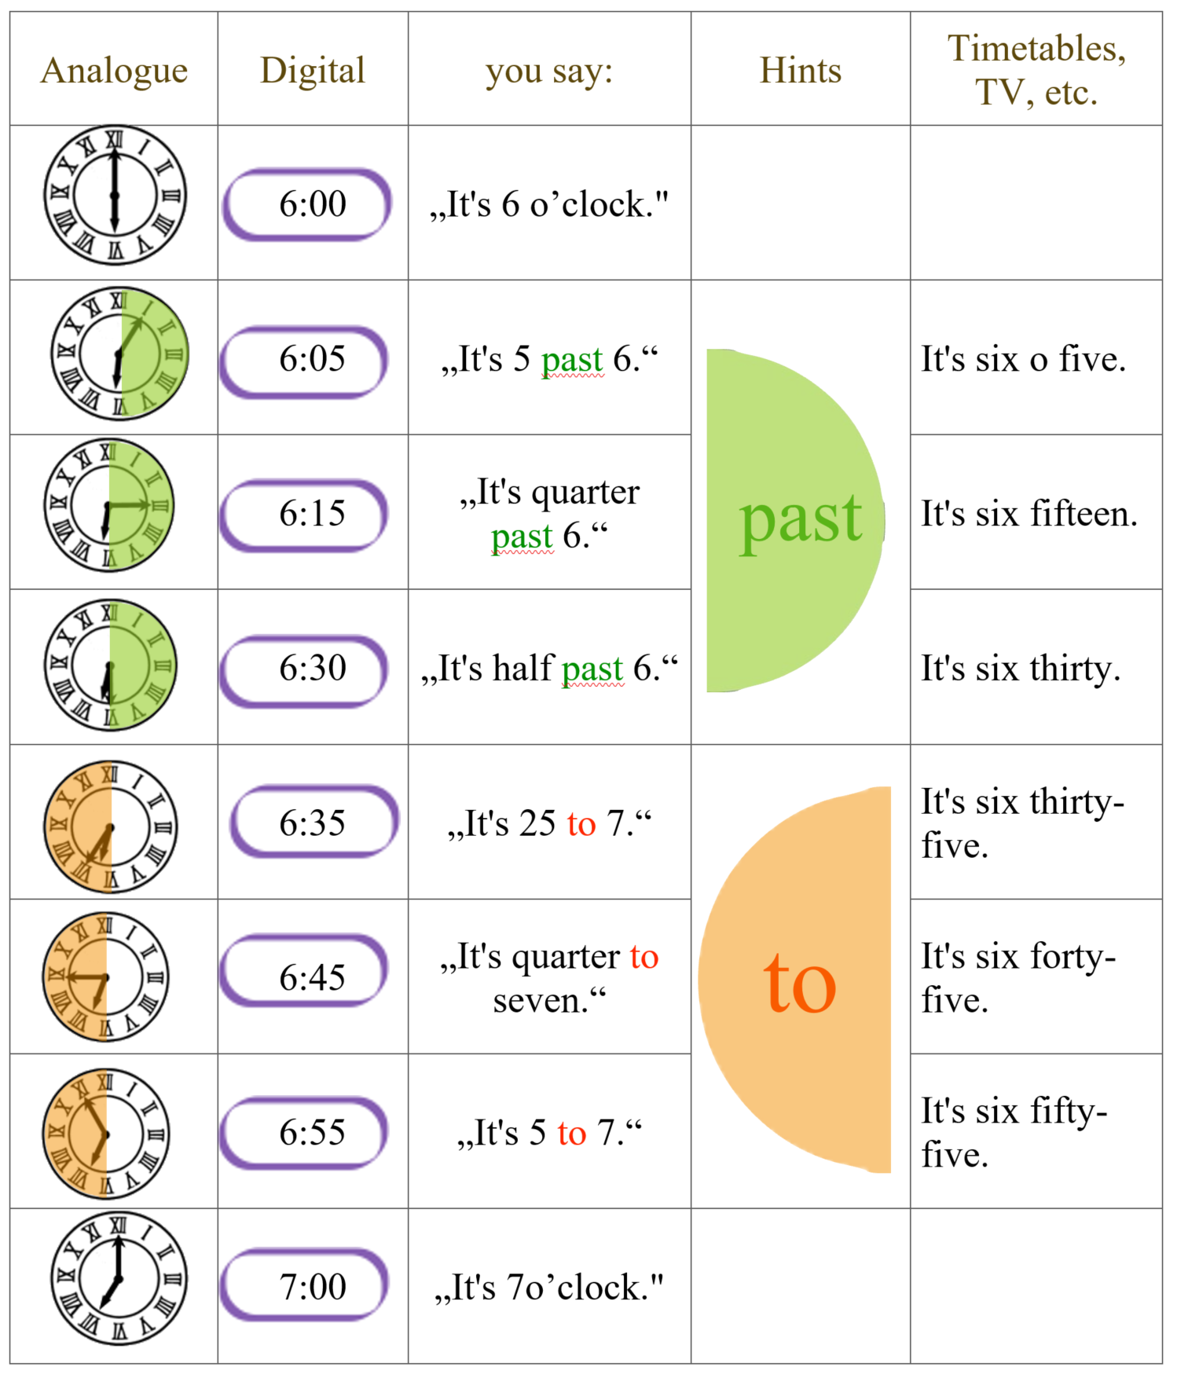

Now it’s your turn:

Answer the following questions. Write complete sentences.

What time is it right now?
What time do you usually get up in the morning?
What time does school start?
What time do you have lunch in the school cafeteria?
What time does school finish?
What time do you usually study vocabulary?
What time do you go to bed in the evening?

M4: Routines

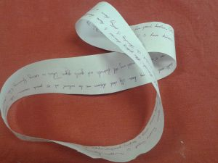 | Maria usually gets up at half past six. Then she takes a shower and gets dressed. At seven o’clock she has breakfast with her family. She eats bread, butter and jam and she drinks a cup of hot chocolate. Then she goes to school by bus. She arrives at school at half past seven. She goes to her locker to change her shoes and to hang up her coat or jacket. School starts at quarter to eight….
xxxx

A: Here we are talking about ………………………………………………………………………………………………………
We use the present simple (get up, take, have, go…).

Now it’s your turn:

My daily routines
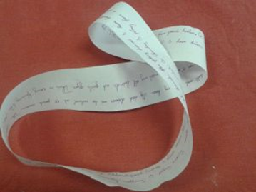
Ask your teacher for a Moebius strip. Then write down all the things you do every day – and every week.
Write as much as you can. Fill all the paper.
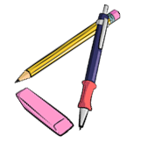
Read your text to your teacher and two a friend.
Then put it into an envelope and glue it on this page.



M5: Routines versus Present activities

Challenge:
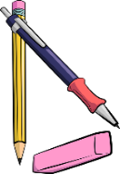
Look at examples on page 26 and here. What’s the difference?
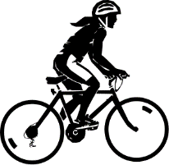  The girl is riding her bike. |   The girl is dancing. | 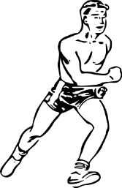  The boy is running.
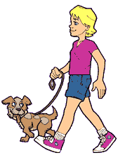  The boy is walking his dog. |   The person is swimming. | 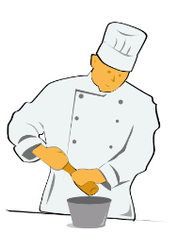  The cook is cooking.
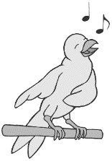  The bird is singing | 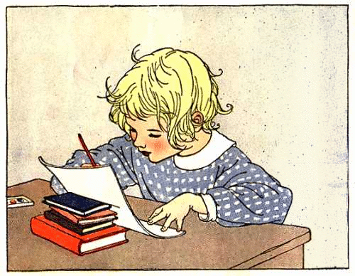  The child is doing homework. | 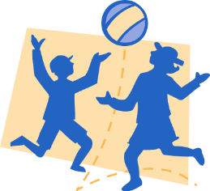  The children are playing with a ball.

B: Here we are describing what……………………………………………………………
We use the present continuous form (singing, riding, dancing).

Be a detective: What is going on in your class and your school?
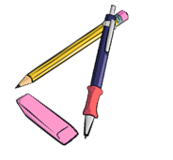
Look around the classroom and write 10 true sentences on a sheet of paper.
What are your classmates doing right now? Show your sentences to your teacher,
then correct your sentences. Write the 5 most interesting things on this page.

1
2
3
4
5

M5: There is --- There are
Einen Ort beschreiben

In our classroom there are 20 children.
There are also 20 chairs and many tables.
There is a computer under the teacher’s desk and there is a projector on the ceiling.
There are two big cupboards at the back of the classroom and there is a big green board on the front wall. Next to the door there is a washbasin and three garbage bins.

Explain: When do we use there is? When do we use there are?

My rule:

We say THERE IS….

We say THERE ARE…

Now it’s your turn:

Write five sentences about your room. Use there is and there are

M5: asking questions with there is—there are

Is there | a | sofa | in your classroom?
Is there | an | orange | in your classroom?
Are there | any | laptops | in your classroom?

Yes, there is.  No, there isn’t. | Yes, there are.  No, there aren’t.

There is a | sofa | in/on/under/next to/in front of/behind/between…..the
There are some | posters | in/on/under/next to/in front of/behind/between…..the

Now it’s your turn:
Work with a partner. Ask your partner 5 questions about his/her room.
Then write your questions and your partner’s answers.

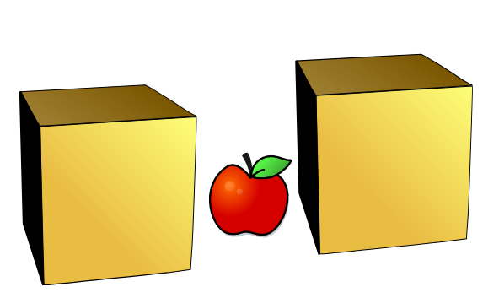
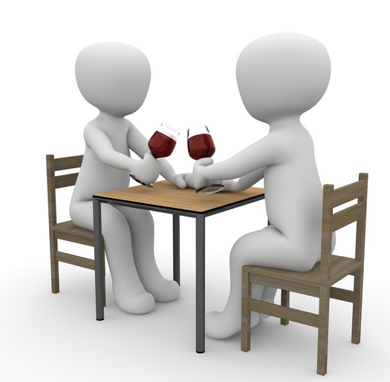
M5: Where things are: Prepositions of place
* between
There is an apple between the two boxes
* opposite
They are sitting opposite each other.
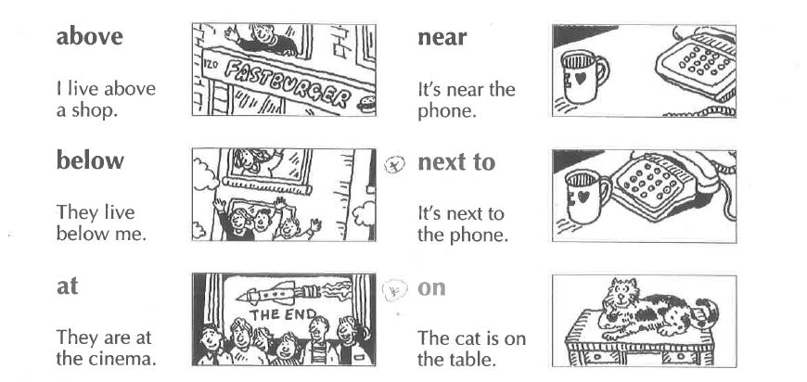

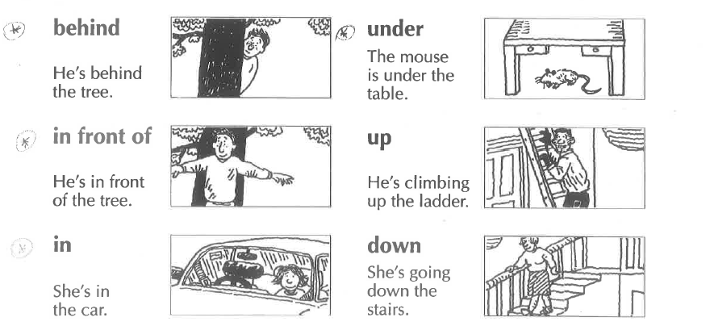

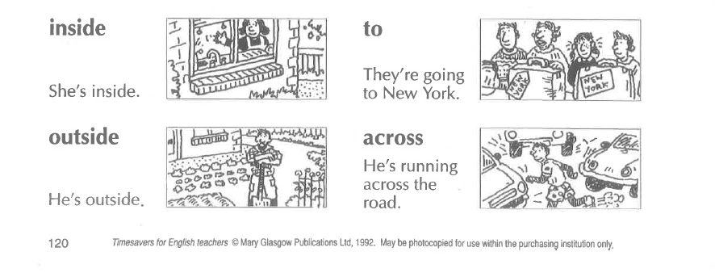
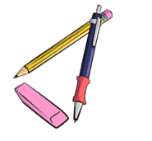

Now it’s your turn:

Write 8 true sentences about your classroom, or your room.
Show your sentences to your teacher.
Correct your sentences.

M-A (June) : Future: making plans: going to

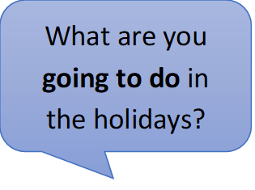
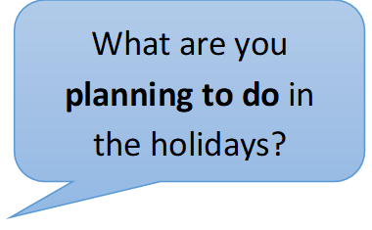
Talking about plans: GOING TO

Write 3 sentences about your holiday plans
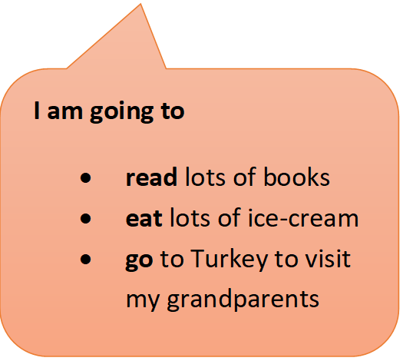
and
3 sentences about your friend’s holiday plans
and
We are going to
- visit our family
- play a lot of games
- go swimming
3 sentences about your teachers’
holiday plans.

Now it’s your turn:

My holiday plans
I am going to
I…
I…

My friend’s holiday plans
Name………….. is going to…

My teacher’s holiday plans
Name………….. is going to…

M7: Past tense: Irregular Verb forms 1

Usually, .. |  | Yesterday …
I | am happy. | I | was sad.
We | are happy. | We | were sad.
I | do my homework. | I | did my math exercises.
I | go to school by bus. | I | went to school by bike.
I | spend 6 hours in school. | I | spent 7 hours in school.
I | have breakfast with my mom. | I | had breakfast with my dad.
I | fly to America. | I | flew to England.
I | take a shower. | I | took a bath.
I | come home at 5 o’clock. | I | came home at 7 o’clock.
I | read a book in bed. | I | read a newspaper.
I | speak with my friends. | I | spoke with my sister.
I | drink water. | I | drank Coke.
I | get up at 6 o’clock. | I | got up at 7 o’clock.
We | drive to my grandmother’s house. | We | drove to my aunt’s house.
I | say funny things. | I | said sad things.
I | eat dinner with my family. | I | ate dinner at my grandmother’s.
We | stand up when a teacher comes in. | We | stood up when Frau Wagner came in.
We | buy our food at SPAR. | We | bought our food at BILLA.
I | write a shopping list | I | wrote an e-mail to my teacher.
I | buy a bottle of water. | I | bought a bottle of Coke.

M7: Past tense, Irregular forms

Now it’s our turn:

Choose 10 verbs from page 31 and write true and meaningful sentences about yourself, your friends and family.
What DID YOU DO (yesterday, in the holidays, last weekend….)?

M7: Past tense: Regular Verb forms
Usually, .. |  | Yesterday … / In summer...
I | visit my grandparents every Saturday. | I | visited my aunt.
I | play soccer in the afternoon. | I | played soccer in the morning.
We | stay in a hotel. | We | stayed with friends.
I | watch TV in the evening. | I | watched TV all day long.

M7: Past tense - Negation

I can say what I did and what I did not do in the holidays.
Examples:
I did not go to America, but | I went to Turkey.
I did not eat any Sauerkraut, but | I ate lots of ice-cream.
I did not buy any souvenirs, but | I bought a new t-shirt.
I did not take an airplane, but | I took a bus and a train.
I did not play chess, but | I played soccer with my friends.

Now it’s your turn:


Write 10 sentences on a sheet of paper. Show your sentences to your teacher. Then write the correct sentences on this page.
Examples:
I did not go to Greece this summer, but I went to Turkey.
I did not read many books this summer, but I watched lots of movies.


Challenge:
What do you notice about the verb forms? Tell your teacher. Then write your rule in this box.

M7: Past tense – Questions

Yes, I did.
Did you go swimming in the holidays?

Did you speak English in the holidays?
No, I didn’t.
Did you visit your grandmother?

Did you like your hotel?

Now it’s your turn:

Write 5 more questions that you would like to ask your teacher. What did your teachers do in the holidays? Then talk to your teacher and ask your questions.

Did you…
Did you…

M7: Irregular Verb Forms (in groups)
There are about 185 irregular verbs in English. You will need only need these 90. Study them carefully
Base form | Past form | Last form | German | Base form | Past form | Last form | German
All forms different |  |  |  | Past form and last form end in [d]
be (is/was) | was / were | been | sein | find | found | found | finden
become | became | become | werden | have | had | had | haben
come | came | come | kommen | hear | heard | heard | hören
do | did | done | tun | hold | held | held | halten
go | went | gone | gehen | lay | laid | laid | legen
run | ran | run | laufen | make | made | made | machen
see | saw | seen | sehen | pay | paid | paid | zahlen
show | showed | shown | zeigen | read [ri:d] | read [red] | read [red] | lesen
 |  |  |  | say | said | said | sagen
All forms the same |  |  |  | sell | sold | sold | verkaufen
cost | cost | cost | kosten (Preis) | stand | stood | stood | stehen
cut | cut | cut | schneiden | understand | understood | understood | verstehen
hit | hit | hit | schlagen | tell | told | told | erzählen
hurt | hurt | hurt | verletzen
let | let | let | lassen | Same sound patterns
put | put | put | stellen/legen | bring | brought | brought | bringen
set | set | set |  | buy | bought | bought | kaufen
shut | shut | shut | schließen | fight | fought | fought | kämpfen
 |  |  |  | think | thought | thought | denken
Past form and last form the same |  |  |  | catch | caught | caught | fangen
dig | dug | dug | graben | teach | taught | taught | lehren
win | won | won | gewinnen
 |  |  |  | sing | sang | sung | singen
Past form and last form end in [t] |  |  |  | swim | swam | swum | schwimmen
build | built | built | bauen | begin | began | begun | beginnen
burn | burnt | burnt | (ver)brennen | drink | drank | drunk | trinken
creep | crept | crept | kriechen | ring | rang | rung | läuten
feel | felt | felt | fühlen
keep | kept | kept | behalten | freeze | froze | frozen | frieren
leave | left | left | verlassen | steal | stole | stolen | stehlen
light | lit | lit | anzünden | break | broke | broken | brechen
lend | lent | lent | borgen | wake | woke | woken | aufwecken
mean | meant | meant | meinen | choose | chose | chosen | auswählen
meet | met | met | treffen | drive | drove | driven | fahren, lenken
send | sent | sent | schicken | write | wrote | written | schreiben
shoot | shot | shot | schießen
sleep | slept | slept | schlafen | beat | beat | beaten | schlagen
smell | smelt | smelt | riechen | bite | bit | bitten | beißen
spend | spent | spent | ausgeben | eat | ate | eaten | essen
spill | spilt | spilt | ausschütten | fall | fell | fallen | Fallen
spoil | spoilt | spoilt | verwöhnen | forget | forgot | forgotten | vergessen
get | got | got | bekommen | forgive | forgave | forgiven | verzeihen
lose | lost | lost | verlieren | give | gave | given | geben
sit | sat | sat | sitzen | hide | hid | hidden | verstecken
sweep | swept | swept | kehren | shake | shook | shaken | schütteln
 |  |  |  | take | took | taken | nehmen
Same sound pattern |  |  |  | tear | tore | torn | zerreißen
grow | grew | grown | wachsen | wear | wore | worn | tragen(Kleider)
fly | flew | flown | fliegen
know | knew | known | wissen
throw | threw | thrown | werfen

M7: Irregular Verbs in alphabetical order
be | was/were | been
beat | beat | beaten
become | became | become
begin | began | begun
bend | bent | bent
bet | bet | bet
bind | bound | bound
bite | bit | bitten
blow | blew | blown
break | broke | broken
bring | brought | brought
build | built | built
buy | bought | bought
can | could | … (been able)
catch | caught | caught
choose | chose | chosen
come | came | come
cost | cost | cost
creep | crept | crept
cut | cut | cut
dig | dug | dug
do | did | done
draw | drew | drawn
drink | drank | drunk
drive | drove | driven
eat | ate | eaten
fall | fell | fallen
feed | fed | fed
feel | felt | felt
fight | fought | fought
find | found | found
fly | flew | flown
forbid | forbade | forbidden
forget | forgot | forgotten
forgive | forgave | forgiven
freeze | froze | frozen
get | got | got
give | gave | given
go | went | gone
grow | grew | grown
hang | hung | hung
have | had | had
hear | heard | heard
hide | hid | hidden
hit | hit | hit
hold | held | held
hurt | hurt | hurt
keep | kept | kept
know | knew | known
lay | laid | laid
lead | led | led
leave | left | left
lend | lent | lent
lie (in bed) | lay | lain
lie (lügen) | lied | lied
lose | lost | lost
make | made | made
mean | meant | meant
meet | met | met
must | had to | …
pay | paid | paid
put | put | put
read | read | read
ride | rode | ridden
ring | rang | rung
rise | rose | risen
run | ran | run
say | said | said
see | saw | seen
sell | sold | sold
send | sent | sent
set | set | set
shake | shook | shaken
shine | shone | shone
shoot | shot | shot
show | showed | shown
shrink | shrank | shrunk
shut | shut | shut
sing | sang | sung
sink | sank | sunk
sit | sat | sat
sleep | slept | slept
slide | slid | slid
smell | smelt | smelt
speak | spoke | spoken
spend | spent | spent
spit | spat | spat
spread | spread | spread
stand | stood | stood
steal | stole | stolen
stick | stuck | stuck
sting | stung | stung
stink | stank | stunk
strike | struck | struck
swear | swore | sworn
swim | swam | swum
swing | swung | swung
take | took | taken
teach | taught | taught
tear | tore | torn
tell | told | told
think | thought | thought
throw | threw | thrown
wake | woke | woken
wear | wore | worn
weep | wept | wept
win | won | won
wind | wound | wound
write | wrote | written

M8: Comparing

1. Read the descriptions of these exotic animals and highlight all the comparisons (Vergleiche). Then match them with the pictures. Draw lines.
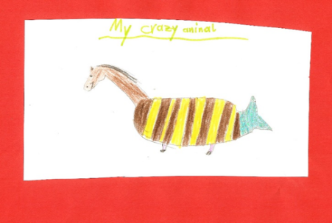
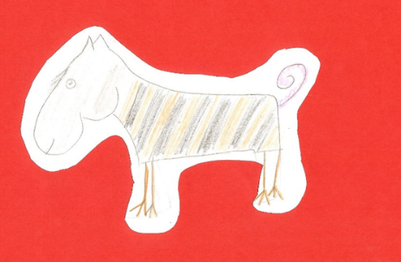
Horsotigopigchick
The horsotoigopigchick has the body of a tiger, the head of a horse, the tail of a pig and the feet of a chicken. Its head is bigger than a tiger’s head and a lot heavier. The horsotigopigchick’s legs are much thinner than a tiger’s legs and it slower than a tiger. It has a thin pink tail and it is more peaceful than the Tigohorsophin. It is the friendliest of these animals and makes a perfect pet.
Crocosharkopeacock
The crocosharkopeacock is a very strange animal. It has a crocodile’s head, the body of a shark and the tail and feathers of a peacock. Its legs are as short as a crocodile’s and it cannot run very fast, but the crocosharkopeacock can fly faster than any other bird. It is the fastest animal in the world. It has very sharp teeth and it is one of the most dangerous animals in the world. It is more dangerous than a crocodile or a shark.
Tigohorsophin
The tigohorsophin is a lovely animal. It has the head and neck of a horse, the body of a fat tiger and the tail and fin of a dolphin. It has the smallest, shortest legs of all the exotic animals. Normally it doesn’t walk but it can swim. The tigohorsophin is the heaviest of the exotic animals and it is even slower than the horsotigopigchick but it is the most intelligent of all the exotic animals. It is more intelligent than a dog.

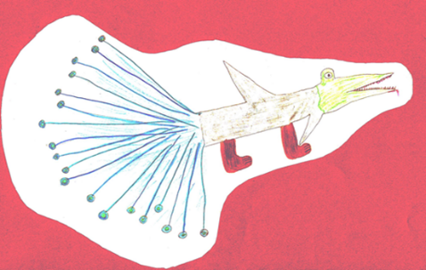

2. Are these sentences true or false? Tick the correct ones and correct the false ones.

Challenge:
Find the rule.
How do we compare adjectives?
How would you explain this to your mom?
Horsotigopigchicks are as fast as tigers.
Tigohorsophins are the heaviest and slowest animals in this group.
Tigohorsophins are the most intelligent of the exotic animals.
The crocosharkopeacock has shorter legs than the other animals.
The horsotigopigchick is more dangerous than the other animals.
The crocosharkopeacock is less dangerous than the horsotigopigchick.

Challenge:
Show that you can do this.
thin
kind
cold
intelligent
beautiful
interesting

Explain it!

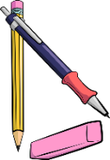
My rule:

Now it’s your turn:
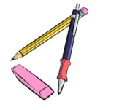
Choose two animals and compare them. Use a piece of paper for your first draft.
Write at least 5 sentences. Ask your teacher to check.
Then copy the corrected sentences into this box.

M9: Talking about the Future

Challenge:
Read the following examples where people talk about the future. Highlight all the verbs (Zeitwörter).
What do you notice? What is the difference between text A and text B? Tell your teacher what you have found out.
A
This weekend I am going to Klagenfurt to celebrate my grandmother’s birthday. All my cousins are also going to be there.
On Saturday evening we are going to watch all the Harry Potter movies together, my cousin Peter has them all on DVD.
On Sunday we are going to celebrate my grandmother’s birthday in a restaurant. There, I am going to order Wienerschnitzel, my favorite food.
I am really looking forward to this weekend.
What are you going to do on the upcoming weekend?


My Rule:
Here we are talking about ………..
We use the form ………………………

That sounds like fun. My weekend is going to be boring. I am going to study for Math, and I am going to work on my module in English. And then, I am going to clean up my room, it’s a real mess.

B
I’m not sure. I think I will live in a flat or in a house with my partner. Maybe I will have some children.
I’ll work in a big company and I’ll have a car of my own. It will probably be an electric car – or maybe I’ll go to work in a self-driving car.
What will your life be like in the year 2040?

Tip: Remember
I am = I’m
I will = I’ll

My Rule:
Here we are talking about ……………………………………

We use the form…………………………………………………..

Your weekend
Your teacher’s weekend
If …
Perhaps…
Maybe…


Perhaps, I’ll go to the bookstore and buy a new book.

Maybe, my sister will visit me. She is very busy, I don’t know if she has got time.



On Sunday I am going to sleep in and have a nice, long breakfast.
I am going to meet my friend Nancy on Saturday afternoon. We are going to have coffee and cake and chat about work.

On Sunday afternoon I am going to work for school. I have a long to-do list.
On Saturday morning I am going to do my grocery shopping for the week, and I am going to clean my house.
I’ll go jogging if the weather is good.

Now it’s your turn:
What are YOU going to do this upcoming weekend (or in the next holidiays)? Do you have any PLANS or VAGUE IDEAS?
Write them on the left side of the arrow.

M10: Talking about experiences: Have you ever …..

Grammar Challenge: Find out about your teacher…

- Step 1: Read the interview. Highlight the verbs. What are the differences in the round and square speech bubbles?

- Step 2: Find the rule and tell it to your teacher. Then write it in the box below.
- Step 3: Ask all your teachers. Who is the teacher who gave the interview?
Have you ever been to America?

Yes, I have been to America twice.

Where did you go?

The first time I went to California and stayed there for four weeks.
The second time I went to America on my honeymoon. My husband and I stayed in New York for a week.

Have you ever visited the White House.

No, I have never visited the White House

Have you ever touched a snake or a tarantula?
I have never touched a tarantula but I have touched a snake.

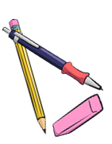

My rule

We use „have + 3rd form“ (present perfect tense) to talk about…
We use the past tense to talk about…
I went skydiving when I was twenty years old. It was fantastic. We went up to almost 4000 metres in a little plane and then we jumped down.
We loved it and wanted to do it again, but it was too expensive.
When did you go skydiving?
Did you like it?

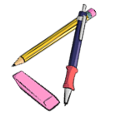
Now it’s your turn:

Find your own questions and answers that you want to ask your teacher or a classmate. Use the correct tenses. Ask until you get the answer: “Yes, I have.”
Tip:
Have a look at 10A+B in your handout
Yes, I have.
Have you ever …

Find out: when – where - why –who- how….

Write down the questions:

Write down the answers:

name: _________________


M10: My exciting life: I have done lots of cool things
Look at the example.
Step 1: Write about three interesting things you have experienced (erlebt). Use the speech bubbles.
Step 2: Give details in the box.

Step 3: Ask your teacher to check.
details

It happened a few years ago. I was at the beach in Caorle. Suddenly I saw a group of children. They were very excited because they had a baby shark in a bucket.
I took the shark and brought it back to the sea. It was very weak so I moved it around in the water. After some time it swam away.
experience
I have touched a shark.

when – where - why –who- how….

details
I have _______________
- - - - - - - - - - - - - - - - - - - - .

when – where - why –who- how….

experience



I h _ _ _ _______________
- - - - - - - - - - - - - - - - - - - - .

experience

when – where - why –who- how….


I ______ _______________
- - - - - - - - - - - - - - - - - - - - .

when – where - why –who- how….
experience

M10: Wishful Thinking: Life could be even cooler.

- if we had lots of money
- if we had a lot of time
- if we could do magic
Step 1: Read about Mrs. Bergmann’s dreams.
Step 2: Underline all verbs. The first one has been done for you. What do you notice?
Step 3: What would you do if …. ? Write at least 2 sentences per topic.
If I had a superpower and could become invisible, I would go to Buckingham Palace and watch the Royal family.
I would also go to a film set of Dr Who. If I was invisible, I would go to a spa in the evening when it is closed and be there all on my own.

Well, if I won a thousand Euros in the lottery, I would book a flight to Great Britain or to Ireland and spend a wonderful week there. Of course, I would take my family with me.
If I won a million Euros, I would buy a house or a castle in Scotland where I would spend the summer. I would have a butler, of course.

If I could travel in time, I would visit many interesting times. I would go to Scotland in the 17th century and visit the Scottish Clans. Then I would go to the 19th century and meet Sissi. Then I would go to the 20th century and take a picture with Albert Einstein. And if I could travel in time, I would also go to the future and meet my great-grandchildren.

Step 1: Read the sentences and look at the underlined words.

If I had a bike, I would go to school by bike every day.
If I was invisible, I could find out all my friends’ secrets.
If I could play the guitar, I would join a band.
I would go for a walk every day if I had a dog.
I would stay in bed all day, if I did not have a test today.

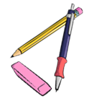
Now it’s your turn.

Use the same structure to complete the sentences
If I had a pet, …
If I had 50 euros, I …
I would go to America if …
If I could fly, I …
If I had a twin sister/ brother, I …
If I could travel in time, …
I would not leave the house, if …
If I was super strong, I
If I could speak every language in the world, I…
I would …………………………………………………., if I was…
I would ……………………………………….………………………………, if I didn’t have to go to school.
I would …………………………………………………………………………, if it wasn’t so expensive.
If I ………

It’s your turn

What are your wishes and dreams? What would you do if they came true?
I would like to …
If I ……

I would like to be 16 years old.
If I was 16, I could stay out really late.




Write at least 5 wishes and dreams of your own.
Use the same structures.

M11: one or ones --- this or these

Challenge 1
Look at the two dialogues below and highlight “one” and “ones”. What do you notice?
When do we use one and when do we use ones and this and these?
Shop assistant: Good morning. How can I help you?
Customer: I’m looking for a woolen sweater.
S: How about the red one in the corner over there?
C: I don’t like red… Do you have any grey ones?
S: Yes, over there. Come with me. Do you like this one?
C: Yes, this one is really nice.
S: What size do you wear?
C: Medium.
S: Ok, try this one
C: It’s too small. Do you have a larger one?
S: No, sorry. The large ones are sold out.

Shop assistant: Good afternoon. What can I do for you?
Customer: I’d like a pair of Converse.
S: What size do you wear?
C: I usually wear size 9. I’d like some golden ones.
S: Sorry, we don’t have any golden ones. But these silver ones are also quite fashionable, or these green ones. The green ones are very popular this year!
C: Can I try them on?
S: Sure.
C: They fit perfectly. How much are they?
S: 110 pounds.
C: That’s too expensive. I can’t afford that. What about the black ones?
S: They are on sale. They only cost 50 pounds right now.
C: Great, I’ll take the black ones!

My rule

We use THIS ONE for ….

We use THESE ONES for …..

M11: some or any

Challenge 1

What do your teachers have in their fridges? Read the texts and mark SOME and ANY in two different colours.

I’m a vegetarian, but Patrick eats meat. In our fridge, there are always some sausages. There is always some cheese, but we never have any milk. I usually have some oat milk in the fridge and we sometimes have some yogurt for Patrick.
There aren’t any eggs in our fridge. Sometimes, we have some tomatoes, and we usually have some carrots and some salad.

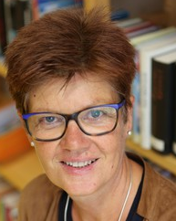
In my family we are all vegetarian. We don’t eat any meat or fish. Therefore, we never have any meat or sausages or fish in our fridge.
We always have some yogurt, because we eat yogurt with fruit for breakfast every day. We always have some milk in our fridge, and we love cheese. There is always some cheese in our fridge.
We eat lots of vegetables and salad, so there are usually some zucchini, some tomatoes and some carrots in our fridge.
Challenge 2
What’s in your teachers’ fridges? Draw the things in the correct fridge and label the picture!
Mrs Pö’s fridge:
Mrs Loitsch’s fridge:

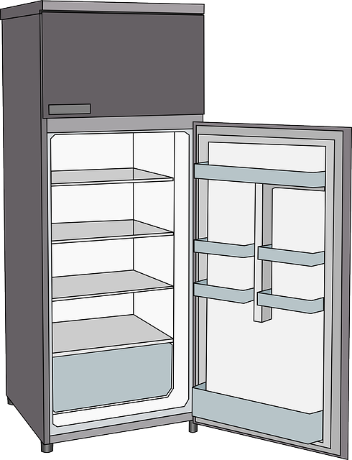

some carrots



Challenge 2
What do your teachers not have in their fridge? Write sentences!
My rule

Ms Loitsch never has any milk in her fridge.
Mrs Pö never…
Challenge 3

Look at these questions. What is the difference? Why does the speaker use some or any?

Mrs. Pölzleitner, do you know some good English books that I could read? | Mr. Grasser, do you know any good English books that I could read?
Mrs. Bergmann, I know your family likes chicken. Do you have some good chicken recipies? | Mrs. Pölzleitner, I know you are vegetarian, but do you know any good chicken recipies?
Ms. Loitsch, I see you always put oat milk in your coffee. Could I try some, please? | Is there any oat milk in the teachers’ fridge at school?
Ms. Loitsch, can I have some colored paper for my Me-book, please? | Felix, do you happen to have any non-permanent markers that I could use?
 | 

Challenge 4

Now it’s your turn! What do you never/sometimes/usually/always have in your fridge?

Draw the things that you have in your fridge! Then write 7 sentences. Use some and any.

M 11: much, many, a lot of, lots of

Challenge 5

Look at the examples. Guess how many there are.

here you can say: many or a lot of or lots of | How many do you think there are? Guess !
In the teachers’ office there are many books and many folders. | I think there are 50 books and 20 folders.
How many brothers and sisters do you have?
There are too many kids in this room.
There were a lot of people at the concert.
I have a lot of friends
Valentina has many pets.
How many days are there till Christmas?
here you can only say: a lot of | What about these sentences?  Can you count these things?  How?
Bill Gates has got a lot of money.
In the holidays a spend a lot of time on the beach.
There is a lot of food in the fridge.
There is a lot of sand on the beach.
This winter we had a lot of snow in the mountains.

Sort the words into the two boxes:
dogs, apples, books, boys, children, time, minutes, money, euros, days, water, milk, butter, food, sand, snow, trees, air, love,
here you can use: many / a lot of / lots of | here you can only say: a lot of
My rule
We say many / a lot of/ lots of when ….
We can only say a lot of when …

Challenge 6

not many | not much // not a lot of
When I was little, I did not have many friends. | He doesn’t have a lot of hair. He is almost bald.    The old man doesn’t have much hair. He is almost bald.
Mrs. Pö has many books, but not many DVDs. | John doesn’t have a lot of money.  John doesn’t have much money.
Mr. Grasser does not have many English books. | We did not have much snow this winter.  We did not have a lot of snow this winter
There are not many Chinese children in Graz. | Hurry up, there is not much time left.
Mrs. Weinzettl does not know many famous soccer players, but she knows many famous singers. | There is not much food left in the fridge, we’ll have to go shopping.

My Rule
We say not many when….
We say not much or not a lot of when ….

Now it’s your turn

Write true and meaningful sentences about yourself, your family and friends.
Use much, many, a lot of, not much, not many,

many
many
a lot of
a lot of
not many
not many
not much
not much

