  Your Language Reference Book for all the important Grammar Rules | My Personal Grammar Book  Name  ………………………….

LR-book

For the teacher
Students get these bits and pieces after each awareness raising and rule-finding activity to make sure the rules in their LR books are correct. They add their own TRUE examples.
For more complex topics (e.g. tense notions) they also draw a LOGO.
Table of Contents
a or an 3
BIG LETTERS – small letters 3
To be: am – is – are 5
Short forms – Long forms 6
Days of the week and months 7
Numbers 8
Ordinal Numbers: first, second, third… 9
I speak --- She speaks – I live ---He lives 10
Personal Pronouns: I, you, he, she, it, we, you, they 11
Wem gehören diese Dinge? Peter’s cat and Maria’s dog… 12
Besitz: for pros 12
Possessive Pronouns: my, your, his, her, our, their 13
Asking Questions in English 14
Negation in English 15
Telling the time 16
There is --- There are 17
Asking questions with there is—there are 17
Where things are: Prepositions of place 18
Future: making plans: going to 19
Routines versus Present activities 20
Past tense: Irregular Verb forms 1 21
Past tense: Regular Verb forms 22
Past tense - Negation 22
Past tense - Questions 24
Irregular Verb Forms 2 25
Comparing 26
Talking about the Future 28
Talking about experiences: Have you ever ….. 30
My exciting life: I have done lots of cool things 31
Wishful Thinking: What would you do if…..?? 32

a or an

Challenge
Look at the two boxes below. What do you notice? When do we use a and when do we use an in front of a word?
an apple  an orange  an onion  an ice-cream  an ugly duck  an interesting book | a boy  a girl  a chair  a dog  a unicorn  a unicycle

My rule
Wenn ich am Beginn eines Wortes ……………………………………………………….., verwende ich an.
Ich sage a unicorn, a unicycle weil…………………………………………………………………………………………………….

Now it’s your turn
Zeichne auf der gegenüberliegenden Seite zwei große Kreise. Schreibe in den einen Kreis möglichst viele Wörter vor denen wir ein a sagen. Im anderen Kreis sammelst du Wörter vor denen wir an sagen.
an
a

BIG LETTERS – small letters
In English we use big letters for
- I
- names (Paula, Peter),
- countries (England, Austria)
- cities (Vienna, Graz, London)
- languages (German, Croatian, English)
- and at the beginning of sentences.
In the English lessons we speak English. Elisabeth and Selina are talking about London and England but I am reading a book about America.

Now it’s your turn:
Write 3-5 sentences and mark the BIG LETTERS. Ask your teacher to check.
Schreibe deine korrigierten Beispiele auf die gegenüberliegende Seite, auf buntes Papier.

To be: am – is – are

My name is …………………….  I am a student at PraxisNMS.  I am ten years old.  I am not in class 4b. |   How old are you?  You are a very nice person.  You are my best friend. |   Anton is not in my class.  He is in NMS Kepler.  He is funny.

Sally is a student in England.
She is very nice.
She is not very tall.
  We are also happy.  We are not sad. |   Mary and Peter are good friends.  They are very happy.  They are not from Austria.

Now it’s your turn:
Write 10 sentences with
am | am not | is | is not (isn’t) | are | are not (aren’t)
Write true sentences about yourself, your friends, your classmates and teachers and your family members or pets.
Schreibe immer wahre, sinnvolle Sätze. Schreibe die korrigierten Sätze auf färbiges Papier und klebe sie auf die gegenüberliegende Seite.

Short forms – Long forms

CHALLENGE
Look at these sentences. What do you notice? Mark the differences with a highlighter.
Maria does not like spinach. | Maria doesn’t like spinach.
Peter is not from Austria. | Peter isn’t from Austria.
We are not in 4b. | We aren’t in 4b.
My friends are not in my school. | My friends aren’t in my school.

Now it’s your turn:
My friend Sally is not from Austria. | My friend Sally…
My mother is not very tall.
In my family, we do not eat meat.
 | My dad doesn’t like sweets.
 | We don’t have any pets.
 | Peter and Sally don’t speak German.

Days of the week and months
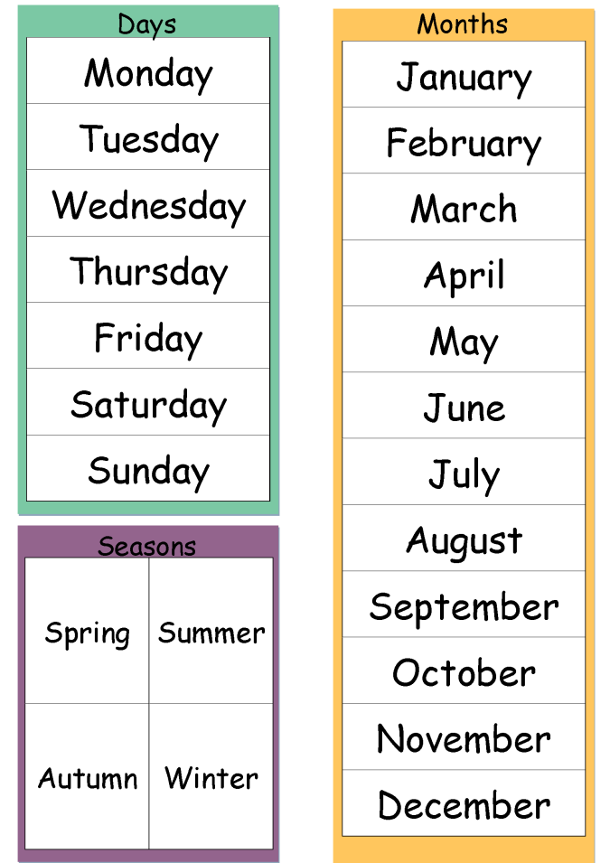
Write your answers on an extra sheet and ask your teacher to check.
Then write the questions and answers on colored paper and put it on the opposite page.

- What is your favorite season?
- What is your favorite month? Tell us why?
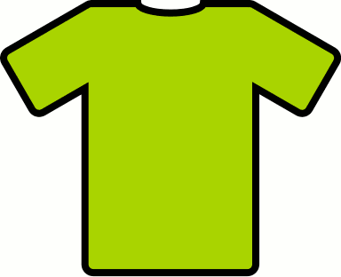
- In which months do you go swimming?
- In which months do you wear short sleeves?
- What is your favorite day of the week? Tell us why.
- What is your least favorite ☹ day of the week? Tell us why.

Numbers
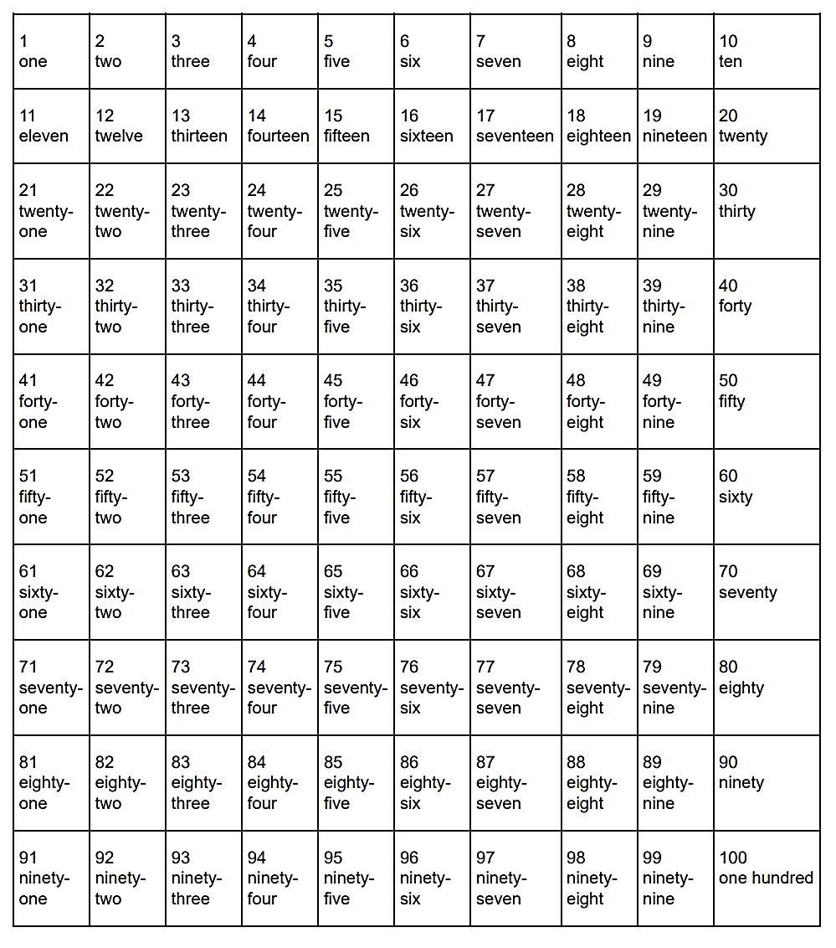

Now it’s your turn:
Task 1: Write page numbers into your ME-book. Write numbers and words: 1 -one, 2 – two 3—three…..

Task 2: Choose one number in each row and tell us what it means for you. Ask your teacher to check.
Then write your answers on colored paper on the opposite page.
Examples:
- twenty-five: Mrs Pö’s daughter is twenty-five years old.
- thirty-three: Thirty-three is my lucky number. My phone number starts with thirty-three.
- seventy-four: I live in Scheigergasse seventy-four.

Ordinal Numbers: first, second, third…
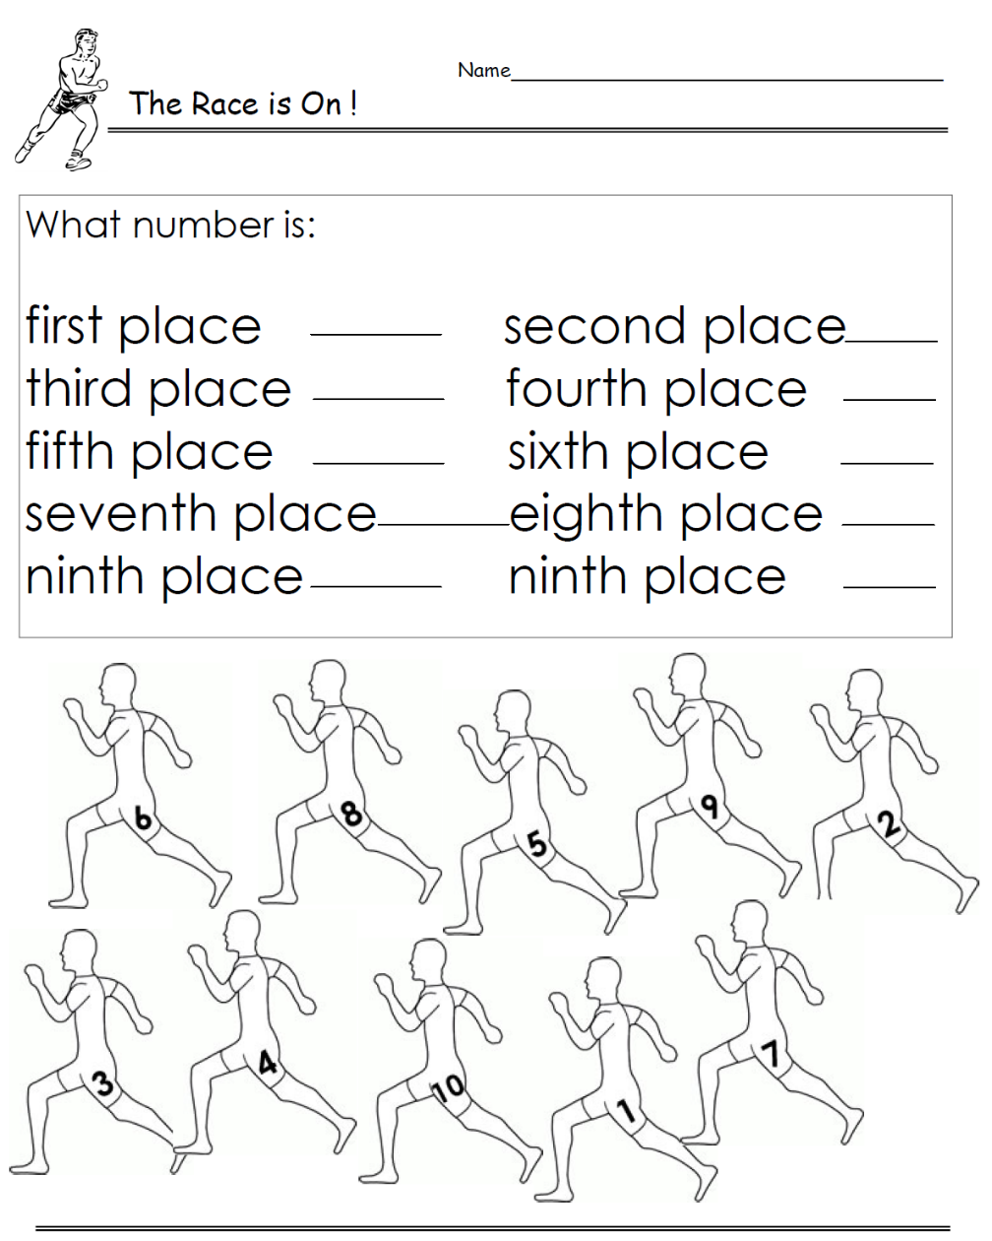
Who wins the race? Write sentences about all the runners:
Example: Number 3 is in first place and number 6 is in second place.
Ask your teacher to check and write your text on coloured paper on the opposite page.
first 1st
second 2nd
third 3rd
fourth 4th
fifth 5th
sixth 6th
seventh 7th
eighth 8th
ninth 9th
tenth 10th
eleventh 11th
…
twenty-first 21st
twenty-second 22nd
thirty-third 33rd
forty-fourth 44th
…
www.worksheetplace.com
GIVING THE DATE
British:
1st October 2018
2nd November 2018
American:
December 3rd, 2018
January 4th, 2019
February 5th, 2019
Example:
When is your birthday?
You write: My birthday is on August 22nd.
My birthday is on the 22nd of August.
You say:

Now it’s your turn.
Write your answers on an extra sheet (written and spoken version) and ask your teacher to check. Then write the questions and answers on coloured paper on the opposite page.
When is your birthday? My birthday is on …
What is today’s date? Today is …
When is Christmas? Christmas is on …
When does Ramadan start this year? It starts on ….
On which floor is the teachers’ office? It’s on the ….

I speak --- She speaks – I live ---He lives
Über sich selbst und andere reden

Challenge part 1:
What do you notice? Find the rule.
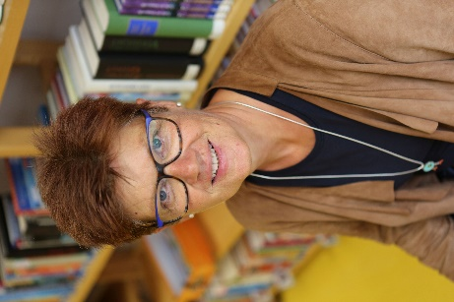

Hello, I am Mrs. Pölzleitner.
I live in a blue house in Graz. I am an English teacher. I love reading books and learning languages. I speak English, German, French, Italian and Greek. I also like sports. In winter I go skiing and in summer I go jogging. I ride my bike to school every day. My favorite food is Indian curry. I am vegetarian, so I do not eat meat.

This is Mrs. Pölzleitner.
She lives in a blue house in Graz. She is an English teacher. She loves reading books and learning languages. She speaks English, German, French, Italian and Greek. She also likes sports. In winter she goes skiing and in summer she goes jogging. She rides her bike to school every day. Her favorite food is Indian curry. She is vegetarian, so she does not eat meat.

Peter speaks French.
He lives in Paris.
He likes pizza.
I speak German and English.
I live in Graz

My rule:

Now it's your turn
Step 1: Draw a large speech bubble and write a text about yourself. Hand it in to your teacher.
Step2: Correct your speech bubble and put it on the pin board.
Step 3: Find a speech bubble from a classmate on the pin board or get one from your teacher. Then draw a box and write about your classmate. Hand your text in to your teacher. (Don’t forget to write YOUR NAME on the sheet.)
Step 4: Copy the text from the box on a coloured paper and glue it on the opposite page.
Step 5: When you have finished the module, put your own speech bubble on the opposite page to show that you can talk about yourself and about a friend.

Personal Pronouns: I, you, he, she, it, we, you, they

Now it’s your turn:
Read the examples and write similar (ähnliche) texts. Use ALL the pronouns
I, you, he, she, it, we, you, they
Ask your teacher to check, then write your texts on coloured paper on the opposite page.
You
I
Examples:

You are my
I am clever.
This is Anna and this is Tom.
They are my friends.
They are smiling.
happy.
My teachers are hapy
I like my classmates.

They are nice
THEY
Do you like cats?

I like you.
You are nice.
BFF
.

Wem gehören diese Dinge? Peter’s cat and Maria’s dog…


Challenge:
Peter’s brother is called Thomas.
Andrea’s sister is very funny.
My mom’s favorite food is pizza.
My dad’s mom is my grandmother.
My aunt’s dog is really big.

’s
What does it mean?

My rule:
Ich schreibe ein …‘s um….

Now it’s your turn:
Write 5 similar (ähnliche) sentences on a piece of paper. Ask your teacher to check. Then write them on coloured paper.
Remember: Always write TRUE sentences that make sense for you.

Besitz: for pros
Match the pictures and the sentences. Write the numbers into the pictures.
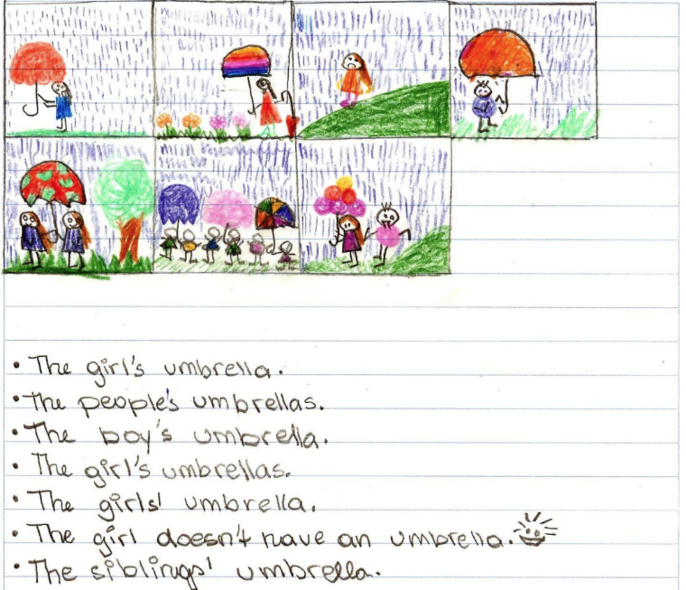
My parents’ bedroom is very big.
My friends’ houses are beautiful.
The girls’ umbrellas are colorful.
s‘s

Now it’s your turn:
Make your own matching game.
Write 5 sentences with … .‘s or s’ and draw a picture for each one. Show them to your teacher.
Then ask a friend to match your sentences and your pictures.

1
2
3
4
5
6
7

Possessive Pronouns: my, your, his, her, our, their
Wem gehören diese Dinge?
Is this your dog, Thomas?
Yes, these are our children.
These are their pets. They are really cute.



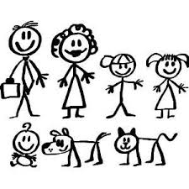
Yes, this is her cat.
Is this Susan’s cat.
Are these your children?
Yes, this is his dog.
Yes, it is my dog.

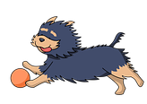
Is this the dog‘s ball?
Yes, it is its ball.

More examples:
Thomas has a sister. His sister is called Mary.
Mrs. Pölzleitner goes to school by bike. Her bike is black and blue.
Mrs. Bergmann has three children. Her children are called Martina, Julia and Matthias.
We have a very nice classroom. Our classroom is the best.
Some children from my old school go to a “Gymnasium”. Their school is not as cool as ours.

Now it’s your turn:
Write 10 TRUE sentences about yourself and your friends and family.
Use: my, your, his, her, our, their
Write your sentences on a piece of paper and ask your teacher to check.
Then write them on colored paper on the opposite page.


Asking Questions in English

The new English teacher…
Ms Bergmann meets the new English teacher.
She asks him lots of questions.
Do you like Great Britain?
Where do you come from?
Where do you live?
What languages do you speak?
Do you go to school by bike?
How do you get to school?
When do you get up?
Do you drink coffee?
Why don’t you drink coffee?
Do you have a pet?

How do your classmates study vocabulary?
How does your best friend get to school?
https://pixabay.com/de/fragezeichen-hinweis-duplikat-2110767/
Questions, questions, questions
Ms Pölzleitner wants to know everything about the new teacher. She texts Ms Bergmann.

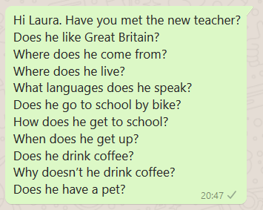

What do you notice? (Was fällt dir auf?)
- Man kann für Fragen Fragewörter (z.B. ___________________________________________) verwenden, aber man muss nicht.
- Man bildet Fragen häufig mit __________ oder ___________.
Does verwendet man wenn man über _________________________________________spricht.
- Das verb (z.B. ________________________________________________) verändert sich nicht.

Now it’s your turn:
- Write your own questions
- Write 5 questions you want to ask your teacher.
- Write 5 questions about one of your classmates. Ask your teacher. How many questions can your teacher answer? _______________
- Make a questionnaire (Fragebogen)
- Write a lot of questions to interview guests and student-teachers.
- When we have guests in class, talk to them and ask them all your questions.
- Put your questionnaire and your questions for the teacher into your LR-Book on the opposite page.

Negation in English


Challenge
Ms Bergmann has a problem.
She needs Ms Pölzleitner’s help.

Read the text. What do you notice?
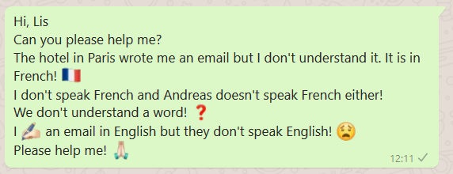

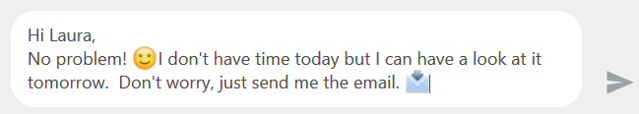

What do you notice? (Was fällt dir auf?)
- In der Verneinung verwendet man ___________ oder _____________ vor dem Verb (z.B. speak, like, eat)
- Doesn‘t verwendet man wenn man über ________________________________________spricht.
- Das verb (z.B. ___________________________________________________) verändert sich nicht.

Now it’s your turn.
Say what people DON’T do! Write your own examples on a piece of paper.
Ask your teacher to check. Then write your sentences on colored paper.
Start your sentences like this:
I … / My best friend … / My teacher … / My cat/dog … / My parents … / My friends … / We…

Telling the time

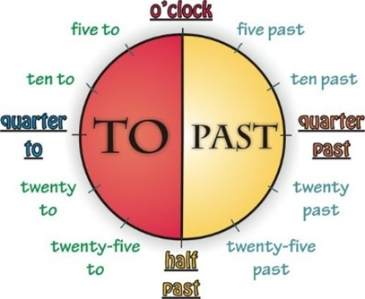
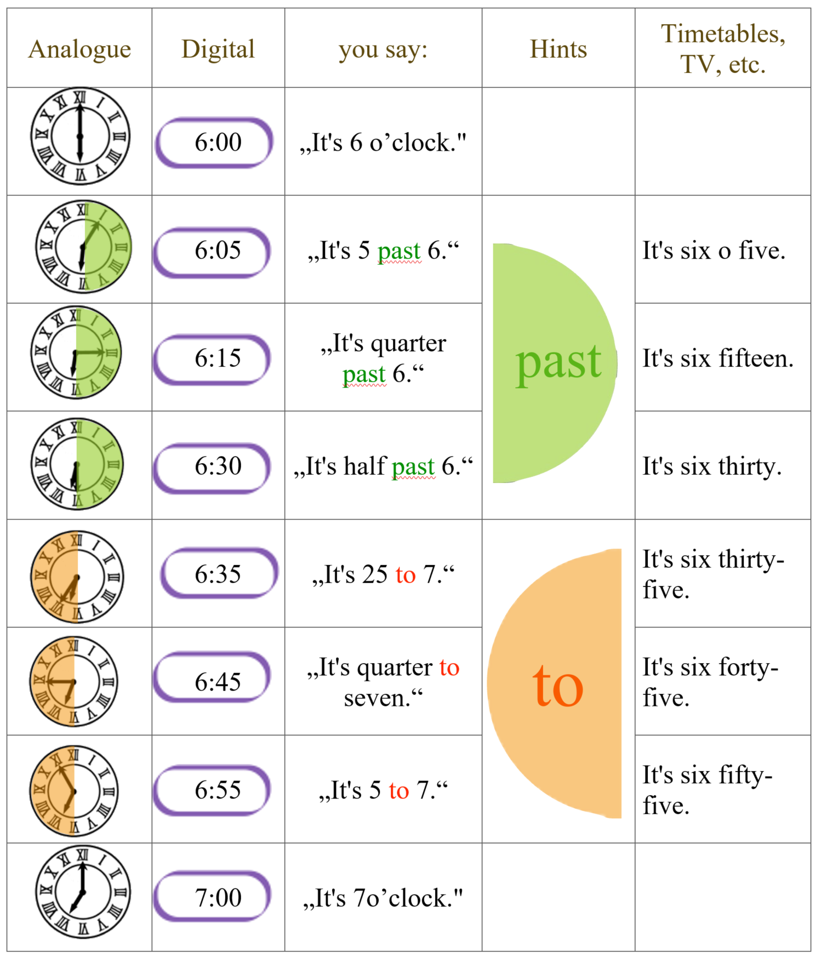

Now it’s your turn:

Answer the following questions. Write complete sentences into your spiral block. Show your sentences to your teacher. Then write a clean copy on a colored sheet and put it on the opposite page.

What time is it right now?
What time do you usually get up in the morning?
What time does school start?
What time do you have lunch in the school cafeteria?
What time does school finish?
What time do you usually study vocabulary?
What time do you go to bed in the evening?

There is --- There are
Einen Ort beschreiben

In our classroom there are 20 children.
There are also 20 chairs and many tables.
There is a computer under the teacher’s desk and there is a projector on the ceiling.
There are two big cupboards at the back of the classroom and there is a big green board on the front wall. Next to the door there is a washbasin and three garbage bins.

Now it’s your turn: Write five sentences about your room. Use there is and there are
Write your sentences on a sheet of paper. Show them to your teacher. Then put your sheet into your LR book, opposite this page.

Explain: When do we use there is? When do we use there are?
We say THERE IS….

We say THERE ARE…

Asking questions with there is—there are

Is there | a | sofa | in your classroom?
Is there | an | orange | in your classroom?
Are there | any | laptops | in your classroom?

Yes, there is.  No, there isn’t. | Yes, there are.  No, there aren’t.

There is a | sofa | in/on/under/next to/in front of/behind/between…..the | ………….
There are some | posters | in/on/under/next to/in front of/behind/between…..the | ………….

Now it’s your turn: Work with a partner. Ask your partner 5 questions about his/her room.
Then write your questions and your partner’s answers on the opposite page.

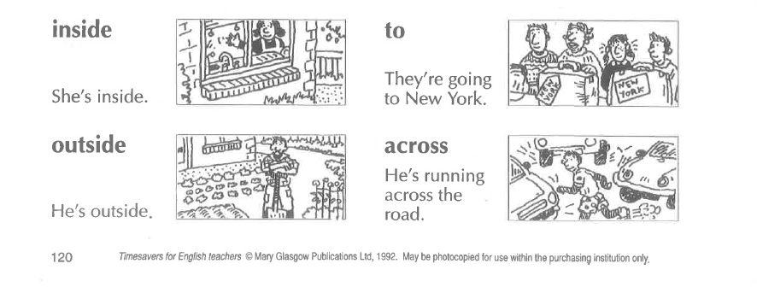
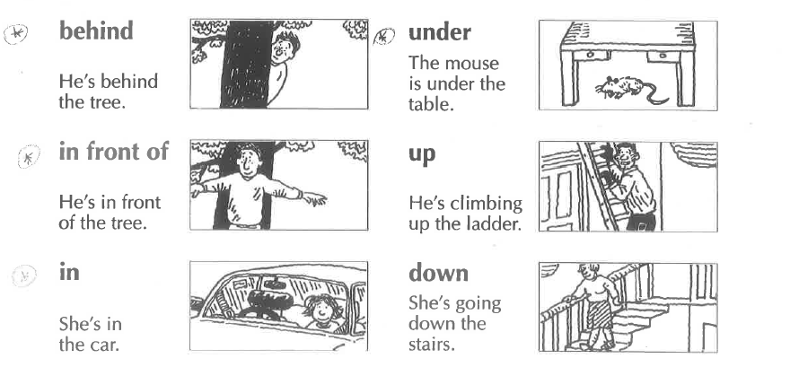
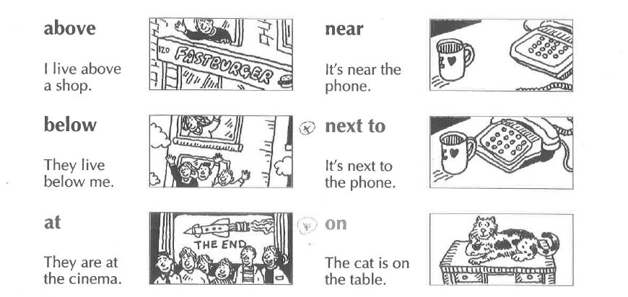
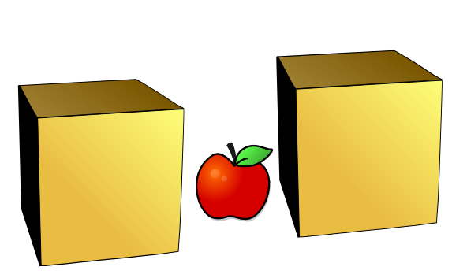
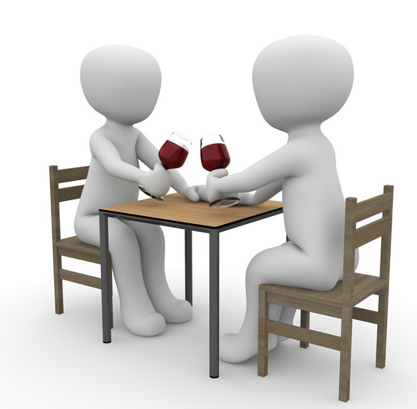
Where things are: Prepositions of place
between
There is an apple between the two boxes
opposite
They are sitting opposite each other.
Is there | a | sofa | in your classroom?
Is there | an | orange | in your classroom?
Are there | any | laptops | in your classroom?

Yes, there is.  No, there isn’t. | Yes, there are.  No, there aren’t.

There is a | sofa | in/on/under/next to/in front of/behind/between…..the | …………. .
There are some | posters | in/on/under/next to/in front of/behind/between…..the | …………. .

Now it’s your turn: Write 8 true sentences about your classroom, or your room. Show your sentences to your teacher. Correct your sentences and put the sheet into your LR book, opposite the blue LR book sheet for this topic.

Future: making plans: going to

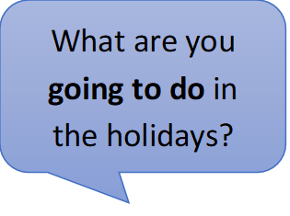
Talking about plans: GOING TO

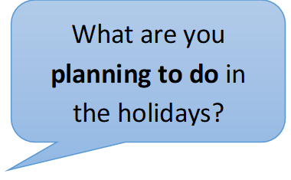
Write 3 sentences about your holiday plans
and
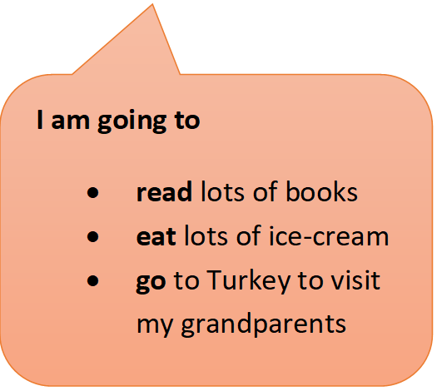
3 sentences about your friends’ holiday plans
and
3 sentences about your teachers’ holiday plans.

My holiday plans

My friends holiday plans

My teachers’ holiday plans

Routines versus Present activities

Challenge:
Look at these examples. What’s the difference?
A: Here we are talking about………………………………………………………………
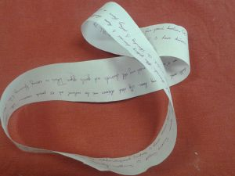 | I usually get up at half past six. Then I take a shower and I get dressed. At seven o’clock I have breakfast with my family. We eat bread, butter and jam and we drink hot chocolate. Then I go to school by bus. I arrive at school at half past seven. I go to my locker to change my shoes and to hang up my coat or jacket. School starts at quarter to eight….

B: Here we are describing what……………………………………………………………
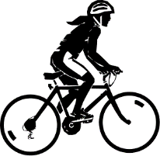  The girl is riding her bike. |   The girl is dancing. | 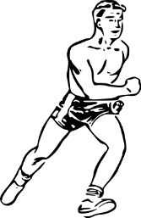  The boy is running.
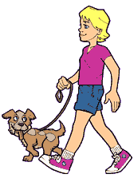  The boy is walking his dog. |   The person is swimming. | 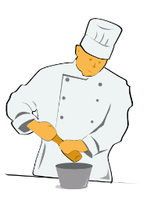  The cook is cooking.
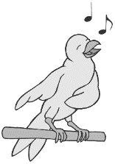  The bird is singing | 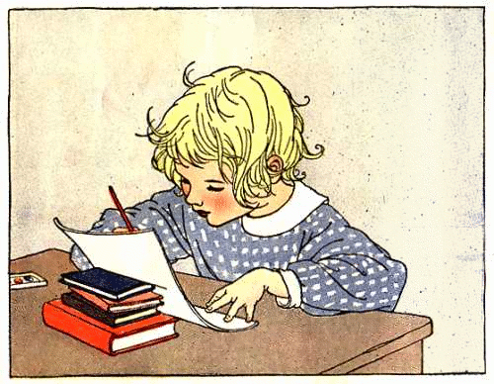  The child is doing homework. |   The children are playing with a ball.

Now it’s your turn:
Look around the classroom and write 10 true sentences on a sheet of paper. What are your classmates doing right now? Show your sentences to your teacher, then correct your sentences and put them into your LR book on the opposite page.

Past tense: Irregular Verb forms 1

Usually, .. |  | Yesterday …
I | am happy. | I | was sad.
We | are happy. | We | were sad.
I | do my homework. | I | did my math exercises.
I | go to school by bus. | I | went to school by bike.
I | spend 6 hours in school. | I | spent 7 hours in school.
I | have breakfast with my mom. | I | had breakfast with my dad.
I | fly to America. | I | flew to England.
I | take a shower. | I | took a bath.
I | come home at 5 o’clock. | I | came home at 7 o’clock.
I | read a book in bed. | I | read a newspaper.
I | speak with my friends. | I | spoke with my sister.
I | drink water. | I | drank Coke.
I | get up at 6 o’clock. | I | got up at 7 o’clock.
We | drive to my grandmother’s house. | We | drove to my aunt’s house.
I | say funny things. | I | said sad things.
I | eat dinner with my family. | I | ate dinner at my grandmother’s.
We | stand up when a teacher comes in. | We | stood up when Frau Wagner came in.
We | buy our food at SPAR. | We | bought our food at BILLA.

Past tense: Regular Verb forms

Usually, .. |  | Yesterday … / In summer...
I | visit my grandparents every Saturday. | I | visited my aunt.
I | play soccer in the afternoon. | I | played soccer in the morning.
We | stay in a hotel. | We | stayed with friends.
I | watch TV in the evening. | I | watched TV all day long.
Now it’s your turn: Find 5 more examples of REGULAR past tense forms in your teachers’ holiday letters. Write the sentences in the lines below.

Past tense - Negation
I can say what I did and what I did not do in the holidays.
Examples:
I went to Turkey. | I did not go to America.
I ate lots of ice-cream. | I did not eat any Sauerkraut.
I bought a new t-shirt. | I did not buy any souvenirs.
I took a bus and a train. | I did not take an airplane.
I played soccer with my friends. | I did not play chess.

Now it’s your turn:
Write 10 sentences on a sheet of paper. Use the LR Book pages for help!

Show your sentences to your teacher. Then correct them and write them and put them into your LR book next to this page.
Examples:
I did not go to Greece this summer, but I went to Turkey.
I did not read many books this summer, but I watched lots of movies.

Past tense - Questions
Yes, I did.
Did you go swimming in the holidays?

Did you speak English in the holidays?
No, I didn’t.
Did you visit your grandmother?

Did you like your hotel?

Now it’s your turn:
Write 5 more questions that you would like to ask your friends. What did your friends do in the holidays?

Irregular Verb Forms 2

There are about 185 irregular verbs in English. You will only need these 90. Study them carefully

Base form | Past form | Last form |  | Base form | Past form | Last form
All forms different |  |  |  | Past form and last form end in [d]
be (is/was) | was / were | been |  | find | found | found
become | became | become |  | have | had | had
come | came | come |  | hear | heard | heard
do | did | done |  | hold | held | held
go | went | gone |  | lay | laid | laid
run | ran | run |  | make | made | made
see | saw | seen |  | pay | paid | paid
show | showed | shown |  | read [ri:d] | read [red] | read [red]
 |  |  |  | say | said | said
All forms the same |  |  |  | sell | sold | sold
cost | cost | cost |  | stand | stood | stood
cut | cut | cut |  | understand | understood | understood
hit | hit | hit |  | tell | told | told
hurt | hurt | hurt
let | let | let |  | Same sound patterns
put | put | put |  | bring | brought | brought
set | set | set |  | buy | bought | bought
shut | shut | shut |  | fight | fought | fought
 |  |  |  | think | thought | thought
Past form and last form the same |  |  |  | catch | caught | caught
dig | dug | dug |  | teach | taught | taught
win | won | won
 |  |  |  | sing | sang | sung
Past form and last form end in [t] |  |  |  | swim | swam | swum
build | built | built |  | begin | began | begun
burn | burnt | burnt |  | drink | drank | drunk
creep | crept | crept |  | ring | rang | rung
feel | felt | felt
keep | kept | kept |  | freeze | froze | frozen
leave | left | left |  | steal | stole | stolen
light | lit | lit |  | break | broke | broken
lend | lent | lent |  | wake | woke | woken
mean | meant | meant |  | choose | chose | chosen
meet | met | met |  | drive | drove | driven
send | sent | sent |  | write | wrote | written
shoot | shot | shot
sleep | slept | slept |  | beat | beat | beaten
smell | smelt | smelt |  | bite | bit | bitten
spend | spent | spent |  | eat | ate | eaten
spill | spilt | spilt |  | fall | fell | fallen
spoil | spoilt | spoilt |  | forget | forgot | forgotten
get | got | got |  | fogive | forgave | forgiven
lose | lost | lost |  | give | gave | given
sit | sat | sat |  | hide | hid | hidden
sweep | swept | swept |  | shake | shook | shaken
 |  |  |  | take | took | taken
Same sound pattern |  |  |  | tear | tore | torn
grow | grew | grown |  | wear | wore | worn
fly | flew | flown
know | knew | known
throw | threw | thrown

Comparing

Read the descriptions of these exotic animals and highlight all the comparisons (Vergleiche). Then match them with the pictures. Draw lines.
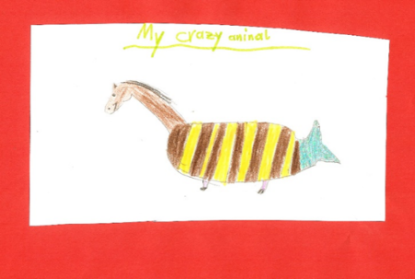
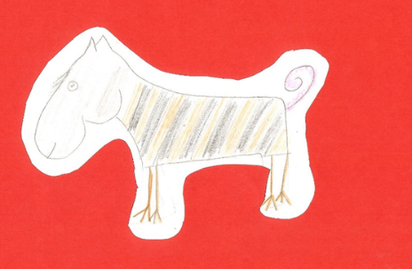
Horsotigopigchick
The horsotoigopigchick has the body of a tiger, the head of a horse, the tail of a pig and the feet of a chicken. Its head is bigger than a tiger’s head and a lot heavier. The horsotigopigchick’s legs are much thinner than a tiger’s legs and it much slower than a tiger. It has a think pink tail and it is more peaceful than the Tigohorsophin. It is the friendliest of these animals and makes a perfect pet.
Tigohorsophin
The tigohorsophin is a lovely animal. It has the head and neck of a horse, the body of a fat tiger and the tail and fin of a dolphin. It has the smallest, shortest legs of all the exotic animals. Normally it doesn’t walk but it can swim. The tigohorsophin is the heaviest of the exotic animals and it is even slower than the horsotigopigchick but it is the most intelligent of all the exotic animals.
Crocosharkopeacock
The crocosharkopeacock is a very strange animal. It has a crocodile’s head, the body of a shark and the tail and feathers of a peacock. Its legs are as short as a crocodile’s and it cannot run very fast, but the crocosharkopeacock can fly faster than any other bird. It is the fastest animal in the world. It has very sharp teeth and it is more dangerous than the other two animals.

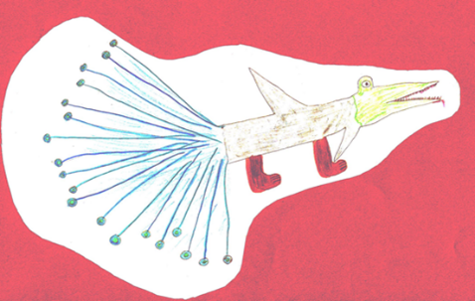

Are these sentences true or false? Tick the correct ones and correct the false ones.
Horsotigopigchicks are as fast as tigers.
Challenge:
Find the rule.
How do we compare adjectives?
How would you explain this to your mom?
Tigohorsophins are the heaviest and slowest animals in this group.
Tigohorsophins are the most intelligent of the exotic animals.
The crocosharkopeacock has shorter legs than the other animals.
The horsotigopigchick is more dangerous than the other animals.

Challenge:
1. Show that you can do this.
thin
kind
cold
intelligent
beautiful
interesting

2. Explain it!

3. Choose two animals and compare them. Write at least 5 sentences.

Show this page to your teacher. Then copy your answers on the blue LR book sheet for this topic and put it into your LR book folder.

asdf

Talking about the Future
Read the following examples where people talk about the future. Highlight all the verbs (Zeitwörter).
What do you notice? What is the difference between text A and text B? Tell your teacher what you have found out. Then ask your teacher for the blue LR book sheets for this grammar topic.
A
In the holidays I am going to do lots of nice things. First, I am going to bake some Christmas cookies. On the 24th of December I am going to decorate our Christmas tree with my daughter and my husband. Then we are going to go to the cemetery to light a candle on my mother’s grave.
In the evening we are going to celebrate Christmas and open our presents. On Christmas day my whole family is going to come to my house and we are going to eat and celebrate together.
In the second week of the holidays I am going to go skiing with my husband. We are going to a small village in Salzburg for a week. In the evenings I am going to read lots of books.
I am really looking forward to the holidays.
What are you going to do in the holidays?


My Rule:
Here we are talking about ………..
We use the form ………………………

B
I’m not sure. I think I will live in a flat or in a house with my partner. Maybe I will have some children.
I’ll work in a big company and I’ll have a car of my own. It will probably be an electric car – or maybe I’ll go to work in a self-driving car.
What will your life be like in the year 2040?

My Rule:
Here we are talking about ……………………………………

We use the form…………………………………………………..
Tip: Remember
I am = I’m
I will = I’ll

If …
Perhaps…
Maybe…


What are YOU going to do in the holidays? Do you have any PLANS or VAGUE IDEAS?
Write them on the left side of the arrow.
Perhaps, I’ll buy a new pair of skis. But only if they are cheap.
Maybe, I’ll visit my friend Mary in Klagenfurt.
I’ll go skiing if there is enough snow.



On Christmas day my father and my sister are going to come to my house for lunch.
I am going to bake some cookies on the weekend before Christmas.
I am going to celebrate the New Year in the mountains with my husband.
I am going to spend a week in the mountains and I am going to read lots of books.

Talking about experiences: Have you ever …..
- Step 1: Read the first part of the interview. Highlight the verbs. When do we use “have + 3rd form” (present perfect tense) and when do we use past tense? Tell the rule to your teacher and write it in the box below.

- Step 2: Complete the interview (First draft on a piece of paper!). Find your own questions and answers. Use the correct tenses.
Have you ever been bungee jumping or skydiving?
I have never been bungee jumping but I have been skydiving.

When did you go skydiving?
Did you like it?

I went skydiving when I was twenty years old. It was fantastic. We went up to almost 4000 metres in a little plane and then we jumped down.
We loved it and wanted to do it again, but it was too expensive.

We use „have + 3rd form“ (present perfect tense) to talk about __________________________________________________________________________ .
We use the past tense to talk about
_____________________________________________________________________________

My exciting life: I have done lots of cool things
Look at the example.
Step 1: Write about two things you have done. Use the speech bubbles.
Step 2: Give details in the box.
Step 3: Ask your teacher to check.

Step 4: Complete page 26 in your LR book.
details

It happened a few years ago. I was at the beach in Caorle. Suddenly I saw a group of children. They were very excited because they had a baby shark in a bucket.
I took the shark and brought it back to the sea. It was very weak so I moved it around in the water. After some time it swam away.
experience
I have touched a shark.

when – where - why –who- how….

details
I have _______________
- - - - - - - - - - - - - - - - - - - - .

when – where - why –who- how….

experience



I h _ _ _ _______________
- - - - - - - - - - - - - - - - - - - - .

experience

when – where - why –who- how….


I ______ _______________
- - - - - - - - - - - - - - - - - - - - .

when – where - why –who- how….
experience

Wishful Thinking: What would you do if…..??

Step 1: Read the sentences and look at the underlined words.

If I had a bike, I would go to school by bike every day.
If I was invisible, I could find out all my friends’ secrets.
If I could play the guitar, I would join a band.
I would go for a walk every day if I had a dog.
I would stay in bed all day, if I did not have a test today.

Step 2: Complete the sentences (First draft on a piece of paper!)

If I had a pet,
If I had 50 euros, I
I would go to America if
If I could fly, I
If I had a twin sister/ brother, I
If I could travel in time,
I would not leave the house, if
If
Write 3 more sentences about cool things you wish you could do.

