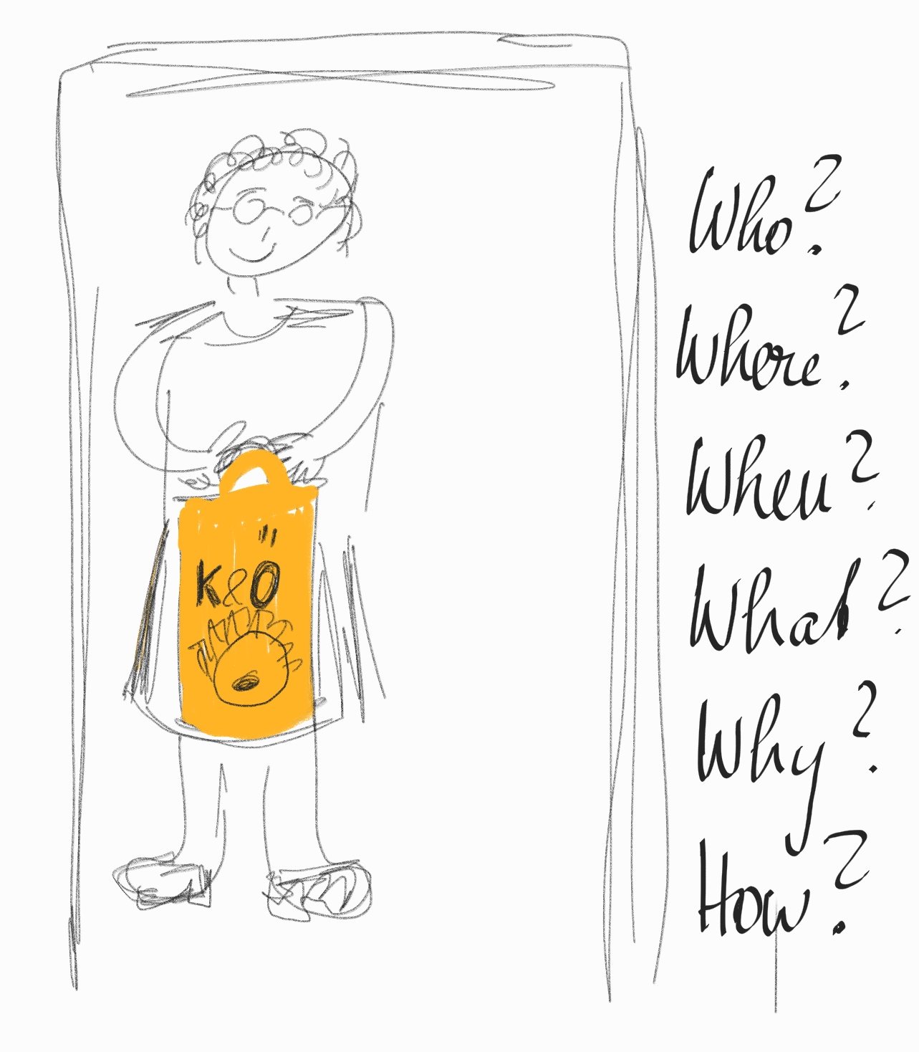
Guess the story of this picture.

The woman in this picture is Frau Baldauf. She was an old lady in our neighborhood. In this picture she is standing at the door of our apartment holding a shopping bag from Kastner and Öhler. It was a Sunday around Easter and my sister and I were home alone. Our parents were taking a walk in the woods, but my sister and I had refused to go with them.
When Frau Baldauf rang the doorbell, we opened for her and she gave us the shopping bag that you can see in the picture. We had no idea what was in the bag, so we opened it curiously.
It was one of the best surprises ever. There was a tiny kitten in the bag. The kitten was looking up at us with big, frightened eyes. We had always wanted to have a pet and we had been begging our parents for a long time to get a hamster or a guinea pig or a rat or some other animal. They never liked the idea.
We didn’t know what to do – would we be allowed to keep the kitten, or would our parents be angry and give it back?
Frau Baldauf was sure we could have the cat, she had talked about this with our parents before and had promised to get a kitten for us as soon as one of her cats would have babies.
This was one of the best surprises in my life. We called our first cat Muni and we all loved Muni a lot.

