1 Put the adjectives under the headings for pleasant ()and unpleasant () weather.


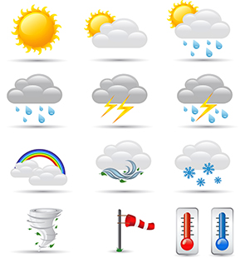
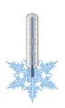
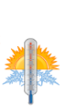
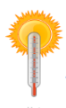
nice hot warm cold dry wet stormy partly cloudy cloudy/overcast
wet
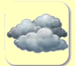

freezing sunny foggy rainy chilly windy snowy
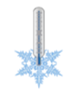
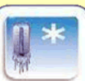
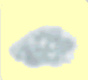

nice | freezing
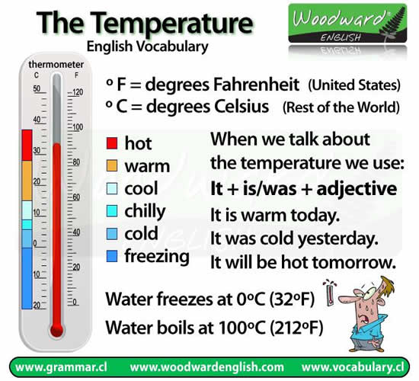

2 What was the weather like in the holidays

I was in Scotland |  | I was in … |  | I was in …. |  | Graz: Today it is
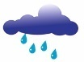

Scotland: I was in Scotland. It was rainy and windy.
___________: ____________________________________
___________: ____________________________________
Graz: Today it is ________________________________

