Describing pictures
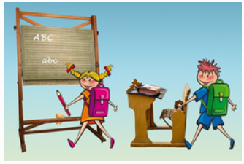

In the picture there are two _____________________, one girl and one ________________.
The girl has got a pink _____________________. In her hand is a _____________________
On the ________________________ you can read ABC.


The students put the ________________ on the ______________________.

