Tea and Talk
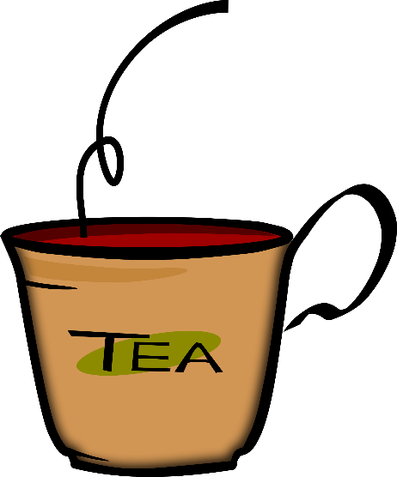
Would you like some tea?
No, thank you.
Yes, please

Would you like sugar or milk in your tea?

Would you like a cookie?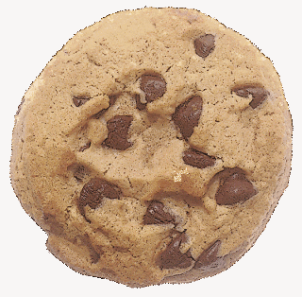

fruit tea  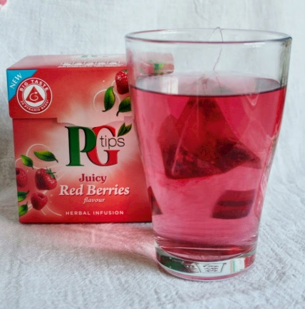  This Photo by Unknown Author is licensed under CC BY-ND | green tea  herbal tea 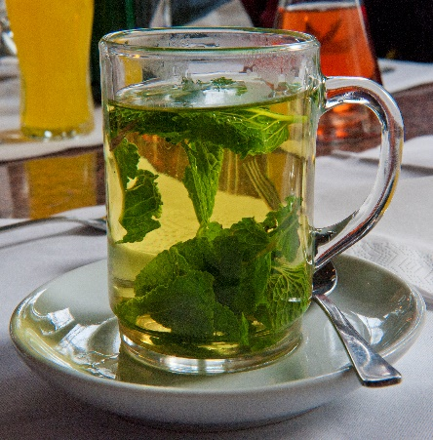  This Photo by Unknown Author is licensed under CC BY-SA | black tea  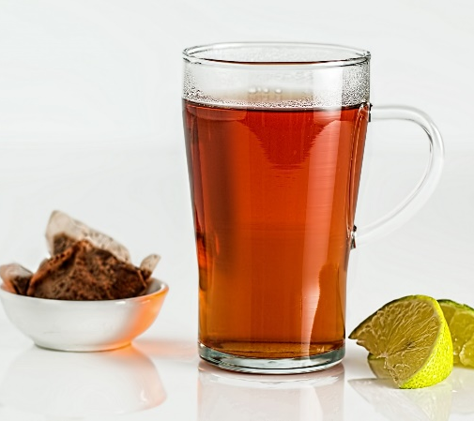
sugar  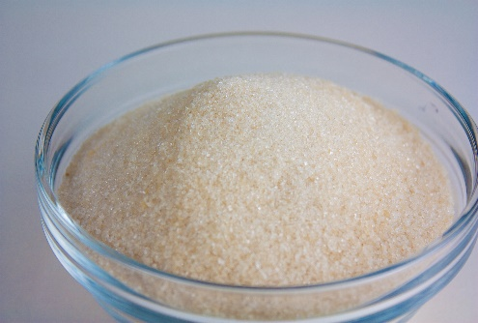  This Photo by Unknown Author is licensed under CC BY-SA | milk  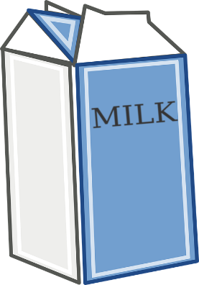 | a spoon  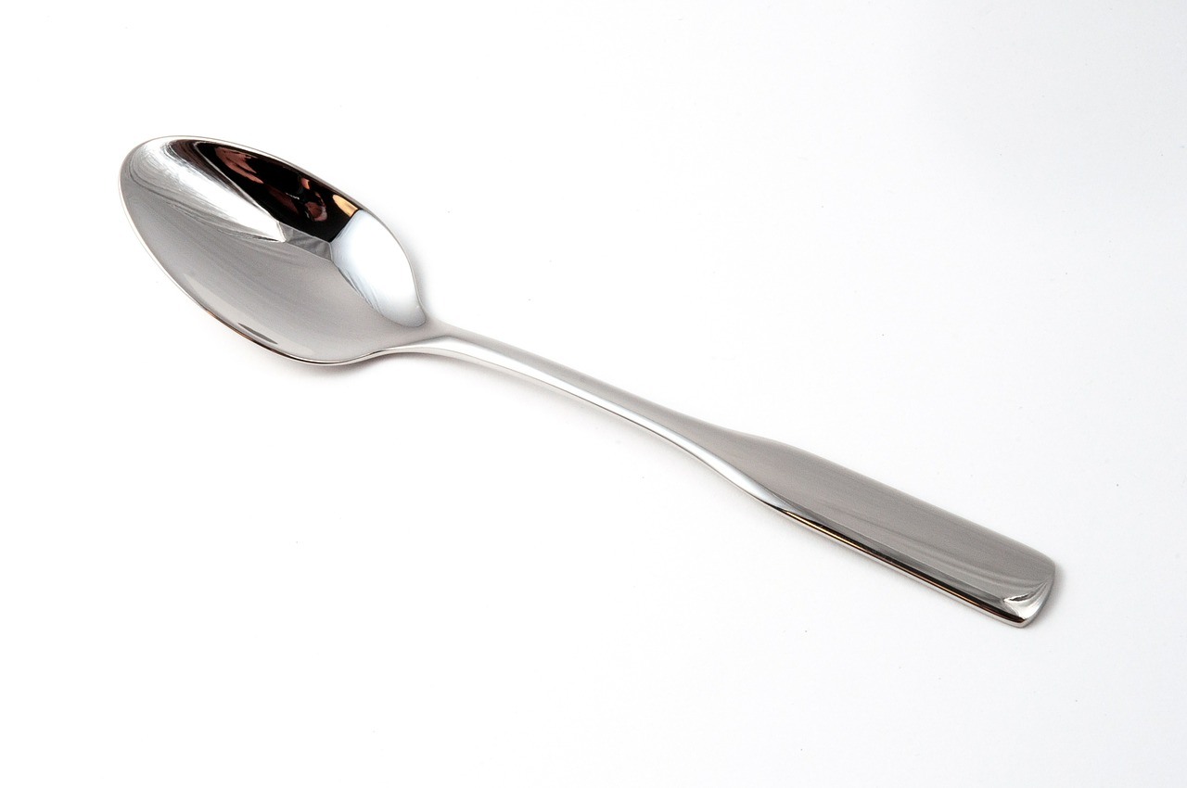  stir the sugar with your spoon.
a cookie | a piece of cake  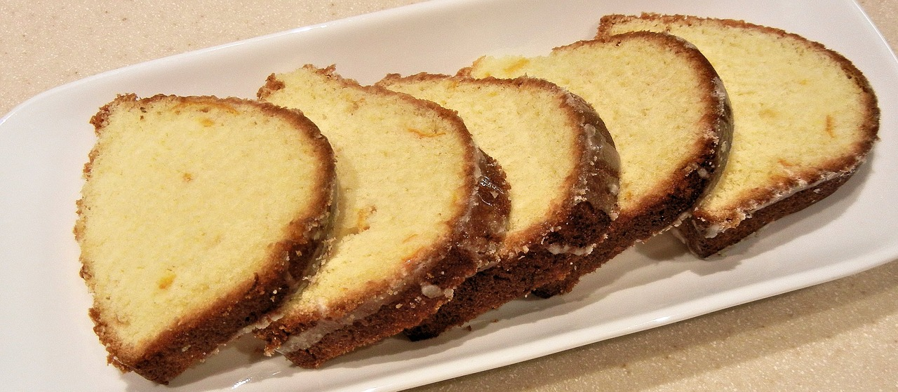 | a muffin  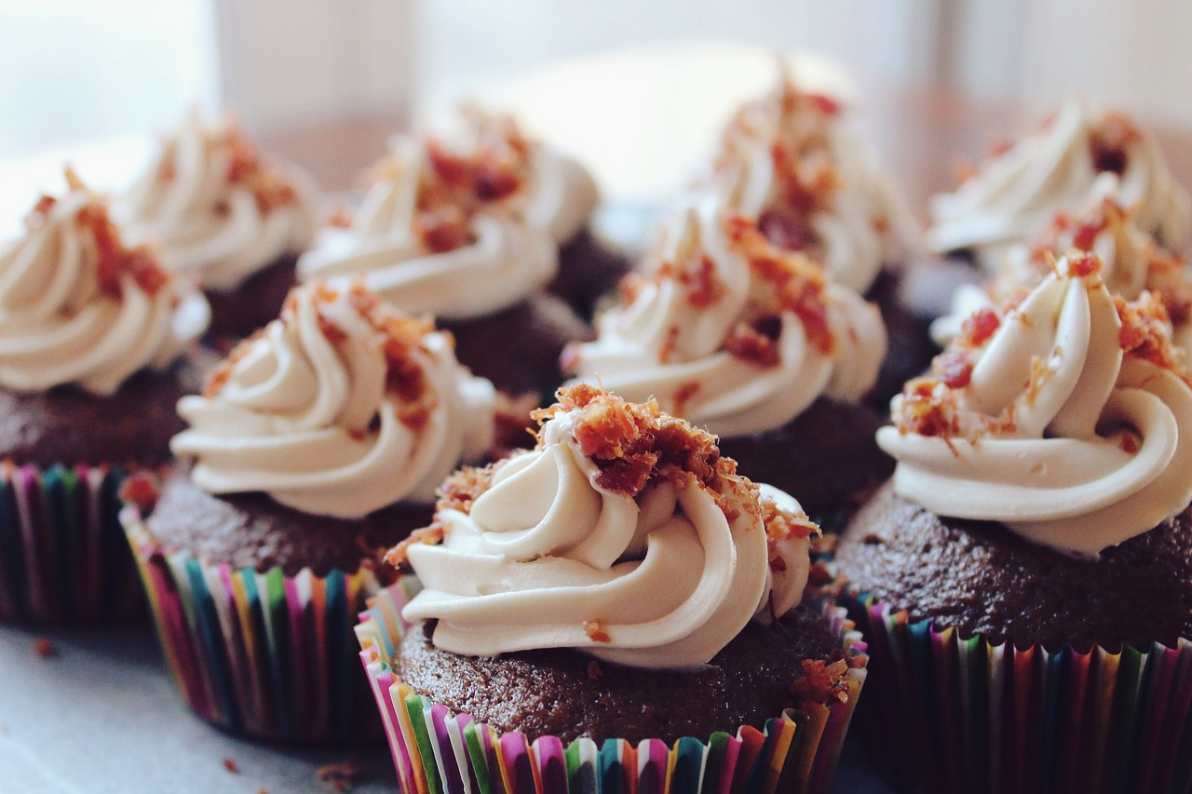

Picture sources:
Teacup and cookie: clipart
fruit tea: https://lh3.googleusercontent.com/M490W5dhiIyB-DFfY1JeKyP-c0r7ZbXD8awgWZITXoBfSmriDzMBCatmb8wZ3Dexx9TtlNA=s85
herbal tea: Wikimedia commons, https://commons.wikimedia.org/wiki/File:Peppermint-tea_hg.jpg
black tea: CCO : http://www.publicdomainpictures.net/view-image.php?image=129199&picture=tea-in-glass-cup
sugar:CC-BY-SA 2.0) https://www.flickr.com/photos/vegan-baking/4107881655/
milk: CCO , https://pixabay.com/en/milk-powder-food-nutrition-healthy-312369/
spoon: CC0, https://pixabay.com/en/teaspoon-coffee-spoon-metal-eat-554065/
muffins: CC0, com/en/cupcakes-dessert-frosting-food-690040/
cake: CC0, https://pixabay.com/en/sliced-orange-cake-icing-sugar-food-739987/

