
Some extra practice
I can use „am“ „is“ „are“ correctly
My best friend Tim
This _____________ Tim. He _______________my best friend. He has got a sister. Her name _______________ Jane.
Jane and Tim ______________ twins. They _____________ eleven years old. But I don’t like Jane. She _______________ nice. She is horrible!
Tim and I ______________ best friends. We ________________ in the same class.
We both like English. Tim likes maths, but I don't like maths!
Tim ____________ clever and funny. I ______________ so happy that he ___________ my friend.
Offering food to someone
Complete the dialog
Sam: Hi Mom, I _______ really hungry.
Mom: No problem, Sam. _________ you like some spinach soup?
Sam: No, I ___________ spinach ☹. Can I have ____ hot dog?
Mom: No, we __________ have any hot dogs, but you can have ___ pizza.
Sam: Yes, that’s good. I like pizza. What kind of pizza do we have?
Mom: We have pizza Margherita, and I can add some ______________ 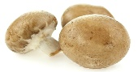
This Photo by Unknown Author is licensed under CC BY-SA
and __________________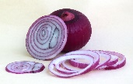
Sam: Ok, please make me a pizza Margherita with ________________, but I don’t want any ______________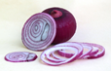 on ______ pizza.
This Photo by Unknown Author is licensed under CC BY-SA

