
MODULE 1: That’s me
October 19th

My Plan
normaler Zeitplan: (2 Jahre)
Abschluss: Vor den Herbstferien
Zeitplan für 3 Jahre:
Abschluss: Mitte/Ende November
October 19th
Week 1  Sep. 19th – 25th |  | Week 2  Sep. 26th – Oct 2nd |  | Week 3  Oct 3rd – 9th |  | Week 4  Oct 10th – 16th
First steps |  | Introduce yourself |  | Focus on Form |  | Reading whole class
Study vocabulary  First steps |  | Introduce yourself |  | Focus on Form |  | Classroom language  Flipgrid Video
Study vocabulary  Introduce yourself |  | Focus on Form |  | Classroom language |  | Finish Grammar Book  Tea and Talk
Week 5  Oct 17th – 23rd |  | Week 6  Oct 24th – 30th |  | Week 7  Nov 7th – 13th |  | Week 8  Nov 14th – 20th
FoF test  Me Book |  | work harder!  and do some work at home |  | work harder!! |  | work harder!!!
Me Book fertig
check Grammar Book
Just for fun
Reading test
Listening test

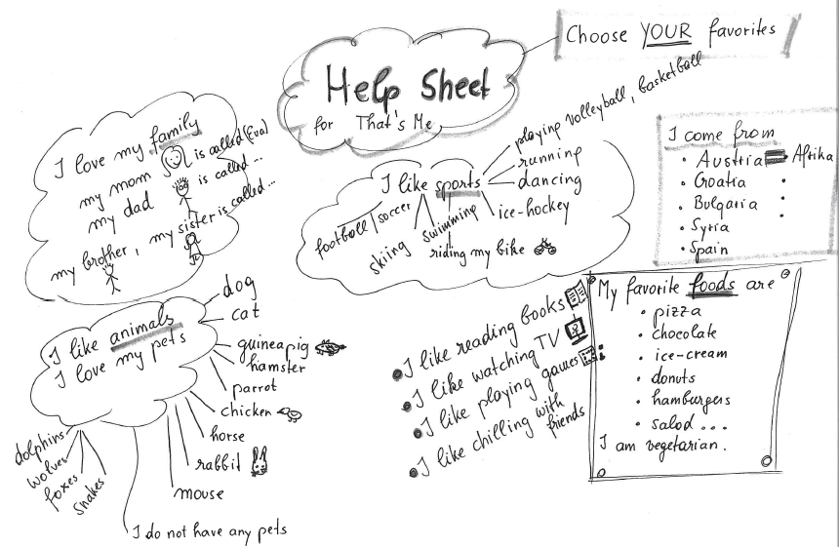
M1-Flexi-WELCOME

CHEAT SHEET PRIME TIME 1 - CB page 11, exercise 9
Introduce yourself and meet new friends

Dialogue 1
Mike: Hello!
Paul: Hi! Hello!
Mike: What’s your name?
Paul: My name is Paul.
Mike: How old are you?
Paul: I’m ten.
Mike: Where are you from?
Paul: I’m from Austria.

Dialogue 2

Mary: Hello!
Daniel: Hi! Hello!
Mary: Are you Daniel?
Daniel: Yes, I am.
Mary: How old are you?
Daniel: I’m ten.
Mary: Where are you from?

Daniel: I’m from Bosnia.

If you need more help with your dialogues, go to page 11 in your course book (CB), exercise 8 a.
CHEAT SHEET FOR VIDEO MODULE 1
Language Tips
- I am from / I live in

- I like ... / I don’t like .... / I love… / I hate…

- My favourite .... is / are

- I have …. / I don’t have any…

Tell us about ....
- Yourself (name / age / where from)
- Your Family
- Things you like doing
- Food
- Animals
- more ideas …

