Help-sheet for your TO BE rap
We are friends and we are …
I am X and this is Y…
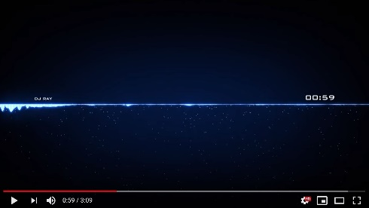
Yes, I am.
I am happy.
Tom is cool and he is tall.
No, I am not.
Are you sad?
And our teachers, they are…

Yes, he is.

I | am | our friends | happy | big
you | are | our teachers | cool | small
he | is not | Mrs. …. | sad | angry
she | is | Mr. ….. | tired | quiet
it | is | my friend …..(name) | clever | loud
we | are | all my classmates, they… | smart | funny
you | are | our classroom | nice | short
they | are | our school | big | tall

