- Listening
on Moodle | ______________/ 50

- Reading:
on Moodle | ______________/ 50

- Focus on Form / Writing 50P

- Look at the pictures. Tell us if you have done the things or not. 12P
Choose 6 pictures. Write one sentence per picture – 6 sentences
 |  | 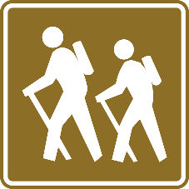
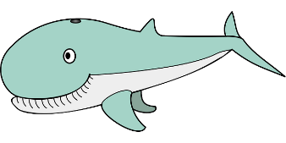 |  | 
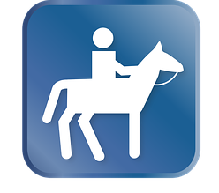 |  | 

- Choose 3 things that you have done. Write about them in more detail. Tell us some interesting facts about that event. Write 3-4 sentences about each event. 18P
- What if … 20P
Write a short text (4-5 sentences) about two of these ideas.
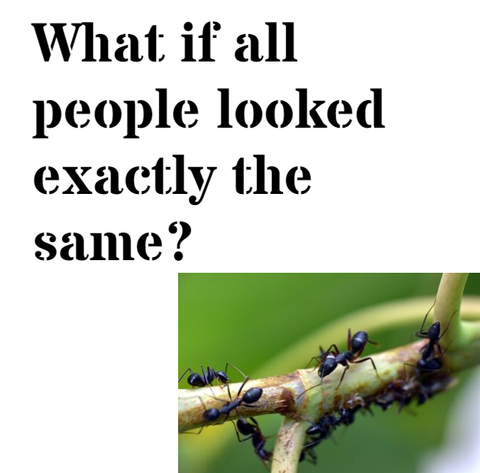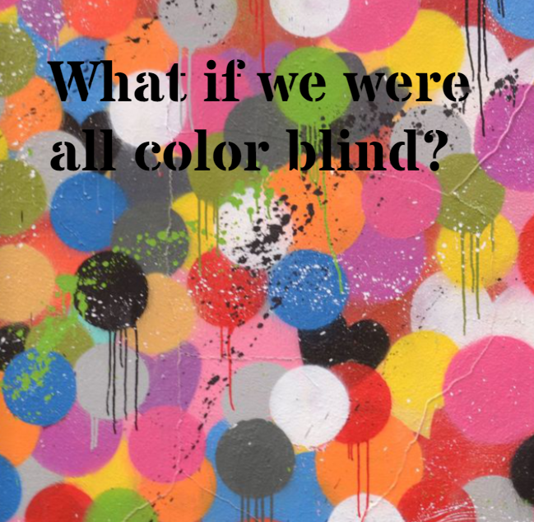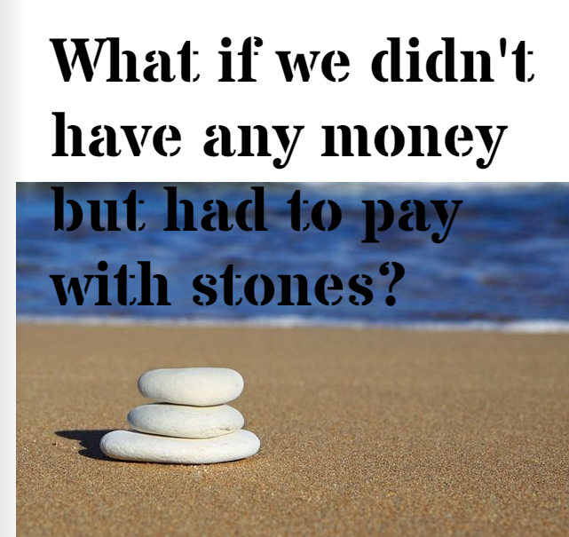
AHS | Sehr gut | 90% -100% | Gut | 80-89% | Befriedigend | 70-79% | Genügend | 60-69% | Nicht genügend | 0-59%
STANDARD | Sehr gut | 70% -100% | Gut | 60-69% | Befriedigend | 50-59% | Genügend | 40-49% | Nicht genügend | 0-39%

