
Graded Writing (M10): If I had a superpower….
- If you could choose a superpower for one day, what would it be?
pixabay C00
- Why?
- What would you do on that day?
Write as much as you can.

Graded Writing (M10): If I could travel anywhere in the world…

- If you could travel anywhere in the world, where would you go?
pixabay C00
- Why?
- What would you do there?
Write as much as you can.

Graded Writing (M10): If I could be another person…

- If you could be another person for one day, who would you be?
- Why?

- What would you do on that day?
pixabay C00
Write as much as you can.

Graded Writing (M10): If I could be an animal…

- If you could be an animal for a day, what animal would you be?
- Why?
- What would you do on that day?
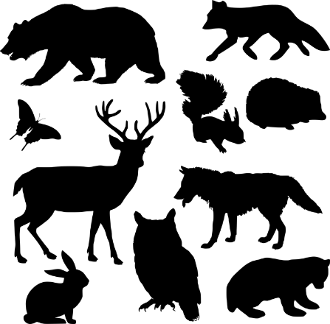
Write as much as you can.

pixabay C00

