Most adventurous teacher contest

The city of Graz is looking for the most adventurous teacher in town. The class that has the most adventurous teacher will win an adventurous, fun day with that teacher – every activity is paid for.
Students have to enter their teachers in the competition.
Write a letter and explain why your English teacher is the most adventurous teacher in town.
Experiences | Details
Swim across Lake Wörthersee  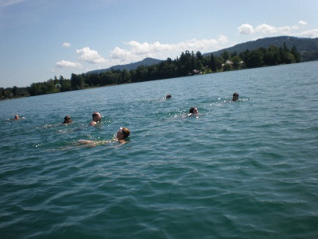 | group of friends  weather: warm, sunny  water warm  1,5 hours each way  great fun
climb in a cave  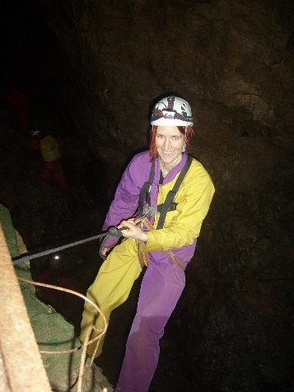 | Lurgrotte  wear special suits / helmet  headlamps  very dark  cold  1 km into cave
Cook and eat insects  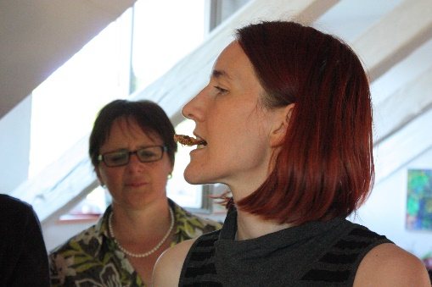 | worms and grasshoppers  fry in a pan  bake in the oven

Read this version of the letter and explain why the writer has used the
present perfect tense and the past tense.
In the last part of the letter translate the green phrases into German and in your first language.
Dear team of the Most Adventurous Teacher Contest,  I would like to enter my teacher Mrs. Bergmann for the prize. I think she is a very adventurous person, and she has done lots of things that show it. | Explain the use of the tenses here:
My teacher has swum across lake Wörthersee. This is a really big lake. It took her 1.5 hours each way. She did it on a sunny day with a group of friends and really liked it.

She has also climbed in a cave. It was a few years ago. Mrs. Bergmann climbed deep into Lurgrotte with a group of friends. It was pitch dark and very cold inside the cave. She had to wear a special suit and a headlamp. Mrs. Bergmann wasn’t scared – she really liked this adventure.

Mrs. Bergmann has done even more crazy things. She has eaten insects. She did this with her family a few years ago. They bought frozen worms and grasshoppers and they baked them or fried them. Mrs. Bergmann liked the insects, they tasted crunchy like chips.

Mrs. Bergmann has done many other crazy things. Last summer she went to Ireland and she spent 2 or 3 days in a church. She slept in the church, she cooked her meals in the church and she even washed her clothes in the church. It’s really unbelievable.

If we won the prize, we would like to spend a day with Mrs. Bergmann and try out some cool things with her. We would like to go to an adventure camp and climb in rope garden with her. If we won the prize we would use the money for this trip and we would buy frozen insects and grill them on a campfire. | Translate the green phrases
I hope that I have convinced you that our teacher is a very adventurous person and that we should win the Most Adventurous Teacher prize. | Translate the green phrases
Best regards,

