

M10: FoF 1

1. Cool things that I have done
List three things that you have done and that you are proud of. Write complete sentences.
0 1 2
0 1 2
0 1 2

Your bucket list:
Write down three things that you have not yet done but would like to do or learn in the future.
0 1 2
0 1 2
0 1 2

2. What if…
What would you do in these situations? Start your sentences with: If I …
  Math test |   lose mobile phone |   This Photo by Unknown Author is licensed under CC BY-SA  cut your finger
If I … 0 1 2
0 1 2
0 1 2

3. Comparing sports:
Choose three sports. Rank them (1. 2. 3….) and use these adjectives: expensive, dangerous, cool,
Write 5 sentences.
0 1 2
0 1 2
0 1 2
0 1 2
0 1 2
____/28



M10: FoF 2

1. Where have you been?
List three interesting places or countries that you have been to and tell us why you liked these places.
0 1 2
0 1 2
0 1 2

What would you like to be able to do?
Write down three things cannot do but would like to learn in the future.
0 1 2
0 1 2
0 1 2

2. What if…
What would you do in these situations? Start your sentences with: If I …
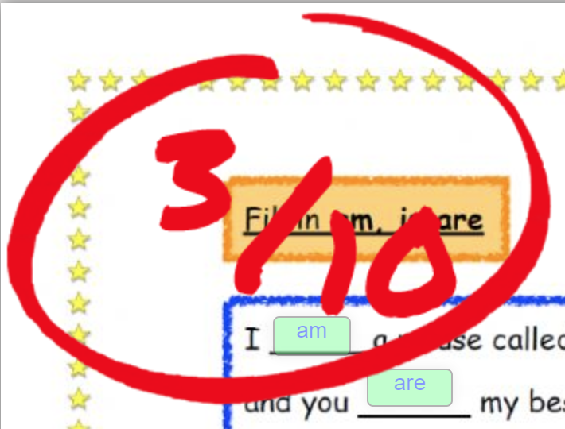  English test |   lose keys |   get a dog
If I … 0 1 2
0 1 2
0 1 2

3. Comparing school subjects:
Choose three sports. Rank them (1. 2. 3….) and use these adjectives: interesting, difficult, easy,
Write 5 sentences.
0 1 2
0 1 2
0 1 2
0 1 2
0 1 2
____/28

